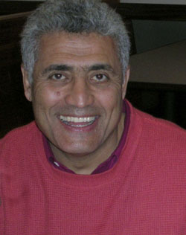
OBTS Board Profile: Magid Mazen

By Kent Fairfield, Fairleigh Dickinson University

Regular participants in the OBTC become aware of the outgoing guy who tells jokes, spins metaphors, and offers astute insights to a conversation. Now a full professor at Boston’s Suffolk University, Magid Mazen grew up in Egypt. For the last half of his life he has built a distinguished career in educating students and doing research in the U. S. He serves on the Board of Directors of OBTS, having been chair of the Doctoral Institute and the Legacy Project that brought luminaries to the conference in June at Babson.

Born in Cairo, Magid loved politics and the arts and gained distinction in both. Leadership positions in college student government from age 17 led to becoming president of the Egyptian Student Association in the U.S. and Canada. By 25 he was elected to the National Congress of the then ruling party. He met and conducted several one-on-one negotiations with late Pres. Anwar Sadat as well as then-Vice President Hosni Mubarak and several prime ministers. Meanwhile, he explored his life-long interest in human behavior by writing several plays as well as scripts that became episodes of dramas on the national broadcasting system. Magid traces his interest in teaching to his earlier work in drama. “Teaching OB puts the teacher in all the roles of writer, producer, director, and actor, responsible for sound effects, music, and even choreography.”

At 29 Magid came to the U. S. to study management, later enrolling in the Ph.D. program at Purdue University. Although working during school was a very un-Egyptian custom, he was drawn to “jobs I would not do again.” He became the assistant to a janitor. His self-effacing manner meant that he called his boss “Mr. Hughes.” Only later when the janitor learned that his underling was actually a graduate student did he tell Magid, “you can call me Mike.”

By the time he completed his degree in 1982, the curious scholar had decided to stay in the Midwest and had begun his first post at Illinois State University. In 1988 he joined the faculty of Suffolk University, which was in pursuit of gaining accreditation. Since that time he has seen the B-School nearly double to 110 faculty and has contributed to its progress through positions on promotion and tenure committees and chairing the Graduate Program Committee. He has shown his research mettle with publications in such places as AMJ, OBHDP, JME, SMJ, JOB, and the Negotiation Journal. Today his teaching covers OB, Negotiation, and his new baby, “Managing Failure for Success.”

He gratefully acknowledges the inspiration of Chris Argyris over the years, emphasizing such challenging issues of action learning as unintended consequences, defensiveness, and undiscussables in both research and the design of his classes as learning organizations. One semester he invited his students to learn the usefulness of collaborative negotiation strategies by buying his new car under the critical eyes of the whole class – at his own expense, of course.

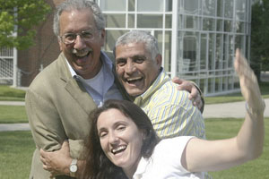
His propensity for metaphor comes out when he describes his holistic approach to organizations by seeing each situation as “the 24 layers of baklava. You can’t taste much baklava in any individual layer, even though each layer is vital for the whole. You have to bite into the entire piece to savor the taste and aroma – and a holistic . . . hmmm.”

Magid and his wife have two children. He reports that he is in his element when teaching and doing research, and they often go together, enhanced by his consulting as well. He thrives on the risk-taking of preparing a course, not sure if new approaches will work. “They could fail!” He recommends that teachers and students get used to staring into uncertainties and anxieties, not eliminate them. Because renewable students are a critical ingredient of the dish, excising all uncertainty from teaching “would be like eating without the zest of some fat or oil.” Instead, “Have a rendezvous, even a blind date with the classroom uncertainty – that is the joy.”
Magid inspiring a jovial moment with Richard Boyatzis and Amy Kenworthy-Uren at the Babson OBTC

Those really interested in observing other versions of his joy need to find him either on the football pitch near Boston on Sundays, where he competes in The Over-The-Hill Soccer Leagues, or in his favorite Cambridge chocolatier savoring conversation and a big cup of hot chocolate. These activities are just other ways in which he, as a scholar fond of the rich smorgasbord of life, can engage in more inquiry about the puzzle of human behavior, tell more stories, and spread his warmth around.

