Development of Potential Agents for the Treatment of Sickle Cell Anemia
Nupur Pandya
I. Introduction
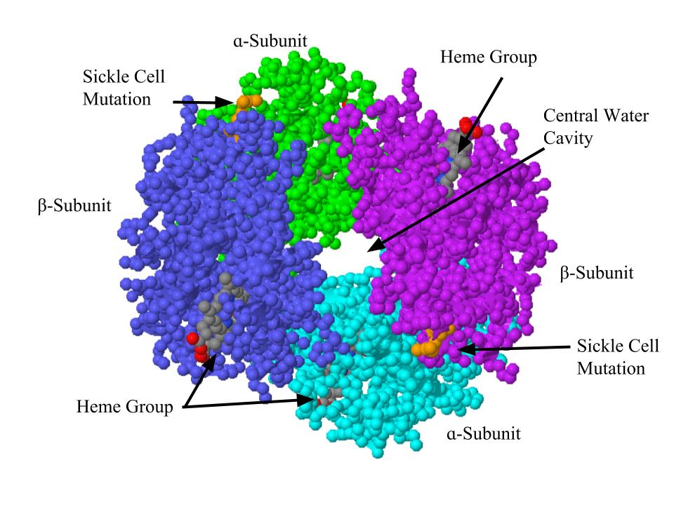
Sickle cell anemia or sickle cell disease (SCD) is an inherited blood disorder that affects between 70,000 and 100,000 Americans¹. This disease is caused by a single mutation in the oxygen-carrying protein hemoglobin (Hb) (Figure 1)¹⁴.
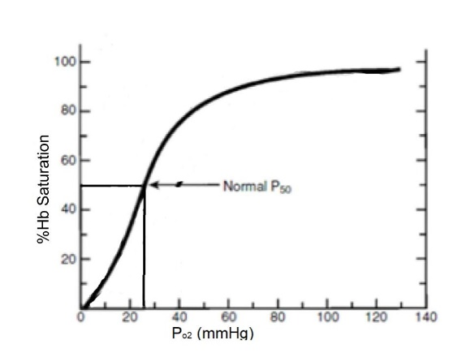
Hb is a quaternary allosteric protein consisting of four subunits-- α1, β1, α2, and β2, with a prosthetic heme group (containing iron) bound to each subunit². The four subunits are arranged around each other to form a large central water cavity by an α-cleft and a β-cleft. In figure 1, the alpha subunits are labeled in green and cyan, while the beta subunits are labeled in dark blue and purple. The heme group is highlighted in grey. The primary function of Hb is the transport of oxygen (O₂) from the lungs to tissues via the heme group. This function can be demonstrated by a sigmoidal O₂ equilibrium curve (OEC)¹⁰ (Figure 2). The OEC represents the O₂ saturation of Hb (y-axis of Figure 2) at varying partial pressures of O₂ (x-axis of Figure 2).¹⁰ The pO₂ at 50% Hb saturation (expressed as the P₅₀, marked on Figure 2) measures the O₂ affinity for Hb. Hemoglobin accomplishes its oxygen delivering function by having multiple conformations that have either a high oxygen affinity (the relaxed, or R-state) or a low oxygen affinity (the tense, or T-state)¹⁰.
Figure 2: Oxygen Dissociation Curve of Hb.
(Figure reproduced from Safo M, Kato G (2014))

Figure 1:Structure of hemoglobin. Orange residues are the location of the sickle cell mutation. Heme groups are in grey. Alpha subunits in green and cyan, Beta subunits in dark blue and purple. Figure from JMOL Protein Explorer, (PDB ID #1BZ0)
Figure 1: Structure of hemoglobin. Orange residues are the location of the sickle cell mutation. Heme groups are in grey. Alpha subunits in green and cyan, Beta subunits in dark blue and purple.
Figure from JMOL Protein Explorer, (PDB ID #1BZ0)
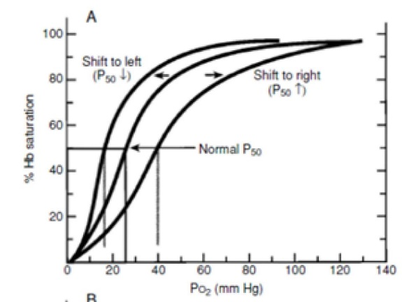
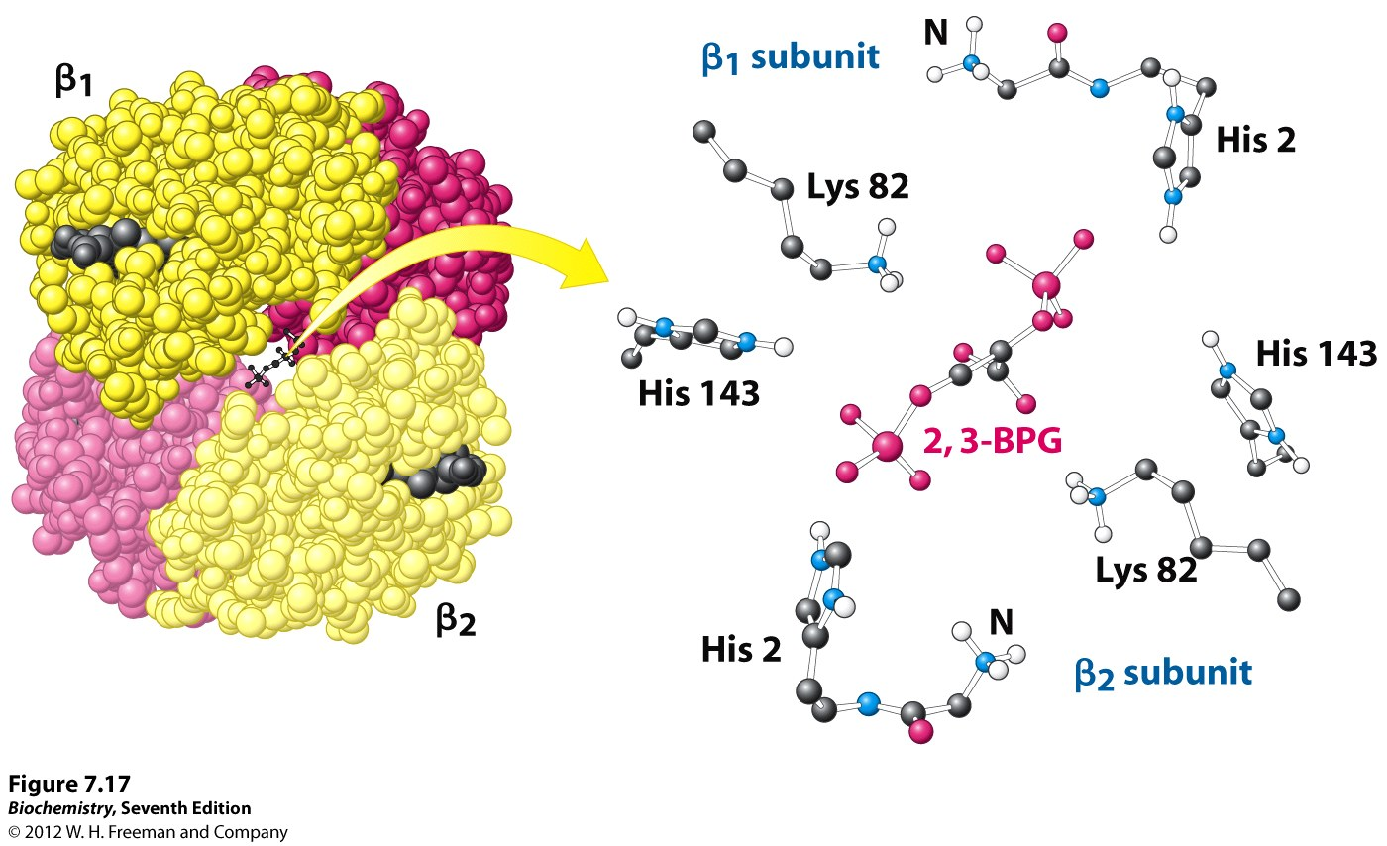
During Hb function, these two states exist in an equilibrium, the high-affinity R-state Hb binds to oxygen in the lungs (oxygenated Hb) and carries it to the tissues. Hb then changes confirmation to the low-affinity T-state Hb to release the oxygen to cells (deoxygenated Hb)². This equilibrium is maintained by allosteric effectors that regulate the transition from one state to another². For example, the natural allosteric inhibitor 2,3-biphosphoglycerate (2,3-BPG) binds to the β-cleft of Hb (Figure 3)². The allosteric inhibitor ties together the two β-subunits to stabilize the T-state, and consequently lower the oxygen affinity of Hb, allowing oxygen to be delivered to the tissuee². Other compounds, including synthetic compounds, can also bind to Hb and shift the OEC to the left (figure 4), stabilizing the R-state and increasing the oxygen affinity of Hb.²
Figure 4: Oxygen Dissociation Curve of Hb with left and right shift.
(Figure reproduced from Safo M, Kato G (2014))

Figure 3: Binding of 2,3-BPG to Hemoglobin
Figure from: http://oregonstate.edu/instruct/bb450/fall14/stryer7/7/figure_07_17.jpg

Figure 2: Binding of 2,3-BPG to Hemoglobin
Image from: http://oregonstate.edu/instruct/bb450/fall14/stryer7/7/figure_07_17.jpg
Sickle cell anemia is caused by a point mutation in the β subunits of Hb, changing the 6th amino acid in the β chain from a hydrophilic β-Glutamine to a non-polar β-Valine to form a sickle Hb (Hb S) (see figure 1, location of mutation highlighted in orange)¹⁴. The mutations do not influence the R-state of Hb S; however, in the T-state the exposed β-Val6 of the deoxygenated Hb S molecule makes hydrophobic contacts with adjacent deoxygenated Hb S molecules leading to polymerization, and eventually causing sickling of red blood cells². Making the polymerization process worse is the fact that Hb S has a significantly low affinity for oxygen, resulting in easy and rapid loss of bound oxygen². Deoxygenated Hb S then polymerizes, which consequently leads to sickling of RBC². The hypoxia (oxygen deficiency) induced RBC sickling can lead to several downstream pathophysiological events including obstruction of blood vessels (vaso-occlusive crisis), destruction and loss of RBC (hemolysis), severe pain, stroke, chronic organ dysfunction, splenic sequestration (the trapping of sickled RBC in the spleen), and other complications¹⁴.
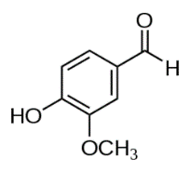
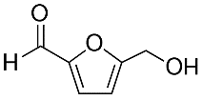
Current treatments for SCD include Hydroxyurea therapy and blood transfusions¹⁴. Hydroxyurea is known to resynthesize fetal Hb (HbF). Clinical symptoms of SCD are known to arise after levels of HbF drop (around 6 to 12 months after birth)¹⁴, as HbF is known to inhibit Hb S polymerization¹⁰. Patients on hydroxyurea therapy are helped by the resynthesis of HbF¹⁴. Furthermore, hydroxyurea is also known to cause a reduction in the expression of cell adhesion molecules that promote vaso-occlusive crisis¹⁴. However, hydroxyurea has been reported to be toxic, especially toward younger patients, and the Food & Drug Administration (FDA) has only approved the treatment for adult patients¹⁴. Blood transfusions have been proven to alleviate clinical complications associated with SCD¹⁴. However, this form of therapy is dangerous as the patients may not react positively toward the donated blood¹⁴. Furthermore, RBC received through transfusion are ultimately metabolized at the end of their life cycle, necessitating a new transfusion¹⁴.
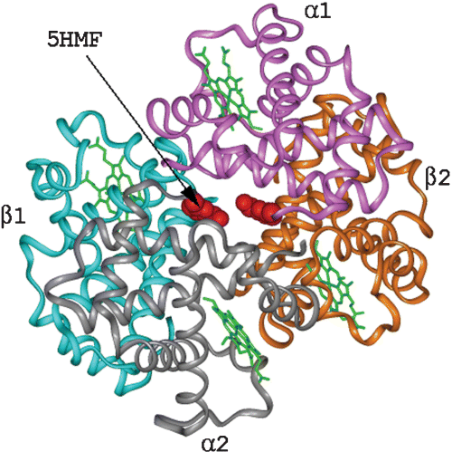
There are several ongoing research schools of thought to develop alternative therapies for SCD.This includes multiple studies that propose the use of allosteric effectors to increase the oxygen affinity of Hb to prevent RBC sickling⁴. The main antisickling allosteric effector candidates are aromatic aldehydes, which can form a Schiff-base interaction with the free N-terminal αVal1 amine to further stabilize the R-state Hb and increase the Hb affinity for oxygen⁹ (see figure 6 for binding).
B
A
Figure 5: Structures of 5-HMF and Vanillin
Figure 4!: Structure of Vanillin
Figure 4B: Structure of 5-HMF

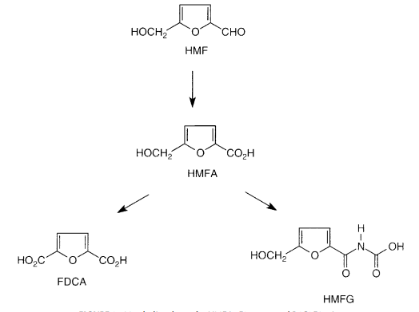
Vanillin (Figure 5a) was one of the first aromatic aldehyde allosteric effectors studied as an antisickling agent for the treatment of SCD.³ Although vanillin was tested and had the ability to elicit in vitro antisickling effects, it was non-bioavailable in vivo and therefore non-clinically viable.^{2,3} Since then, other aromatic aldehydes that bind to Hb and stabilize the R-state to increase Hb affinity for oxygen, for example, 5-hydroxymethyl-2-furfural (5-HMF), have been studied in clinical trials (structure of 5-HMF figure 5B, binding of 5-HMF figure 6).⁵ 5-HMF exhibits high antisickling potency; however 5-HMF undergoes extensive metabolism of the aldehyde moiety (scheme shown in figure 7) which leads to a short half-life and a low bioavailability.⁵ Therefore, the pharmacologic effect of 5-HMF is reduced and phase II clinical trials were ended.^{4,5}
Figure 7: Metabolic schene for 5-HMF metabolism in rats and mice
(Figure from Godfrey VB, et al. (2010)

Figure 6: Hb bound to 5-HMF
Figure from Abdulmalik O, et al (2005)
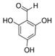
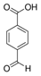
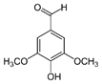
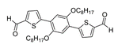
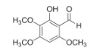
This study seeks to investigate the possible antisickling properties of five aromatic aldehydes (pictured in figure 8). The objective of this study is to develop other aromatic aldehydes that not only exhibit potent antisickling effects but also are stable from in vivo metabolism and therefore can become orally bioavailable. In this paper, we are proposing one method to study the antisickling activities of these compounds. Since the mechanism of antisickling activity of aromatic aldehydes is due to an increase in the Hb affinity for oxygen, we will measure the effect of these compounds on Hb affinity for oxygen. This method measures the P₅₀ value of the aldehyde effectors when bound to Hb.
2,4,6-trihdroxybenzaldehyde
4-formylbenzoic acid
Syringaldehyde
2,5-di(5-aldehyde-2-thienyl)-1,4-dioctyloxybenzene
An aromatic aldehyde isolated from the roots of Uvaria siamensis (Annonaceae).
A
B
C
D
E
Figure 8: Proposed Allosteric Effectors
(A) Figure from Maton A, et al. (2016)
(B) Figure from Cheng B, et al. (2017)
(C) Figure from Kamimura N, et al. (2017)
(D) Figure from Geng Y, et al. (2015)
(E) Figure from Salae AW, et al. (2017)

II. The Experiment
The aim of this experiment is to test the shift in the oxygen equilibrium curve (OEC) of the proposed aromatic aldehyde allosteric effectors liganded to Hb. Figure 4 shows the left and right shift of the OEC curve and the resulting P₅₀ values, which can be influenced by the binding of effectors onto Hb. If the effector binds to Hb and promotes the oxygen affinity of the protein (and therefore promoting the R-state), the P₅₀ will decrease as the oxygen equilibrium curve is shifted left. Concurrently, if the effector binds to Hb and decreases the oxygen affinity (promoting the T-state), the OEC curve will be shifted right, and the P₅₀ will increase. The direction and magnitude of the shift depends on the structure and binding properties of the allosteric effector. The degree of change in the P₅₀ value of the Hb liganded to the aromatic aldehyde allosteric effectors directly correlates to the degree of inhibition of sickling of SS cells by aromatic aldehyde effectors as a result of the Schiff-base reaction.
By measuring the P₅₀ of the allosteric effector-Hb complex, we can measure the direction and magnitude of the shift in P₅₀ and therefore analyze the antisickling properties. This process will follow the procedures of Deshpande T, et al (2018)¹⁵; we will use 5-HMF as a control as the molecule has been studied extensively.
Part A: Formation of Hb-effector complexes in normal whole blood
To measure the P₅₀ of the proposed aromatic aldehydes (structures in figure 8), first the Hb-aldehyde adducts need to be formed by treating human whole blood samples with test compounds (the compounds in figure 8 and 5-HMF); this is then allowed to incubate for about one to two hours. The samples will then be incubated at various oxygen concentrations (4, 20, and 40 mmHg), for about 5-10 minutes. This is done as 4% oxygen concentration is hypoxic, and 40% is hyperoxic (excess oxygen); measurement of the oxygen saturation at these three pressures can help us draw an OEC curve and therefore estimate the P₅₀ values.
Part B: Determination of P₅₀
OEC studies will be conducted with aliquot samples from the solution in part A. Aliquots will be subjected to analysis by an IL 1420 Automated Blood Gas Analyzer and an IL 482 or IL 682 Co-oximeter (from Instrumentation Laboratories) to measure the partial pressure of oxygen and the Hb oxygen saturation values. All measurements will be done multiple times to ensure accuracy.
The measurements will then be used to calculate an OEC curve, and the P₅₀ values will be calculated. The degree of P₅₀ shift will be expressed as the percent fraction of control samples.
III. Discussion
P₅₀ measurements of an effector bound to Hb can tell us its potential antisickling activity. An effector bound to Hb with high antisickling activity will have a high oxygen affinity (i.e. promote transition into the R-state of Hb), and therefore will produce a large left shift in the P₅₀ value. We can express the activity of the compound by calculating the ratio of P₅₀ of the Hb-effector complex divided by the P₅₀ of the control solution.¹³
As aromatic aldehydes are known to prevent hypoxia-induced sickling of RBC by forming Schiff-base adducts with Hb and increasing the oxygen affinity for oxygen the proposed aromatic aldehyde effectors (in figure 8) are hypothesized to have antisickling properties. If these effectors can produce a strong right-shift in the P₅₀, further studies must be done to test the potency of the effectors. A measurement of time- and concentration-dependent adduct formation can help study the potency of the effectors, specifically, the amount of time Hb-effector complexes are formed before metabolic breakdown and the concentration at which Hb-effector complex formation is optimal. Furthermore, to study the binding of the Hb-effector complex, X-ray crystallographic studies must be done. If these effector compounds are concluded to be viable as potential agents for use as antisickling drugs, these compounds can go onto in vivo pharmacokinetic/pharmacodynamic (PK/PD) studies to observe their in vivo antisickling properties.
Aromatic aldehydes are known to prevent hypoxia-induced sickling of RBC by forming Schiff-base adducts with Hb and increasing the oxygen affinity for oxygen. Some of these compounds have been studied in clinical trials for the treatment of SCD; however, it has been studied that these compounds have a very high clinical rate of metabolism, which makes these compounds exhibit poor bioavailability. Therefore, for an aromatic aldehyde to be effective, not only should it be potent and have antisickling properties, but it should be stable from enzymatic metabolism. This proposal focuses on testing five aromatic aldehydes for their ability to modify Hb, form Hb-effector adduct complexes, and consequently increase the hemoglobin affinity for oxygen, therefore translating into an antisickling effect. We expect these compounds to be as potent as 5-HMF, if not more in terms of P₅₀ and antisickling activities. More importantly, for these compounds to be potentially considered for treating SCD, they should exhibit longer and sustained pharmacologic effect when compared to 5-HMF, which can be tested by a time and concentration-dependent adduct study.
The development of a new drug for SCD is crucial, as the population suffering from the disease is high, and no proper treatment exists yet. Although it is possible the aromatic aldehyde effectors proposed in this paper may have low antisickling properties, low potency in vivo, or high rates of metabolism; this school of thought-- development of antisickling aromatic aldehyde effectors to treat SCD-- is extremely important in treating sickle cell disease patients all over the world. If these compounds exhibit the proposed pharmacologic effect if increased potency and sustained effect, they could be potentially studied in animal models for their pharmacologic activities.
IV. References
- http://www.hematology.org/Patients/Anemia/Sickle-Cell.aspx
- Safo M, et al. (2010). Hemoglobin-ligand binding: Understanding Hb function and allostery on atomic level. Biochimica et Biophysica Acta, 1814(6):797-809.
- Abraham D, et al. (1991). Vanillin, a potential agent for the treatment of sickle cell anemia. Blood, 77(6):1334-1341
- Oder E, Safo MK, Abdulmalik O, Kato GJ. (2016). New developments in anti-sickling agents: can drugs directly prevent the polymerization of sickle haemoglobin in vivo? British Journal of Haematology. 175(1):24-30
- Guoyan G, et al. (2018). Design, Synthesis, and Biological Evaluation of Ester and Ester Derivatives of Antisickling Agent for the Treatment of Sickle Cell Disease. Molecular Pharmacology, 14(10):3499-3511.
- Pagare PP, et al. (2018). Rational design of pyridyl derivatives of vanillin for the treatment of sickle cell disease. Bioorganic & Medicinal Chemistry, 26(9):2530-2538.
- Davies R, et al. (2018). Improved method to measure aldehyde adducts to N-terminal valine in hemoglobin using 5-hydroxymethylfurfural and 2,5-furandialdehyde as model compounds. Food and Chemical Toxicology, 47(1950-1957).
- O Abdulmalik, et al. (2005). 5-hydroxymethyl-2-furfural modifies intracellular sickle haemoglobin and inhibits sickling of red blood cells. British Journal of Haemotology, 128(4):552-561.
- Abraham D, et al. (1995). How Allosteric Effectors Can Bind to the Same Protein Residue and produce Opposite Shifts in the Allosteric Equilibrium. Biochemistry, 34(15006-15020)
- Safo M, Kato G. (2014). Therapeutic Strategies to Alter the Oxygen Affinity of Sickle Hemoglobin. Hematology/Oncology Clinic of North America, 24(217-231).
- Maton A, et al. (2016). Vanillin Analogues o-Vanillin and 2,4,6-Trihydroxybenzaldehyde Inhibit NFkB Activation and Suppress Growth of A375 Human Melanoma. Anticancer Research, 36(11):5743-5750.
- Boyiri T, et al. (1995). Bisaldehyde Allosteric Effectors as Molecular Ratchets and Probes. Biochemistry, 34(15021-15034)
- Randad Rs, et al. (1991). Allosteric Modifiers of Hemoglobin. 1. Design, synthesis, testing and structure-allosteric activity relationship of novel hemoglobin oxygen affinity decreasing agents. Journal of Medicinal Chemistry, 34(2):752-757.
- Fernandes Q. (2017). Therapeutic strategies in Sickle Cell Anemia: The past present and future. Life Sciences, 178:100-108.
- Deshpande T, et al. (2018). Rational modification of vanillin derivatives to stereospecifically destabilize sickle hemoglobin polymer formation. Acta Crystallogr D Struct Biol, 74(10):956-964
- Cheng B, et al. (2018). A pH-responsive glycolipid-like nanocarrier for optimizing the time-dependent distribution of free chemical drugs in focal cells. International Journal of Pharmaceutics, 522(1-2):210-221,
- Kamimura N, et al. (2017). A bacterial aromatic aldehyde dehydrogenase critical for the efficient catabolism of syringaldehyde. Science Reports, 7:444722
- Geng Y, et al. (2015). Formation of C═C bond via knoevenagel reaction between aromatic aldehyde and barbituric acid at liquid/HOPG and vapor/HOPG interfaces. ACS Applied Materials & Interfaces, 7:(8):4659-4666.
- Salae AW, et al. (2017). Antiplasmodial dimeric chalcone derivatives from the roots of Uvaria siamensis. Phytochemistry, 135:135-143.
- Godfrey VB, et al. (2010). Distribution and Metabolism of (5-Hydroxymethyl)Furfuram in Male F344 Rats and B6C3F1 Mice After Oral Administration. Journal Toxicology and Environmental Health, Part A, 57(3):199-210.

