S1P effect on cIAP2 knockout mice microglia during EAE, an animal model of Multiple Sclerosis

Introduction:
Multiple Sclerosis(MS) is an autoimmune disease of the Central Nervous System(CNS) portrayed by demyelination, axonal degeneration, and oligodendrocyte cell death.¹ Due to this, patients diagnosed with MS show symptoms of impaired coordination, vision loss, loss of motor skills, etc. Most patients are between the ages of 20-50 and it is more commonly diagnosed in women than men.²

In order to study MS, Experimental Autoimmune Encephalomyelitis(EAE) has been used as an animal model. To induce EAE the mice are injected with MOG₃₅₋₅₅, myelin oligodendrocyte glycoprotein, that can activate T cells; specifically, TH-1 and TH-17. These T cells cross the blood brain barrier and enter into the CNS to activate microglia, astrocytes and recruit monocytes from periphery.³ These activated glial cells and immune cells create pro-inflammatory environment in CNS that results in death of oligodendrocytes and degeneration of myelin. Due to this demyelination, the animal’s motor skills will begin to diminish as the disease progresses.

A determining factor of death and survival during inflammation are two IAPs. IAPs are inhibitors of apoptosis, which, when present, are known to inhibit cell death. The IAP of interest is cellular inhibitor of apoptosis 2 (cIAP2), an E3 ubiquitin ligase necessary to activate NF-kB pathway.⁴ It has been previously shown that bacterially derived, lipopolysaccharide (LPS) treated cIAP2^{-/-} mice survived better than wildtype mice. Due to the death of macrophages, leading to attenuated inflammation.⁵ In contrast, the Kordula group showed that during EAE, cIAP2^{-/-} mice exhibited high inflammation and exaggerated symptoms of EAE. They also observed an increase number and activation of microglia and increased oligodendrocyte death by tunnel assay in vivo. Along with other pro-inflammatory cytokines, TNF-α was highly expressed in the CNS of cIAP2^{-/-} mice.

TNF-α binds to TNFR1, which in the presence of cIAP1 and cIAP2, causes the ubiquitination of RIPK1 leading to the activation of the NF-kB pathway. However, in the absence of cIAPs, RIPK1 is phosphorylated and a Death Induced Signaling Complex (DISC) domain is formed, as shown in the figure 1. ⁶ Loss of cIAP2 particularly can lead to attenuated NF-kB pathway activation, but increased cell death induced by either caspase 8-mediated apoptosis or RIPK3-mediated necroptosis. Kordula lab showed that in the absence of cIAP2, microglial cells were dying in vitro in the presence of TNF-α. However, it was observed that there was an increased number of activated microglial cells in cIAP2 ^{-/-} mice. One of the factors that causes the suppression of apoptosis and recruits microglial cells is Sphingosine-1-phosphate (S1P). S1P is a sphingolipid that is present at elevated levels in the CNS during inflammation.⁷ Therefore, the question which arises is why are cIAP2^{-/-} mice microglial cells not showing apoptotic features and is S1P suppressing these features in the cells? We hypothesize that in the absence of cIAP2, S1P suppresses the TNF-α induced apoptosis and this leads to the activation of microglial cells.

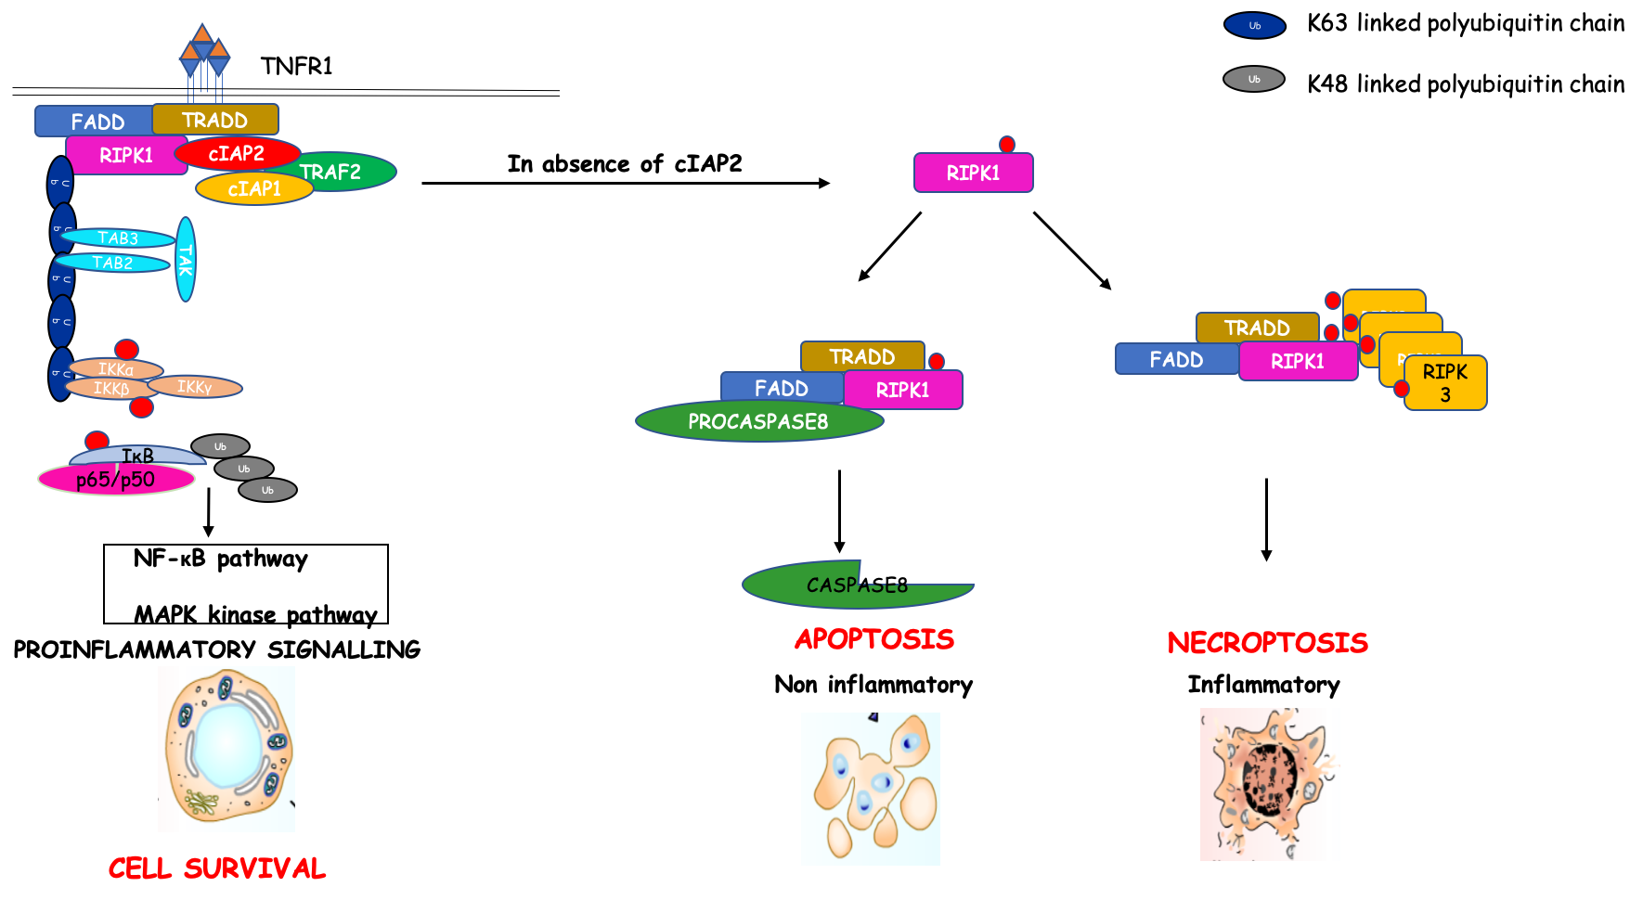
Figure 1: TNF signaling (D Biswas)
Figure 1 shows the mechanism by which TNF works when bound to the R1 receptor. In the presence of cIAP2, NF-kB pathway is activated leading to pro-inflammatory signaling. However, in the absence of cIAP2, RIPK1 is phosphorylated which leads to either apoptosis or necroptosis. When a cell goes through apoptosis, caspase-8 is cleaved into two parts. When a cell goes through necroptosis, RIPK3 is phosphorylated; therefore, showing that cIAP2 is a vital factor in determining the fate of a cell.

Experiment:

In order to answer the question if S1P supports the survival of microglia in the absence of cIAP2 in vitro, a LDH cytotoxicity assay will be conducted. A LDH cytotoxicity assay is used to determine the cytotoxicity by measuring the lactate dehydrogenase (LDH) activity released from cells that have been damaged. LDH is a ubiquitous enzyme that is released through the damaged plasma membrane. It is involved in the catalysis of lactate to pyruvate, which also reduces NAD⁺ to NADH shown in figure 2. ⁸ The quantification of WST formazan is done by spectrophotometry. The spectrophotometer works by shining a light through a lens which diffracts into separate wavelengths. The diffracted light then interacts with the sample inserted. The detector on the other side of the sample will detect both transmittance as well as absorbance. For this particular experiment, the absorbance will be measured for each well at 490nm.

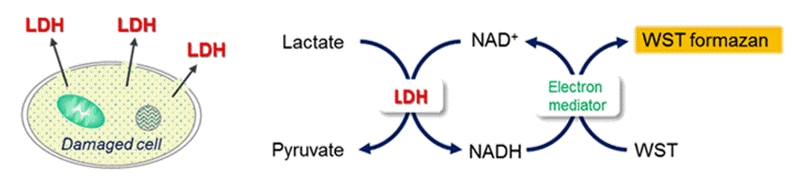
Figure 2: LDH cytotoxicity principle (Dojindo Molecular Tech)
Figure 2 shows that LDH is released when lactate is catalyzed to pyruvate and LDH reduces NAD⁺ to NADH. Iin the presence of an electron mediator, NADH reduces a water-soluble tetrazolium salt(WST) to WST formazan which is an artificial product resulting from the reduction of a salt from a dehydrogenase, in this case LDH. LDH is released from a damaged cell through the cell membrane.

Step 1 Harvest microglial cells from WT and cIAP2^{-/-} mice
Step 2 Plate cells with media; 10% Fetal Bovine Serum(FBS), Dulbecco’s Modified Eagle’s Media(DMEM) and allow to adhere overnight
Step 3 Treat cells with TNF (30ng/ml), S1P(100nM), both together, and control
Step 4 Create low and high control
- Low control is cell with media
- High control is adding acetone or a lysing agent to intentionally kill cells to have a comparison
Step 5 After 24 hours, high control will be treated with acetone for 30 min at 37°C
Step 6 Centrifuge cells, collect supernatant, then re-centrifuge to collect supernatant in order to collect all living cells
Step 7 In 96-well plate, add 20 μl of supernatant and 80μl of media
Step 8 Add 100 μl of start buffer in order to start reaction reducing WST to WST formazan and place in 37°C for 30 min
Step 8 Add 50 μl of stop buffer in order to stop reaction and take reading using spectrophotometer

In order to calculate the cytotoxicity, the formula:
$$Cytotoxicity \left(\%\right)=\left(\frac{A-C}{B-C}\right) × 100$$ “A” = the test substance absorbance, “B” = high control absorbance, “C” = low control absorbance

In order to interpret this data, a table is made using the percentages calculated and comparing between each treatment.

*Experiment will be done in triplicates in order to establish significance*

Discussion:

The results of an LDH assay should indicate that S1P is indeed suppressing apoptosis in microglial cells in vitro; therefore, supporting the hypothesis stated. However, another outcome shown could be the exact opposite; thus, disproving the hypothesis made. If the results obtained from this assay support the hypothesis stated, further questions and experiments will be conducted in order to determine the mechanism in which S1P works to suppress microglial death. It has been shown that S1P activates S1P Receptor 4 on the microglia, to recruit it to the site of inflammation. However, whether or not S1PR4 and S1P is affecting the survival of microglia has not been shown. Therefore, conducting a similar experiment but adding S1PR4 inhibitor to identify if microglial survival is directly mediated through S1PR4. Limitations are faced when an LDH assay is completed, in this particular assay, whether the cell is dying by apoptosis or necroptosis is not determined. The significance of the outcome of the remaining experiments can help improve the treatments and therapy for patients that have been diagnosed and are suffering with MS.

References:

- Yester, J. W., Bryan, L., Waters, M. R., Mierzenski, B., Biswas, D. D., Gupta, A. S., . . . Kordula, T. (2015). Sphingosine-1-phosphate inhibits IL-1–induced expression of C-C motif ligand 5 via c-Fos–dependent suppression of IFN-β amplification loop. The FASEB Journal, 29(12), 4853-4865. doi:10.1096/fj.15-275180
- What Is MS? (n.d.). Retrieved from https://www.nationalmssociety.org/What-is-MS
- Constantinescu, C. S., Farooqi, N., Obrien, K., & Gran, B. (2011). Experimental autoimmune encephalomyelitis (EAE) as a model for multiple sclerosis (MS). British Journal of Pharmacology, 164(4), 1079-1106. doi:10.1111/j.1476-5381.2011.01302.x
- Silke, J., & Meier, P. (2013). Inhibitor of Apoptosis (IAP) Proteins-Modulators of Cell Death and Inflammation. Cold Spring Harbor Perspectives in Biology, 5(2). doi:10.1101/cshperspect.a008730
- Conte, D., Holcik, M., Lefebvre, C. A., Lacasse, E., Picketts, D. J., Wright, K. E., & Korneluk, R. G. (2005). Inhibitor of Apoptosis Protein cIAP2 Is Essential for Lipopolysaccharide-Induced Macrophage Survival. Molecular and Cellular Biology, 26(2), 699-708. doi:10.1128/mcb.26.2.699-708.2006
- Chen, G. (2002). TNF-R1 Signaling: A Beautiful Pathway. Science,296(5573), 1634-1635. doi:10.1126/science.1071924
- Cuvillier, O., Pirianov, G., Kleuser, B., Vanek, P. G., Coso, O. A., Gutkind, J. S., & Spiegel, S. (1996). Suppression of ceramide-mediated programmed cell death by sphingosine-1-phosphate. Nature, 381(6585), 800-803. doi:10.1038/381800a0
- Dojindo Molecular Technologies (2012). LDH Cytotoxicity Assay

