Does MicroRNA-7 inhibition significantly affect tumor growth in breast to brain metastasis?
- Introduction

Cancer is the second leading cause of death in the United States. In 2018, an estimated 1.7 million people Americans will be diagnosed with cancer and roughly 600,000 Americans will die from this ailment [1]. It is estimated that 90% of cancer deaths happen when a cancer has metastasized. Metastasis is the process of a tumor spreading from its first site to a secondary site. Metastasis is also commonly known as being at or past stage 3 cancer, where a tumor has spread past the primary site. Much of the reason why the 90% of patients who have a tumor metastasized die is because their initial site is in a non-vital area of the body, but parts of the tumor will break off and attach itself to a different location in the body, where it can grow and become a new tumorous mass.
Fig. 2 Pathway of miRNA production and usage

The function of cancer metastasis and the inner workings of it were very late to be explained, with some aspects of it still being researched today. People have been able to recognize and attempt to treat cancer since Hippocrates in ancient Greece [2], but it wasn’t till after the scientific and industrial revolution that cancer and metastasis by extension could be properly studied. The initial hypothesis of how cancer metastasizes was formed by Stephen Paget in 1889[3]. In this hypothesis he claims that cancer metastasis is based on tumor cells being a “seed”, having a favorable interaction with good “soil”, and being an organ’s tissue that work well with the “seed”. The theory would be titled the “seed and soil hypothesis. This was not scientifically confirmed until much later by papers like Bruns et al. “In Vivo Selection and Characterization of Metastatic Variants from Human Pancreatic Adenocarcinoma by Using Orthotopic Implantation in Nude Mice” (1999) [4] where there were more empirical results to the mechanisms of tumor metastasis. Tumorous cells are commonly spread through the lymphatic system or the bloodstream, where a cell will break off from the initial tumor and move to a different site where it will multiply uncontrollably as cancerous cells do.
Fig. 1 Number of New US Female Cases of Cancer in 2016 [5]

As seen in Figure 1., the one of the most common type of female cancer is breast cancer. While cancer in the breast is not inherently deadly because the breast does not serve a vital part to living, the tumor in the breast very commonly can spread to more vital parts of the body if left undetected and become a fatal metastasis. It is recorded that there is only a 20% one-year survival rate in persons who have a breast-to-brain metastasis [6]. There are many ways the human body counteracts the production of cancerous cells and growth of tumors within the primary site and how the tumorous cells spread to other sites in the body. Common ways the body’s immune system fights the tumor growth and metastasis is through T, B, and NK cells which are adult cells that attempt to destroy the site.

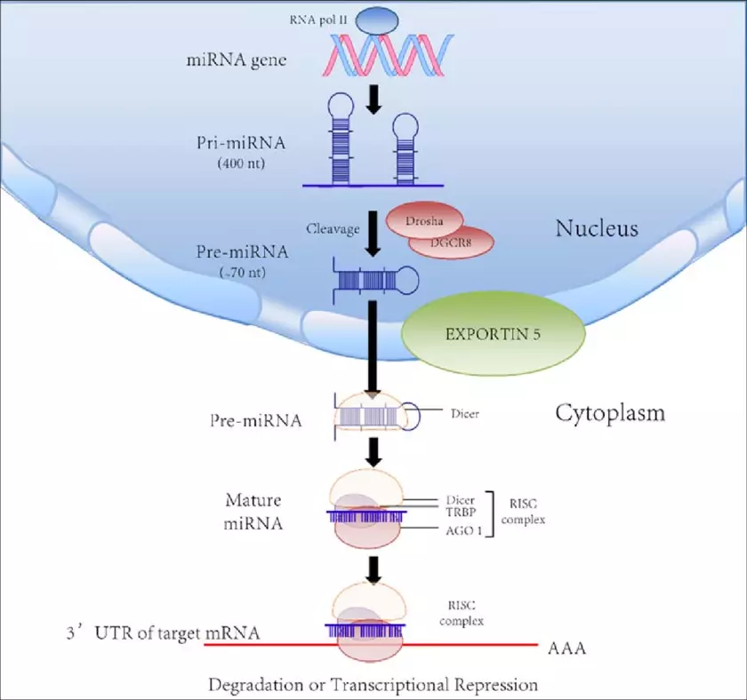
One newly discovered and is thoroughly studied MicroRNA(miRNA), a single stranded fragment of mRNA. It is roughly 19 to 25 nucleotides long, the location of where the miRNA is made in the DNA is in non-coding regions of DNA, meaning that it is not the genetic makeup used to encode proteins. The usage of miRNA is implemented when it either attaches to a protein that will regulate the usage of genes or enzymes. MicroRNA was not discovered till 1993 in Lee at al. “The C. elegans heterochronic gene lin-4 encodes small RNAs with antisense complementarity to lin-14” (1993) [7] where they found small RNA fragments that were produced in the expression of a protein. They would further be researched more as time progressed as an essential part of gene regulation, including oncogenes. As seen in Figure 2, we know have a good idea on the production of how microRNA is produced and how it is used in gene transcription to regulate genes. The creation of microRNA starts when the gene is read by RNA polymerase II. It is then clipped and trimmed by enzymes Drosha and Dicer that leave it at a final length, where it then can attach to the RISC complex where it is then used to attach to its target to regulate the gene.

MicroRNA has been found to play a very large role in breast cancer. While breast cancer is becoming very treatable when caught early, prevention of metastasis is of high value. A metastasis to the its likely target of places like the lung or the brain make it much harder to diagnose and treat. An important microRNA for this situation is microRNA-7. The function of microRNA-7 or MiR-7 is to work as a regulator for the KLF4 gene. This connection was stated by Okuda et al. in “miR-7 suppresses brain metastasis of breast cancer stem-like cells by modulating KLF4” [10] in their work to better understand Cancer stem-like cells. KLF4 gene is an important punitive target because of its function in producing proteins that assist in the mediation of the p53 gene [11]. The p53 gene is important as a lynchpin for the cellular response to tumor formations. This is done by promoting cellular arrest and apoptosis. Finding pathways, like microRNA, to manipulate p53 to work at a higher or more efficient function is of great interest. MiR-7 has been shown to be one of those pathways, so this experiment aims to better find its role to be used as a manipulator to the body’s response to cancer.
Fig. 2 Steps to creating and uses a microRNA in the cell [8]
Table 1. Regulation and target of microRNA to where it is preventing metastasis [9]

II. Experiment

Goal of this experiment

The goal of this experiment is to be able to find and create empirical data on microRNA-7’s effect on cancer proliferation and metastasis. This is done in three phases of increase size. First, a RT-PCR (Real Time Polymerase Chain Reaction) to show how the cancer cells’ expression of miRNA-7 changes with the up and down regulation of the pre-miRNA gene. This is needed as a base to go off in the second section of a western blot test to see if the inhibition of the microRNA will affect the protein production of KLF4’s encoded zinc finger protein to find how cells with inhibited microRNA-7 production react in their protein production. The last part of this experiment would conclude in a in vivo portion to be able to compare an microRNA-7 inhibited of mice with a control group.

Part A. PCR test of Pre-MiR-7

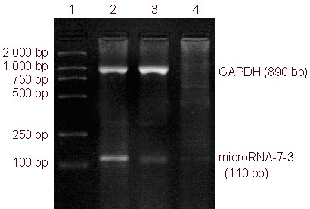
PCR is one of the most popular methods in modern molecular biology. Historically, pre-microRNA has been seen as a challenging to perform because its hairpin structure, but with better techniques it is becoming realistic. This portion would begin first by the obtainment of appropriate cell lines for study. MDA-MB-231 and MCF7 breast cancer cell lines would be the best candidate as they have been used in similar experiments on the same type of tissue this experiment wants to test [10]. The lentiviral infection system would be used to create a inhibited cell group. This is done by cloning then creating and using a vector like “FIV-CMV-GFP-miR-7-3” created in Dong et al. [12]. This will use a restriction enzyme and a fluorescent tag to transform the pre-miRNA so that we can expect a large change in its expression and have visual results like in figure 3. The system would make it so that there was a group where there can be an overexpression of miRNA-7 along with a group of the opposite where the expression of miRNA-7 will be inhibited in the complementary strand of the region. Added in, would be two control groups where they would be given “nonsense” regions where the overexpression and inhibition of the fake region would almost certainly result in no change between the two because of its irrelevance to expression of miRNA-7. Figure 4 shows the procedure of the PCR to be done to each group to do a reverse translation followed by the Real-Time PCR to show the expression. Once the process is done, the physical results would show where the expression is for each group and to what degree that is.
Figure 3. Example of what pre-miRNA PCR looks like in lab [13]

Part B. Western Blot Test of protein production

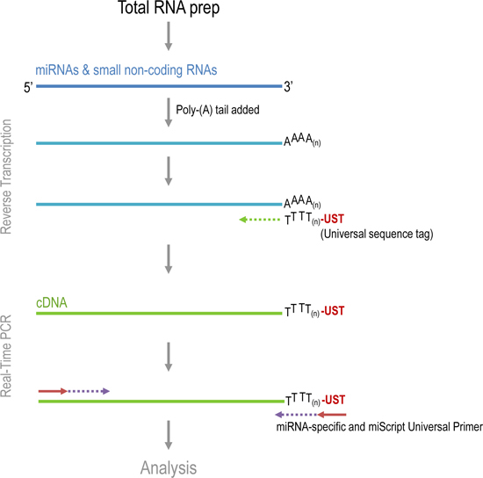
The second part of the experiment would be to do a Western Blot test to then better understand how the expression of the microRNA in the PCR experiment carries on into the next phase in protein production and synthesis. The experimental groups from the previous part would stay the same, but this test would be used to know how those same groups in their expression levels behave once protein production happens. The control in this would be known as NC, as it is unaffected by the lentivirus used from PCR on the experimental group. In the western blot test, the endothelial Kruppel-like zinc finger protein associated with the KLF4’s control of the G1 to S phase of the cell cycle [11] would be tested. In the test, the chosen antibodies would attach the endothelial Kruppel-like zinc finger protein and create antigen bands that could be read and compared. Between the two types of tissues possessed, the control and downregulated tissues would be expected to have distinguishable differences between the inhibited group and the normal group, with the inhabited group expected to be smaller and/or lighter because of a lacking of proteins. This would also come with an actin line to show that there is a normal, full expression dot from proteins. [15, 16]
Figure 4. Step by step of PCR procedure [14]

Part C. In Vivo injection study

Once the results of the western blot would show, a mice study would be implemented to show the metastatic effects of microRNA-7. NSG mice [17] would be used to remove other confounding anti-tumorigenic and anti-metastatic behavior to get the most telling results of the how much the microRNA effects tumor growth. To test the breast to brain metastasis, tumors would have to be put in the breast, let time pass, and then observe tumors in the brain. The cultured cancer line cells of differing groups would be surgically placed into breast of the mice. The linings would also have bioluminescent added in chemically to be able to be shown in radio imaging where the proteins are localized or spread. The two groups in this would be the inhibited group with the cell lining that has been changed by the lentivirus system and a group with the cancerous cell lining unaffected (NC group). After a set amount of time the tumors would be removed from the breast and brain and tested for diameter, weight, and count. Comparative analysis would be done between the two groups to see if there are significant differences. [18]

III. Discussion
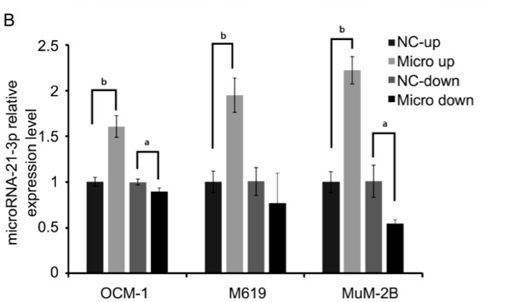
The possible results of this experiment would obviously be different for all parts. An admitted inherent flaw of this experiment would be if the first part does not go according to plan, there would not be much hope for the results wanted at a later portion. For the PCR, some graphic results would look similar to Figure 5. In a similar test by Wang et al. [18] studying a different microRNA in uveal melanoma. As seen in the graphs, it would be expected that the NC up and down are exactly the same, while the up regulators and down regulators behave similarly to what has been researched and referenced before. A problem that could be run into is making sure that there is no way that expression is not affected by the miRNA in question. Introducing another variable that could affect this on this level would have effects on the remainder of the experiment.
Figure 5. Possible PCR results [18]

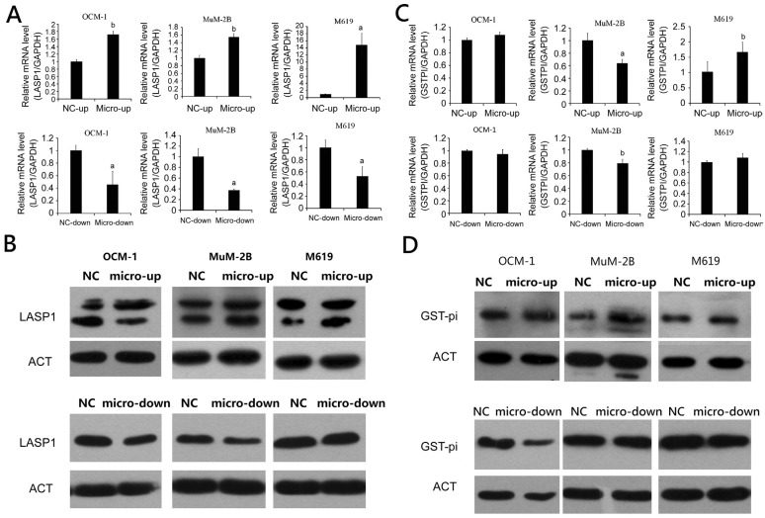
In the second portion of the experiment, results would look similar to what is displayed in figure 6. The results would want to show physical results in the western blot to show significant differences, but also the bar graphs would be very telling of what is the difference in the production of the two separate groups. Western blot is considered to be a very high confidence test, so I do not believe in any inherent problems that would question the validity of the experiment.
Figure 6. Possible western blot results[18]
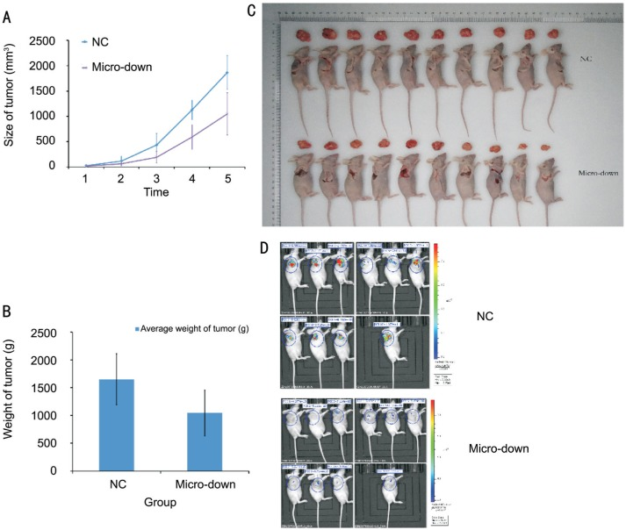
Lastly, the mice study would want to show significant data showing that one group would have a difference in both weight of tumor at the end of the study, volume of tumor as time has progressed, the count of how many tumorous masses there are, where the biofluorescence particles traveled over time, and what physical differences could be observed of the subjects in the end. Figure 7 shows what that looked like in a similar study to observe liver metastasis in mice. In it can be seen how there is an observable difference in the how the tumors grew and weighed depending on the inhibition of the microRNA, with the same level of confidence this study would have if all went according to plan. Problems could arise in this, for example death of mice too early or outliers could throw off the way data is used. There are many factors that could lead to redo of the same thing with better luck of the unfortunate happening.

The data in the third part of the experiment would be very telling and a good cap to the experiment in hopefully showing a fluidity on multiple levels of a similar line of logic. Showing that if the production of microRNA-7 is inhibited, there would hypothetically be a chain reaction that would have an effect on the genes that create proteins that can make a sizeable difference in tumor growth and tumor metastasis. Having a solid line of logic showing microRNA has a cancer affected would help cement its growing reputation as a strong candidate for better cancer prognosis and diagnosis. A larger goal of this would also be to create more questions than questions are answered in this. For example, if all goes according to plan one could ask, “What are the drawbacks to effecting microRNA? What would change outside of just tumors?” Those are questions that one would hope to ask because it means we can move on with confidence that this is something worth exploring and understanding better how can this be used efficiently and productively.
Figure 7. Possible In Vitro results [18]

IV. References

- Cancer Statistics. (n.d.). Retrieved from https://www.cancer.gov/about-cancer/understanding/statistics
- Sudhakar, A. (2009). History of Cancer, Ancient and Modern Treatment Methods. Journal of Cancer Science & Therapy,01(02), I-Iv. doi:10.4172/1948-5956.100000e2
- Langley, R. R., & Fidler, I. J. (2011). The seed and soil hypothesis revisited-The role of tumor-stroma interactions in metastasis to different organs. International Journal of Cancer,128(11), 2527-2535. doi:10.1002/ijc.26031
- Bruns, C. J., Harbison, M. T., Kuniyasu, H., Eue, I., & Fidler, I. J. (1999). In Vivo Selection and Characterization of Metastatic Variants from Human Pancreatic Adenocarcinoma by Using Orthotopic Implantation in Nude Mice. Neoplasia,1(1), 50-62. doi:10.1038/sj.neo.7900005
- 4 Essential Cancer Charts for 2016. (2016, January 14). Retrieved November 24, 2018, from https://www.cancer.org/latest-news/4-essential-cancer-charts-for-2016.html
- Alsidawi, S., Malek, E., & Driscoll, J. (2014). MicroRNAs in Brain Metastases: Potential Role as Diagnostics and Therapeutics. International Journal of Molecular Sciences,15(6), 10508-10526. doi:10.3390/ijms150610508
- Lee, R. C., Feinbaum, R. L., & Ambros, V. (1993). The C. elegans heterochronic gene lin-4 encodes small RNAs with antisense complementarity to lin-14. Cell,75(5), 843-854. doi:10.1016/0092-8674(93)90529-y
- Lorenzo, M., Loarca, L., Ivanics, T., & LaRusso, N. (2015). MicroRNAs in the Cholangiopathies: Pathogenesis, Diagnosis, and Treatment. Journal of Clinical Medicine,4(9), 1688-1712. doi:10.3390/jcm4091688}
- Alsidawi, S., Malek, E., & Driscoll, J. (2014). MicroRNAs in Brain Metastases: Potential Role as Diagnostics and Therapeutics. International Journal of Molecular Sciences,15(6), 10508-10526. doi:10.3390/ijms150610508
- Okuda, H., Xing, F., Pandey, P. R., Sharma, S., Watabe, M., Pai, S. K., . . . Watabe, K. (2013). MiR-7 Suppresses Brain Metastasis of Breast Cancer Stem-Like Cells By Modulating KLF4. Cancer Research,73(4), 1434-1444. doi:10.1158/0008-5472.can-12-2037
- National Center for Biotechnology Information (US). (1998, January 01). The p53 tumor suppressor protein. Retrieved from https://www.ncbi.nlm.nih.gov/books/NBK22268/
- Dong, L., Han, C., Zhang, H., Gu, X., Li, J., Wu, Y., & Wang, X. (2012). Construction of a recombinant lentivirus containing human microRNA-7-3 and its inhibitory effects on glioma proliferation. Neural Regen Res,7(27), 2144-2150. doi:10.3969/j.issn.1673-5374.2012.27.009
- Schmittgen, T. D., Lee, E. J., Jiang, J., Sarkar, A., Yang, L., Elton, T. S., & Chen, C. (2008). Real-time PCR quantification of precursor and mature microRNA. Methods,44(1), 31-38. doi:10.1016/j.ymeth.2007.09.006
- Gordanpour, A., Nam, R. K., Sugar, L., Bacopulos, S., & Seth, A. (2012). MicroRNA Detection in Prostate Tumors by Quantitative Real-time PCR (qPCR). Journal of Visualized Experiments,(63). doi:10.3791/3874
- Zhang, L., Li, X., Chao, Y., He, R., Liu, J., Yuan, Y., . . . Song, X. (2018). KLF4, a miR-32-5p targeted gene, promotes cisplatin-induced apoptosis by upregulating BIK expression in prostate cancer. Cell Communication and Signaling,16(1). doi:10.1186/s12964-018-0270-x
- Yang, P., & Mahmood, T. (2012). Western blot: Technique, theory, and trouble shooting. North American Journal of Medical Sciences,4(9), 429. doi:10.4103/1947-2714.100998
- Puchalapalli, M., Zeng, X., Mu, L., Anderson, A., Glickman, L. H., Zhang, M., . . . Koblinski, J. E. (2016). NSG Mice Provide a Better Spontaneous Model of Breast Cancer Metastasis than Athymic (Nude) Mice. Plos One,11(9). doi:10.1371/journal.pone.0163521
- Role of microRNA-21 in uveal melanoma cell invasion and metastasis by regulating p53 and its downstream protein. (2018). International Journal of Ophthalmology. doi:10.18240/ijo.2018.08.03

