Jacob Rodriguez
Understanding the mechanism of Chemokine CXCL13 will help improve immunotherapies
Introduction:
In the recent years of studying, chemokines play a major role in tumor microenvironments to regulate tumor growth, invasion, metastasis, and immune response. However, their mechanisms are not well understood. Studies have shown that the expression of CXCL13 and CXCR5 were significantly higher in patients with stage 3 tumor than those with stage 2 diseases⁹. Higher expressions of CXCL13-CXCR5 was associated with improved outcomes in breast cancer. Increased amounts of CXCL13 recruit more CXCR5+, T cells, and B cells to the tumor which could enhance the anti-tumor immunity⁹.
The ability for a cell to communicate with distant or neighboring cells requires is essential for many biological processes. A key role in this process includes soluble factors, which diffuse into the extracellular medium and bind with the cell surface receptors trigger specific biological responses. The role of Glycosaminoglycans (GAGs) are important components of cellular signaling transduction. They are long unbranched linear biopolymers consisting of disaccharide units. The repeating units are N-acetylglucosamines or N-acetylgalactosamines with uronic sugars such as glucuronic acid, iduronic acids, or galactose. GAGs are found on many cell surfaces and within the extracellular matrices as they bind to large arrays of proteins such as chemokines.
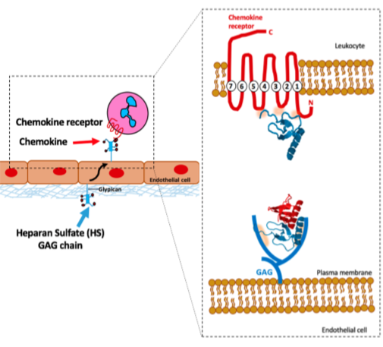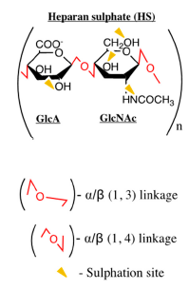
Figure 1: Structure and composition of GAGs. Linkages are shown in red, and sites of sulfation indicated by yellow triangles. The backbone is made up of repeating disaccharide block composed of uronic acid (glucuronic acid (GlcA) or iduronic acid (IdoA)), or galactose (Gal) and an amino sugar (N-acetyl-galactosamine (GalNAc) or N-acetyl-glucosamine (GlcNAc)).

Traditionally, Heparan is used to study the mechanisms of chemokines to maintain the haptotatic gradient to direct cell migration to the correct site. Chemokines are known to recruit immune cells to inflammation cites by various interactions between their receptors. The major interaction includes binding to glycosaminoglycans which facilitates chemokines into haptotactic gradients within tissues. Chemokines are comprised of 50 members that control the migratory patterns and position for immune and non-immune cells through GAGs. Two major subfamilies include CC and CXC as well as two minor subfamilies CX₃C and C. CC and CXC are very similar as they both contain cysteine residues that form two disulfide bonds. However, CXC has an extra amino acid between two cysteines toward the N-terminal.
Experiment:
Computational approaches must be done due to the complexity of HS because it is a heterogenous chain. Solution based experiments cannot be done because it is challenging to synthesis and prepare a GAG. Heparan sulfate is a heterogenous repeating biopolymer chain. To figure out the different variations and protein recognition of the individual GAG sequence computational algorithms, parameters, and force fields must be used. The 48 possible repeating disaccharide units have 12.2 x 10⁹ different possibilities. The aim of this experiment is to determine the mechanism of CXCL13 by mutating the amino acid residues to specific binding sites to HS. It is expected that the binding cites of CXCL13 basic residues with HS acid residues.
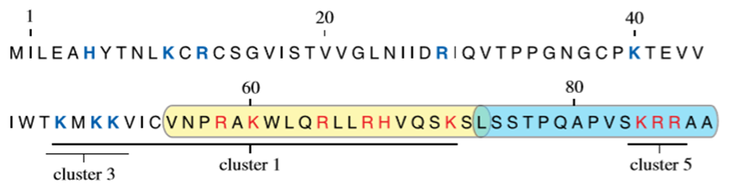
Figure 2: CXCL13 showed high bonding interactions in clusters 1 and 5; involving residues Lys60, Arg64, Arg67, Lys72, and Arg67.
Molecular dynamics simulation:
To determine the interaction of HS sequences to CXCL13, docking protocol is used. This approach will require 4 sets of 254 sequences of HS applied to both clusters 1 and 5. Docking will require 100 genetic algorithm runs and 100,000 iterations followed by the highest 25 ranking sequences (approximately the top 10% for accuracy) in triplicates for consistency of binding. Furthermore, we will run a hydrogen bonding simulation for clusters 1 and 5 for more binding consistency. HS, are very polar and can posses multiple water molecule interactions with proteins.
Nuclear Magnetic Resonance Spectroscopy: 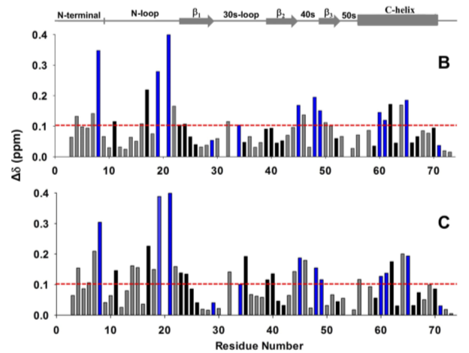
Figure 2: CXCL1 to heparin GAGs. The direction of the peak movement. B and C are the histograms of chemical shift changes in the CXCL1 dimer binding to HS. The basic residues Lys, Arg, and His are shown in blue. The red horizontal lines at 0.1 ppm is the cutoff for a residue to be considered important to the binding cite.
All chemokines have the same basic tertiary fold as they are fully active binding to their receptors as monomers. Generally, CXC chemokines form CXC-like dimer through their B-sheets. From previous studies of different chemokines, we can compare the binding site of the chemokine-GAG complex. To validate the MD simulations, we can characterize the structural basis of heparin interactions using Nuclear Magnetic Resonance spectroscopy. The binding site of CXCL13 and HS should have the highest peaks in specific regions of the structure.
Discussion:
For the best results computational approaches must be made first due to the complexity sequence of HS. Using molecular dynamics by modifying CXCL13 residues will allow us to determine the best binding sites to the GAG. However, the complications of modifying the residues may not be fully active to recruit leukocytes and may interact with other chemokines. After figuring out the specific binding cites. The CXCL13 residues of the binding site to HS can be mutated. Then be experimentally in mice to validate MD simulations. If all works well, concentration gradients of HS can be made in the cite of inflammation to bind with CXCL13 to recruit leukocytes. Understanding the mechanism of CXCL13 binding with HS will allow us to better understand how chemokines work. This will bring forth better approaches and new methods of immunotherapies for selective targeting the inflammatory pathways. Thus, will allow for better eradication of diseases and cancer.
References:
- Desai, R. U., Sarkar, A., A Simple Method of Discovering Druggable Specific Glycosaminoglycan-Protein Systems. Elucidation of Key Principles from Heparin/Heparan Sulfate-Binding Proteins. Plos One. 2015.

- Dyer, P. D., Migliorini, E., Salanga, L. C., Thakar, D., Handel, M. T., Richter, P. R., Differential Structural Remodeling of heparan sulfate by chemokines: the role of Chemokine Olgiomerization. The Royal Society. 2016.

- Mohan, K., Nagarajan, B., Desai, R. U., Rajarathnam, K., Molecular Basis of Chemokine CXCL5-Glycosaminoglycan Interactions. JBC. 2016.

- Monneau, R. Y., Luo, L., Viji, N., Nagarajan, B., Vives, R. R., Baleux, F., Desai, R. U., Seidedos-Arenzana, F., Jacob, L, H., Solution structure of CXCL13 and Heparan Sulfate binding show that GAG binding site and cellular signaling rely on distinct domains. The Royal Society, 2017.

- Nagarajan, B., Desai, R. U., Sepuru, M. K., Rajarathnam, K., Molecular Basis of Chemokine CXCL5-Glycosaminoglycan Interactions. Jour of Biological Chem. 2016. 291. 20539-20550.

- Patel, N.J., Karuturi, R., Al-Horani, R.A., Baranwal, S., Patel, J., Desai, U.R., and Patel, B.B Synthetic, Non-saccharide, Glycosaminoglycan Mimetics Selectively Target Colon Cancer Stem Cells. ACS Chemical Biology. 2018.

- Sepuru, M. K., Rajarathnam, K., CXCL1/MGSA Is a Novel Glycosaminoglycan (GAG)-binding Chemokine. Jour of Biological Chem. 2015. 291, 4247-4255.

- Solution NMR Characterization of Chemokine CXCL8/IL-8 monomer and dimer binding to glycosaminoglycans: Structural plasticity mediates differential binding interactions. Biochemical Jour. 2018.

- Tan. P., Shi, M., Lai, L., Tang. Z., Xie, N., Xu, H., Wei, Q., Zhang, X., Yang, L., Wu, L. Regulative role of The CXCL13-CXCR5 axis in the tumor microenvironment. Precision Clinical Medicine. 2018. 49-56.

- Ziarek, J. J., Volkman, F. B., NMR in the analysis of Functional Chemokine Interactions and Drug Discovery. 2012. E293-e299.

