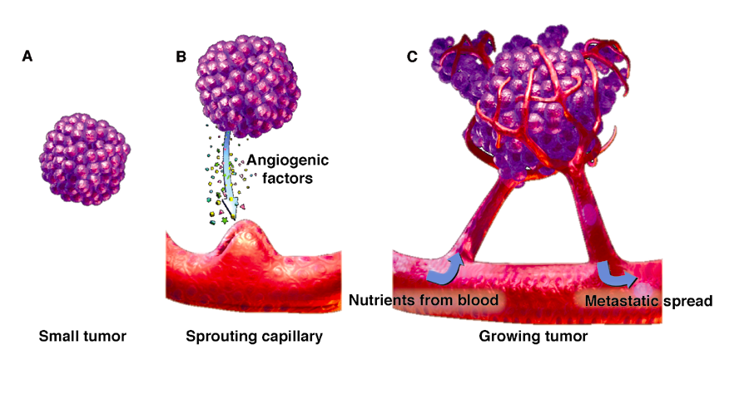
Sarah Otih 11/23/2018

Tie1 and Tie2 Dimerization and the Possible Inhibition of Angiogenesis in Tumor endothelial cells.

Cancer Research is a major topic in the world of scientific research due to the deadly nature of the disease. The commonplace treatments for cancer patients are chemotherapy and radiation. Although these regimens have been found be somewhat effective, they result in extreme side effects and are not always guaranteed to exterminate cancerous cells. Cancer cells are able to grow and multiply due to the creation of new blood vessels which is known as angiogenesis(Figure 1). If there is some way to target epithelial cancer cells, we could potentially target angiogenesis in tumor cells.

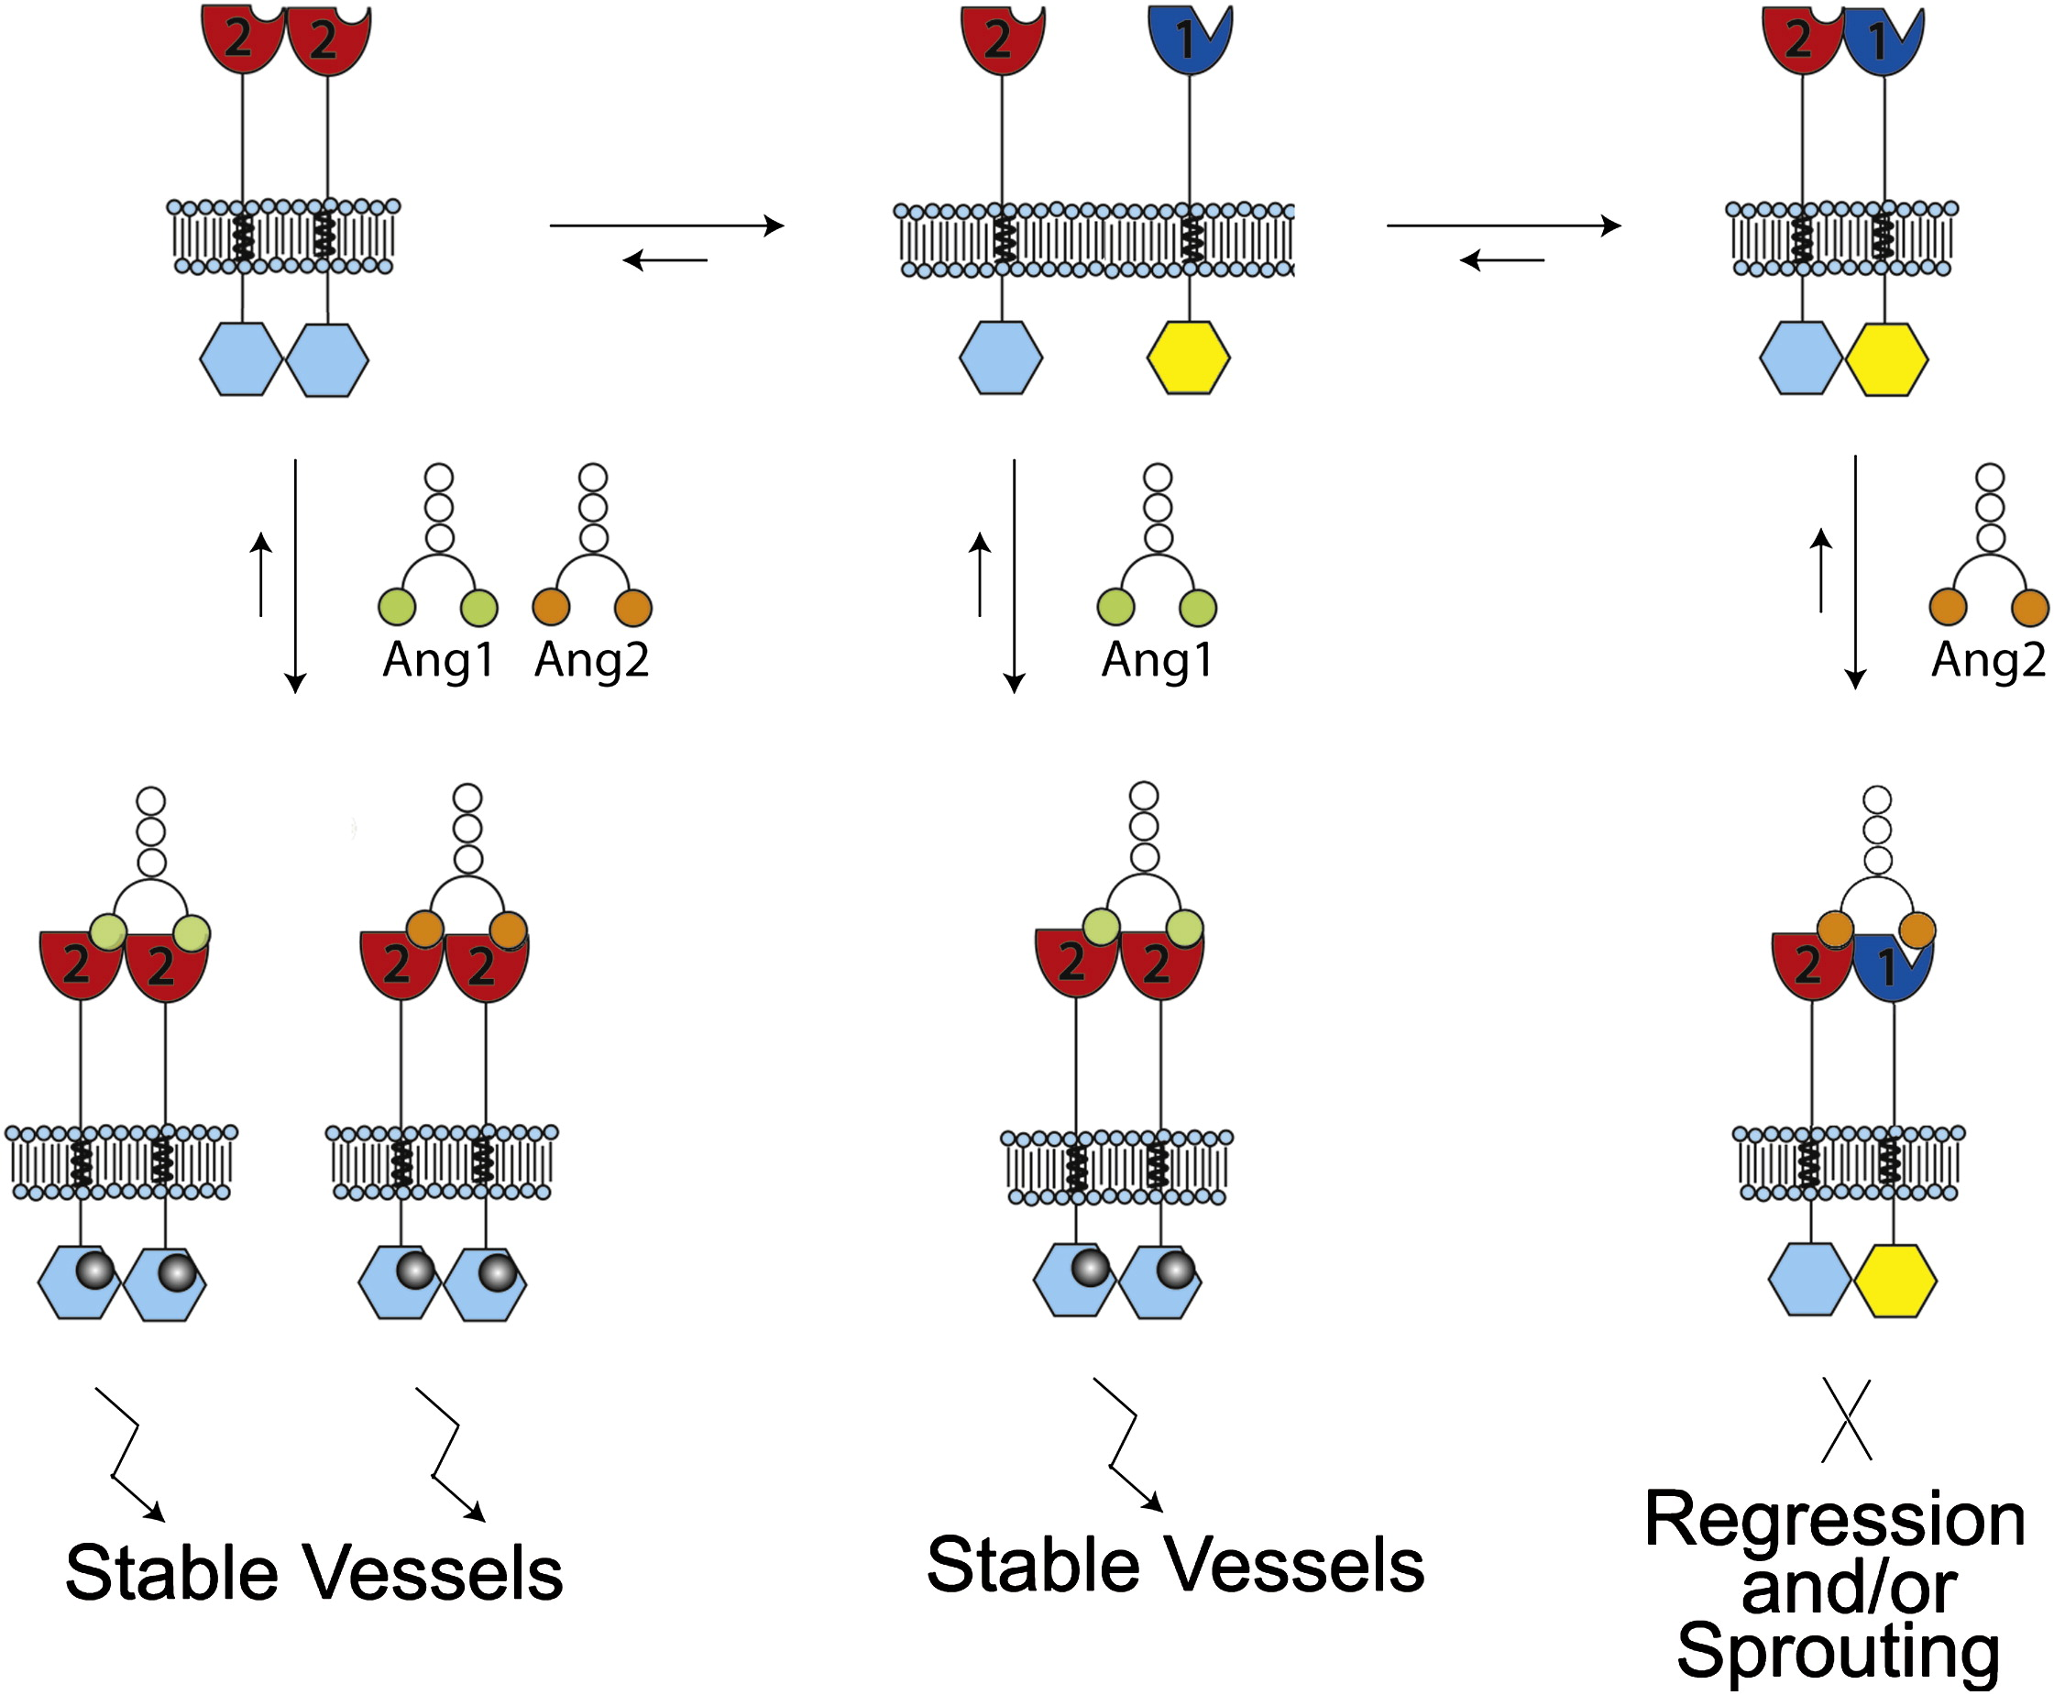
A scarcely visited target for cancer research is that of a family of Receptor Kinase known as the Tie receptors, in particular, Tie1 and Tie2. These two receptors are unique as they physical connection between Tie1 and Tie2 has been seen to halt the process of angiogenesis in endothelial cells. This dimerization being in tact or apart is what control the angiogenesis of their endothelial cells. As illustrated in Figure 2, When Tie1 and Tie2 are physically bound to one another, this prohibits the process of angiogenesis to take place. To prevent the growth and life of cancer cells, targeting epithelial cancer cell’s Tie1 and Tie2 receptors could provide a solution. Base off of previous findings ², a deduction can be made that these oppositely charged surfaces are the cause for physical interaction between Tie1 and Tie2 prohibits angiogenesis from taking place. After obtaining the crystallographic structure of both Tie1 and Tie2, oppositely charged surfaces on both Tie1 and Tie2 were found and isolated. Tie2 was found to contain a large negatively charged surface in Ig1 and EGF1 which was made up of glutamic acid and aspartic acid. Additionally, Tie1 was found to contain a large positively charged surface in Ig1 and EGF2 made up of Arginine and Lysine ². These oppositely charged surfaces indicates that there is the location for physical attraction between the two receptors. Due to this attraction facilitated by oppositely charged surfaces, this may be a prime target for the prevention of angiogenesis because this attraction causes the dimerization between Tie1 and Tie2. One possible strategy that could be utilized in order to inhibit the growth and survival of epithelial cancer cells, and subsequently, tumor cells is through the the constant physical contact, dimerization, between Tie1 and Tie2.
Experiment. After isolating the specific charges and subsequent amino acids that are between Tie1 and Tie2 when physically bound to one another, the addition of charged residues and increase charge density could possibly facilitate the constant dimerization between the two. Positively charged residue made up of arginine and lysine. Likewise, a Negatively charged residue made up of glutamic acid, and aspartic acid. These amino acids were found through the crystallographic images and manipulation of Tie1 and Tie2. With these charge residues, this would increase the charge density between Tie1 and Tie2. If this charged interaction between Tie2 an Tie1 impacts angiogenesis, increased charged density at locations Ig1 and EGF1/2 would cause a constant physical affinity between the te receptor kinases. One would expect there to be a complete halt in angiogenesis.

From previous experiments ¹,opposite charges between Tie1 and Tie2 cause a dimerization between the two receptors. With a centralized increase between Tie1 and Tie2, one would expect the result to be continuous interaction and, in turn, prohibit supplies and nutrients transfers to the tumor cell which would later cause cellular death of endothelial tumor cells.

This experiment proposal was intended to be a basis for further research to potentially build upon in hopes that Tie1/Tie2 receptor interactions could be a possible cancer research focus.

Although charged residues are a very useful tool, the outcome may not be as clear cut as hoped if the incorrect amino acids were added to the residue. Due to the nature of these charges, the correct amount of charge amplification is necessary. By looking very closely at the interactions and in turn, the ratio of amino acids that make up both of the positive and negative charged surfaces of Tie1 and Tie2, this obstacle will most likely be bypassed. However, despite this issue, charged residues would allow for a amplification of charge density which would facilitate a constant physical interaction between both Tie1 and Tie2. Due to the unique nature of the Tie family of receptor kinases, this constant interaction may be the next positive step in prohibiting the growth of tumor cells.

References:

- Cancer Free World, cancerfreeworld.wordpress.com/tag/angiogenesis/.
- Seegar, T. C. M., Eller, B., Tzvetkova-Robev, D., Kolev, M. V, Henderson, S. C., Nikolov, D. B., & Barton, W. A. (2010). Article Tie1-Tie2 Interactions Mediate Functional Differences between Angiopoietin Ligands. https://doi.org/10.1016/j.molcel.2010.02.007
- Yu, X., Seegar, T. C. M., Dalton, A. C., Tzvetkova-Robev, D., Goldgur, Y., Rajashankar, K. R., … Barton, W. A. (2013). Structural basis for angiopoietin-1-mediated signaling initiation. Proceedings of the National Academy of Sciences of the United States of America, 110(18), 7205–7210. https://doi.org/10.1073/pnas.1216890110

