The Functional Diversity of CYC2 Transcriptional Factors during the Evolution of Schizanthus.
- Introduction
TCP gene family was first described in 1999, as a small group of plant genes encoding proteins sharing the TCP domain that allows DNA binding, protein-protein interactions, and encode for transcriptional factors. Teosinte Branched1 (tb1) / Cycloidea (CYC) / Pro-Liferating Cell Factor (PCF 1 & PCF2) (TCP) family is the given family name for these plants specific group of genes. Tb1 was originally found from maize, CYC was first found from snapdragon, and PCF1 & PCF2 were initially detected from rice. These transcriptional factors greatly influence the growth patterns of tissues and organs during plant development, which are key essentials for plants to form. Based on previous gene evolution study, TCP genes fall under two classes known as Class I and Class II. They are distinguishable by four-amino acid deletion in the domain of Class I compared to Class II proteins. Although both classes are given significance to these TCP genes, the gene function of Class II members of the TCP family are better studied. Within the Class II there are two further lineages found known as Cincinata (CIN) and Cycloidea / Teosinte Branched 1 (CYC/TB1) clades. The members of CIN clade has been suggested involving in the development of leaves in multiple plant species. CYC-like and TB1-like genes are usually found in the control of the floral symmetry and branching patterns, respectively. These traits are essential for evolutionary fitness and they affect important aspects of plant ecophysiology such as light interception efficiency, adaptation to resource availability, and pollination success.

The last large-scale phylogeny of TCP genes including the species from green algae to flowering plants inferred based Next-Generation Sequencing (NGS) database was published about 11 years ago. By the new NGS technology, more NGS datasets (both whole genome and transcriptome data) have been published. A newly designed iteration Basic Local Alignment Search Tool (BLAST) is used to mine TCP genes from these published NGS database thoroughly from about 80 different plants. The NGS database calls Blast once runpip.sh file runs which it then retrieves sequences from the database, takes the reverse compliment, finds the Open Reading Frame (ORF), and gets the alignment. After these steps, Geneious software is used to manually check for regions in the sequences that share similarities. Sequences that are significantly different from other sequences are deleted. This process is repeated until all sequences share similarities to each other. After data mining is performed, I processed the gene evolution study by reconstructing the phylogenetic relationship between the detected TCP genes. When focus on the CYC2 linage of CYC/TB1 clade, I found that the gene structures were modified in several plant groups. CYC2-like genes are usually with three consistent coding domains, i.e., TCP, ECE, and R domains. However, in Schizanthus, a genus of Solanaceae family, ECE domain is lost. The gene function of CYC2-like genes have been studied in several flowering plant groups, including XXX (https://www.sciencedirect.com/science/article/pii/S136013850900048X) ( Need to add this later). In these previous studies, CYC2-like genes have been confirmed playing a key role to establish the floral zygomorphy by the dorsiventrally different expression on the floral meristem. Species of Schizanthus have significant zygomorphic flowers. Therefore, I want to test whether the CYC2-like genes of Schizanthus, that are missing ECE domain, also involve the development of floral zygomorphy. I used Virus Induced Gene Silencing technique to silence the CYC2-like gene in one Schizanthus species and observe whether the floral morphology will be modified or not.

- Experiment
The first step is designing an efficient TRV2 VIGS is the selection of the CYC2 gene fragment. The goal is to choose a gene fragment that produces siRNAs with a minimal predicted off-target gene silencing. About 200 – 400 nucleotides are selected from a coding or an untranslated region (UTR) of the CYC2 gene. Poly-A-tail sequences are avoided. Bioinformatics tools are used to detect the siRNA sequences as well as to design vectors for silencing as many CYC2 genes in the gene family. The second step is selecting an appropriate tissue of Schizanthus at a particular time of day or night to extract the RNA. In this case, tissue was selected during the day time. This depends on the expression pattern of the targeted gene. The third step is to clone the CYC2 gene fragment into TRV2 based vector. The last step is the inoculation in Schizanthus. This method includes syringe inoculation, agrodrench, and prick inoculation with toothpicks. Syringe inoculation is used to deliver an accurate amount of inoculum and invokes consistent gene silencing across various replicate Schizanthus plants. The aggrotech method is used to improve gene silencing at a whole plant level, such as roots, that are compared with the syringe-mediated leaf infiltration method. Prick inoculation by toothpicks is used as an easy and quick method to perform for the procedure.

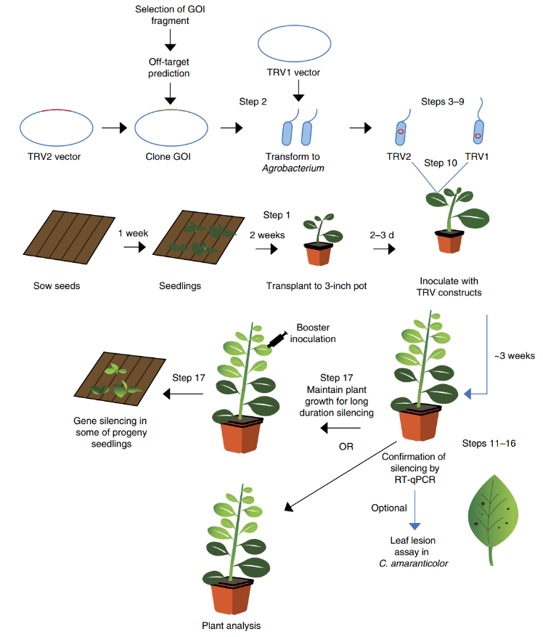

- Discussion
Silencing the CYC2 gene results in the changes of floral symmetry of Schizanthus. It is expected that zygomorphic becomes active. If the zygomorphic flowers of Schizanthus become to actinmorphic after silencing the CYC2-like gene, this indicates XXX; (Need to add more later) otherwise, this suggests that the XXX and it may relate with the loss of ECE coding domain.

References (still need to add more)
- Martin-Trillo, M. and Cubas, P. TCP genes: a family snapshot ten years later. Cell Press, December 2009; 10.1016
- Behjati, S. and Tarpey, P.S. What is next generation sequencing? US National Library of Medicine National Institutes of Health, August 2013; 10.1136
- Preston, J.C. and Hileman, L.C. Developmental genetics of floral symmetry evolution. Trends in Plant Science, March 2009; 10.1016
- Senthil-Kumar, M. and S Mysore, K. Tobacco rattle virus-based virus-induced gene silencing in Nicotiana benthamiana. National Institute of Plant Genome Research, June 2014; 10.1038

