Determining the Neuron Type Specificity of a
Potential Mechanism for Alcohol Addiction
I. Introduction
Alcohol use disorders (AUD) are a prevalent disease in the US and is the fourth leading cause of preventable death in the United States¹. This disease is characterized by impulsive craving and consumption of ethanol, despite negative consequences. It is largely heritable, and genetic factors been shown to account for 40–60% of the risk of developing an AUD². By understanding the genetic mechanisms and neurobiology that govern AUD, new therapeutic targets could be identified to treat alcoholism.
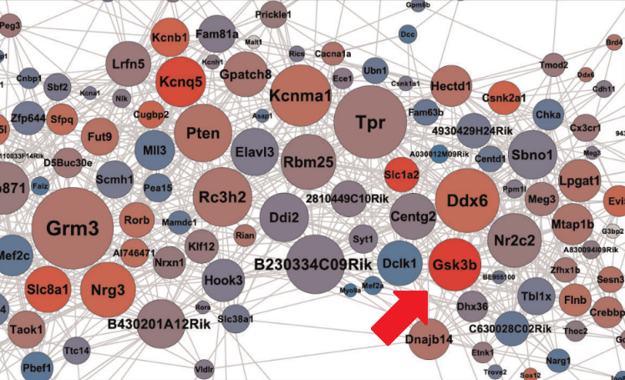
In order to determine the major genes responsible for the heritability of alcoholism, Wolen et al (2018)³ used a genome-wide expression network analysis of genetically diverse mice before and after treatment with ethanol. This experiment identified several key genes that were central to ethanol-correlated gene expression in the medial prefrontal cortex (mPFC), a region of the brain associated with drug-seeking behavior. One of these genes was Gsk3b (Figure 1), encoding for Glycogen Synthase Kinase 3 Beta, a multifunctional serine/threonine kinase which is known to be involved in ethanol-induced neurotoxicity⁴.
Figure 1: Gene network for acute ethanol. Gsk3b shown as a hub gene at the red arrow. Redder circles indicate a higher transcriptional response to ethanol and a larger size indicates amount of connectivity to other genes. Figure adapted from Figure 6 of Reference 3.
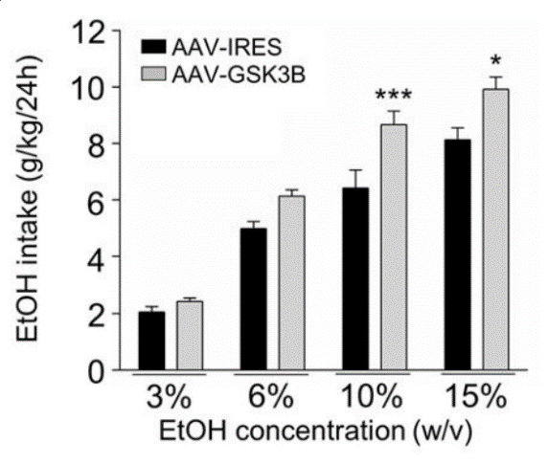
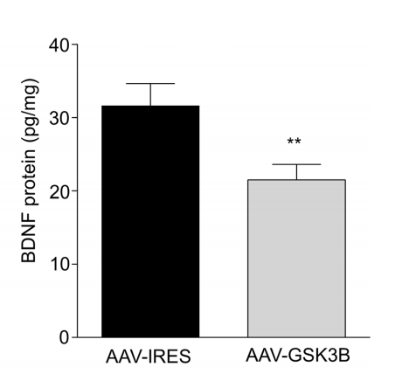
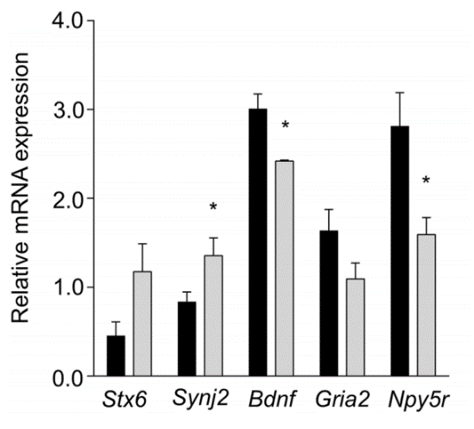
A follow-up study by van der Vaart et al (2018)⁵ explored the potential regulatory effects of GSK3B in the mPFC. One experiment overexpressed Gsk3b in the neurons of mouse mPFC, and measured mean ethanol consumption on a progressively increasing concentration. The increase in neuronal Gsk3b expression positively correlated with the consumption of ethanol (Figure 2). A second experiment measured the expression levels of synaptic signaling genes using Real-Time Quantitative Polymerase Chain Reaction (RT-qPCR). One gene in particular, Bdnf, coding for Brain-derived Neurotrophic Factor, was found to have a decreased expression levels after neuronal overexpression of Gsk3b (Figure 3). Protein levels of BDNF were measured by a quantitative Western Blot and that was also shown to decrease (Figure 3). This is a protein that has been shown to be increased in the striatum after ethanol consumption, correlating with a decrease in further ethanol intake as a potential negative feedback loop⁶. In other words, the increase in ethanol consumption after overexpression of Gsk3b could be a consequence of a decrease in BDNF protein.
Figure 2: Ethanol consumption after overexpression of Gsk3b. Black bars show control mice while grey bars show mice with Gsk3b neuronal overexpression. Figure obtained from Figure 2A of Reference 5.
Figure 3: Changes in other genes as a response to Gsk3b neuronal overexpression. Black bars show control mice while grey bars show mice with Gsk3b neuronal overexpression. (Left) mRNA expression levels of various synaptic signaling genes. (Right) protein levels of BDNF. Figure obtained from Figure 3 of Reference 5.

A separate study by van der Vaart et al (2018)⁷ attempted to explore the neuronal specificity of the regulatory effects of Gsk3b on alcoholism. One neuron type in particular, the glutamatergic pyramidal neurons in the forebrain, showed significant changes in the consumption of alcohol upon deletion of the Gsk3b gene. These neurons, characterized by the expression of CamkIIa, Calmodulin Dependent Kinase II A, form the principle output of the mPFC⁸. Deleting Gsk3b in these neurons led to a significant decrease in ethanol consumption.
To explore the potential mechanism behind Gsk3b and Bdnf interactions, it is important to understand whether or not this process is dependent on a certain cell type. Since Gsk3b has already been shown to have an effect in the CamkIIa+ neurons in the forebrain, this cell type is a likely candidate to look into to understand the pathway of Gsk3b and Bdnf. This purpose of this experiment is to determine whether or not this potential mechanism of the regulation of alcohol addiction is specific to the glutamatergic pyramidal neurons in the mPFC.
II. Experiment
This experiment will aim to measure the expression levels of Bdnf in the mPFC of genetically identical (C57B6J) mice brains upon overexpression of Gsk3b in only CamKIIa expressing neurons. Knowing that overexpression of Gsk3b in all neurons correlates with a decrease in Bdnf expression, this experiment will determine if this effect is fully, partially, or not dependent specifically on glutamatergic pyramidal neurons in the forebrain. Bdnf expression levels in these mice will be compared against expression in control wild-type mice and against mice with Gsk3b overexpressed in all neurons. If the downregulation of Bdnf is fully dependent on CamKIIa expressing neurons, the experimental levels of Bdnf expression should match exactly what was seen in the general overexpression experiment by van der Vaart et al. (2018)⁵.

II.A. Cell-type specific overexpression of Gsk3b
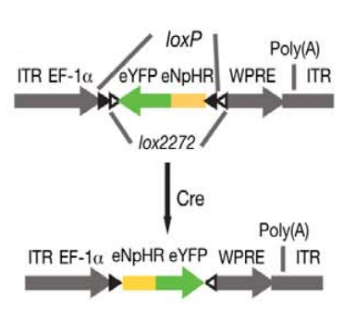
To achieve overexpression of Gsk3b in only CamKIIa+ neurons, a viral vector (AAV, Adeno-Associated Virus) containing a double-floxed inverted open reading frame (DiO) of Gsk3b will be injected into the mPFC of mice brains. This means that DNA encoding Gsk3b is added in reverse order to all cells in the mouse mPFC. However, this inverted open-reading frame lies in between two pairs of short DNA segments, known as loxP and lox2272 sites (Figure 4). When in the presence of the enzyme Cre-recombinase, the Gsk3b open-reading frame will undergo inversion, followed by excision of one copy of each lox site to prevent re-inversion⁹. The result is a Gsk3b open-reading frame that is only functional in the presence of Cre-recombinase.
Figure 4: Example DiO Vector. Figure obtained from Figure 1A of Reference 11.

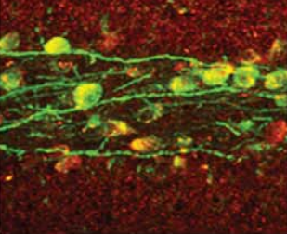
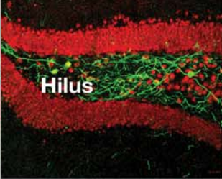
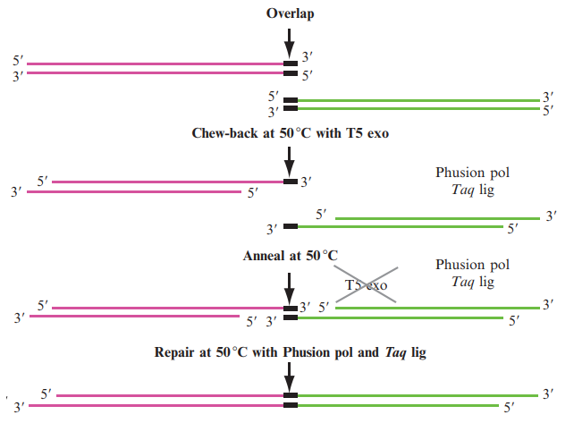
This construct will be synthesized using a pre-existing DiO plasmid, with the open reading frame of Gsk3b replacing the pre-existing one through the use of Gibson Assembly. This molecular biology technique can take virtually any two DNA sequences and attach them into a single molecule of DNA¹⁰. It involves primers that only partially anneal to the region of interest, creating products with single stranded overhangs. By generating PCR products of each segment with complementary overhangs, both PCR products will fuse into a single product (Figure 5). The resulting plasmid will contain the Gsk3b open reading frame in reverse as long as the single stranded overhangs matched the correct ends of the plasmid.
Figure 5: Gibson Assembly Method. Figure obtained from Figure 15.4 of Reference 10.
The DiO system has been employed by Andrews-Zwilling et al (2012)¹¹ to express their gene of interest, eNpHR3.0 in hilar GABAergic interneurons of the dentae gyrus. They created a DiO plasmid with an inverted eNpHR3.0 open reading frame to make the expression Cre-dependent. They then expressed Cre only in hilar GABAergic interneurons through the use of an enhancer sequence specific to this cell type (Dlx-I12b). With this construct, they were able to achieve expression of their vector in only the hilar GABAergic interneurons (Figure 6). Essentially, cell-type specific gene expression can be achieved as long as Cre is expressed in a cell-type specific manner.
Figure 6: Regiospecific Expression using DiO Plasmid. Green represents eNpHR3.0. (Left) Red represents NeuN marker staining for all neurons. (Right) Red represents a marker for GABA. Figures obtained from Figure 1D and 1H of Reference 11.
Using the DiO system for Gsk3b, expression can be limited to only the glutamatergic pyramidal neurons in the forebrain through the use of a CamkIIa promoter. This can be achieved through a transgenic mouse line, where the Cre gene has been inserted into the mouse genome and is driven by the promoter. These mice will only express Cre in cells that are also expressing CamkIIa, which therefore means that the injected Gsk3b will only be inverted and expressed in these cells, causing overexpression of Gsk3b in CamkIIa+ neurons. We will use CreER(T2), a type of Cre-recombinase fused with an estrogen receptor that will only be active in the presence of tamoxifen. With this particular Cre-recombinase, we can ensure that overexpression can only occur when injected together with tamoxifen, controlling for the possibility that Cre-recombinase is a confounding factor.
II.B. Measuring expression levels of Bdnf
To measure expression levels of Bdnf, we will use Real-Time Quantitative Polymerase Chain Reaction (RT-qPCR). This molecular biology technique starts by taking all of the mRNA transcripts in a sample and synthesizes the complementary sequence as DNA (cDNA) to maintain stability. Then, by using forward and reverse DNA primer sequences that target a section in the Bdnf transcript, the region encapsulated between the two primers can be amplified with a three step cycle:
- Denaturation: All double stranded DNA is separated into individual strands at high temperatures.
- Annealing: The DNA primer sequences will hybridize to their corresponding regions onto the single stranded DNA.
- Extension: DNA polymerase binds and completes the reaction in the presence of deoxynucleotides.
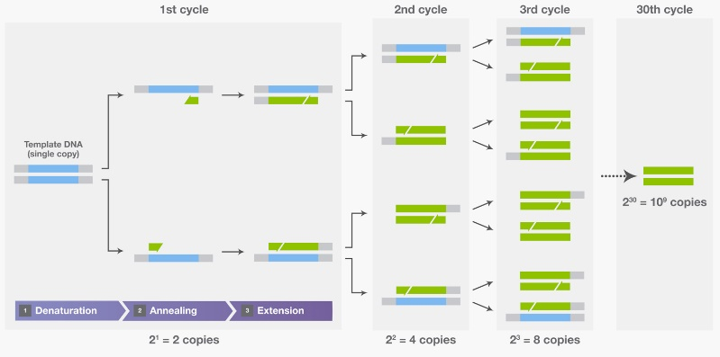
By repeating this cycle, the segment of DNA between the two primer sequences is amplified (Figure 7). To quantitatively measure the transcript made, a fluorescent double stranded marker such as SYBR Green I can be used to induce a signal whenever double stranded DNA (the PCR product) is created. If a sample contains more of the targeted transcript, it will amplify faster and produce a detectable signal earlier compared to samples with less expression. This way, the relative expression levels between samples can be measured.
Figure 7: Description of the three steps of a Polymerase Chain Reaction. Blue represents template DNA and Green represents newly synthesized DNA. Figure obtained from Thermo Fisher Scientific - PCR Basics.
Through the use of this method in conjunction with the CamkIIa+ neuron specific overexpression of Gsk3b, Bdnf expression levels can be compared between mice with basal expression levels of Gsk3b, mice with neuronal overexpression of Gsk3b, and mice with CamkIIa+ neuron specific overexpression of Gsk3b.
III. Discussion
Should this experiment proceed as expected, differences between the expression levels of Bdnf should be clear between these different overexpression conditions. If, hypothetically, the decrease in Bdnf is dependent specifically on Gsk3b overexpression in CamkIIa+ neurons, we could expect to see the same decrease in expression between the CamkIIa+ neuronal overexpression condition and the general neuron overexpression condition. If this effect is dependent on more than just the glutamatergic pyramidal neurons, the decrease in Bdnf should only be a fraction of what is observed after general neuronal overexpression. Similarly, if Gsk3b induced downregulation of Bdnf is not at all dependent on CamkIIa+ neurons, no decrease in Bdnf expression should be seen, and it should match what is observed in the control condition.
These data would give valuable insight into the molecular mechanisms of how Gsk3b downregulates Bdnf expression. If Bdnf expression downregulation can be correlated to a particular neuron type, then the molecular mechanism behind it should be limited to a specific process of that cell type. Conversely, if the downregulation is not limited to CamkIIa+ neurons and is consistent across other neurons, then mechanism would likely be controlled by a common process between all those neuron types. The benefit of having a DiO plasmid with Cre-dependent expression of Gsk3b is that to overexpress in another neuron type, all that needs to be changed is the promoter for expressing Cre.
It is important to understand that with this experimental design, since only one neuron type is being studied, if Bdnf expression is downregulated but not to the extent of the general overexpression, it can be hard to interpret if the underlying mechanism is involved with all neurons, or with a specific subset of them. Determining which of these cases is more likely would have to be done in subsequent experiments that explore other neuronal types. However, just the glutamatergic pyramidal neurons in the forebrain definitely has merit, since it is a likely candidate where interactions with Gsk3b have already been confirmed.

References
- Stahre, M., Roeber, J., Kanny, D., Brewer, R. D., Zhang, X. (2014). Contribution of Excessive Alcohol Consumption to Deaths and Years of Potential Life Lost in the United States. Preventing chronic disease. 11, E109. doi:10.5888/pcd11.130293
- Kendler, K. S., Neale, M.C., Heath, A.C., Kessler, R.C., Eaves, L.J. (1994) A twin-family study of alcoholism in women. Am J Psychiatry 151, 707–715.
- Wolen, A. R., Phillips, C. A., Langston, M. A., Putman, A. H., Vorster, P. J. ... Miles, M. F. (2012) Genetic Dissection of Acute Ethanol Responsive Gene Networks in Prefrontal Cortex: Functional and Mechanistic Implications, PLoS One, 7(4):e33575, doi:10.1371/journal.pone.0033575
- Chen, G., Bower, K. A., Xu, M., Ding, M., Shi, X ... Luo, J. (2009) Cyanidin-3-glucoside reverses ethanol-induced inhibition of neurite outgrowth: role of glycogen synthase kinase 3 Beta. Neurotox Res 15, 321–331. doi:10.1007/s12640-009-9036-y
- van der Vaart, A. D., Meng, X., Bowers, M. S., Batman, A. M., Aliev, F. ... Miles, M. F. (2018). Glycogen synthase kinase 3 beta regulates ethanol consumption and is a risk factor for alcohol dependence. Neuropsychopharmacology. 0:1-11, doi: 10.1038/s41386-018-0202-x
- Logrip, M. L., Barak, S., Warnault, V., Ron, D. (2015). Coritcostriatal BDNF and alcohol addiction. 1628. 60-67.
- van der Vaart, A. D. (2018). Molecular Brain Adaptations to Ethanol: Role of Glycogen Synthase Kinase-3 Beta in the Transition to Excessive Consumption. (Doctoral dissertation). Retrieved from VCU Electronic Theses and Dissertations (Number 5510).
- Warthen, D. M., Lambeth, P. S., Ottolini, M., Shi, Y., Barker, B. S. ... Scott M. M. (2016). Activation of Pyramidal Neurons in Mouse Medial Prefrontal Cortex Enhances Food-Seeking Behavior While Reducing Impulsivity in the Absence of an Effect on Food Intake. Front Behav Neurosci 10, 63. doi:10.3389/fnbeh.2016.00063
- Schnütgen, F., Doerflinger, N., Calléja, C., Wendling, O., Chambon, P., Ghyselinck, N. B. (2003). A directional strategy for monitoring Cre-mediated recombination at the cellular level in the mouse. Nature Biotechnology. 21(5). 562. doi:10.1038/nbt811
- Gibson, D. G. (2011). Enzymatic Assembly of Overlapping DNA Fragments. Methods in Enzymology. 497, 349–361. doi:10.1016/B978-0-12-385120-8.00015-2
- Andrews-Zwilling, Y., Gillespie, A. K., Kravitz, A. V., Nelson, A. B., Devidze, N. ... Huang, Y. (2012). Hilar GABAergic Interneuron Activity Controls Spatial Learning and Memory Retrieval. PLoS One. 7(7), e40555. doi:10.1371/journal.pone.0040555

