Is the KLF4 gene or Heparanase a more productive punitive target in the gene silencing of Breast to Brain metastasis?

- Introduction

Cancer is the second leading cause of death in the United States. In 2018, an estimated 1.7 million people Americans will be diagnosed with cancer and roughly 600,000 Americans will die from this ailment ¹. It is estimated that 90% of cancer deaths happen when a cancer has metastasized. Metastasis is the process of a tumor spreading from its first site to a secondary site. Metastasis is also commonly known as being at or past stage 3 cancer, where a tumor has spread past the primary site.
Fig. 2 Pathway of miRNA production and usage

The initial hypothesis of how cancer metastasizes was formed by Stephen Paget in 1889. In this hypothesis he claims that cancer metastasis is based on tumor cells being a “seed”, having a favorable interaction with good “soil”, and being an organ’s tissue that work well with the “seed”. The theory would be titled the “seed and soil hypothesis. This was not scientifically confirmed until much later by papers like Bruns et al. “In Vivo Selection and Characterization of Metastatic Variants from Human Pancreatic Adenocarcinoma by Using Orthotopic Implantation in Nude Mice” (1999) where there were more empirical results to the mechanisms of tumor metastasis. Tumorous cells are commonly spread through the lymphatic system or the blood stream, where a cell will break off from the initial tumor and move to a different site where it will multiply uncontrollably as cancerous cells do. Much of the reason why the 90% of patients who have a tumor metastasized die is because their initial site is in a non-vital area and goes to an area like the lung or brain where it has a much higher chance of being fatal. As seen in Figure 1., the one of the most common type of female cancer is breast cancer. While cancer in the breast is not inherently deadly because the breast does not serve a vital part to living, the tumor in the breast very commonly can spread to more vital parts of the body if left undetected and become a fatal metastasis. It is recorded that there is only a 20% one year survival rate in persons who have a breast-to-brain metastasis. There are many ways the human body counteracts the production of cancerous cells and growth of tumors within the primary site and how the tumorous cells spread to other sites in the body. Common ways the body’s immune system fights the tumor growth and metastasis is through T, B, and NK cells which are adult cells that attempt to destroy the site.
Fig. 1 Number of New US Female Cases of Cancer in 2016

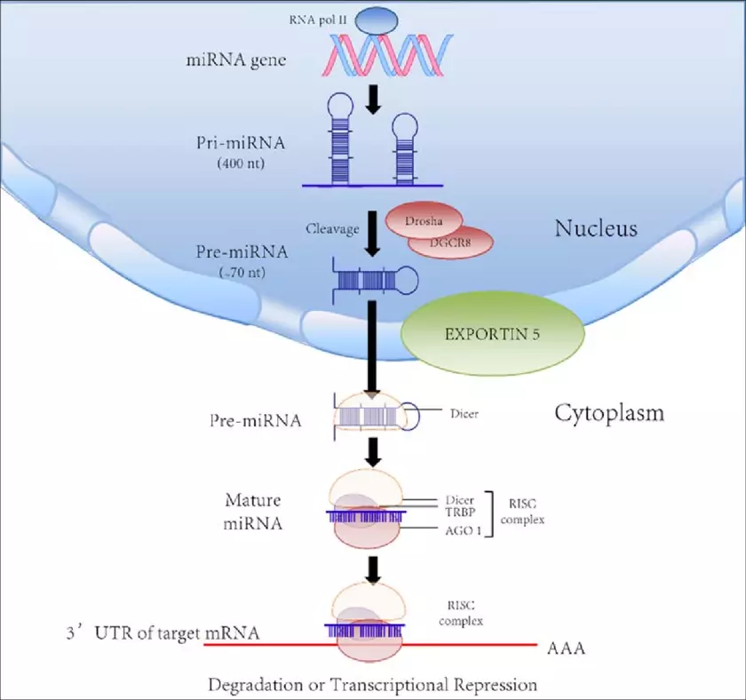
One newly discovered and is through MicroRNA(miRNA) a single stranded fragment of mRNA. It is roughly 19 to 25 nucleotides long, the location of where the miRNA is made in the DNA is in non-coding regions of DNA, meaning that it is not the genetic makeup used to encode proteins. The usage of miRNA is implemented when it either attaches to a protein that will regulate the usage of genes or enzymes. MicroRNA was not discovered till 1993 in Lee at al. “The C. elegans heterochronic gene lin-4 encodes small RNAs with antisense complementarity to lin-14” where they found small RNA fragments that were produced in the expression of a protein. They would further be researched more as time progressed as an essential part of gene regulation, including oncogenes. As seen in Figure 2, we know have a good idea on the production of how microRNA is produced and how it is used in gene transcription to regulate genes. The creation of microRNA starts when the gene is read by RNA polymerase II. It is then clipped and trimmed by enzymes Drosha and Dicer that leave it at a final length, where it then can attach to the RISC complex where it is then used to attach to its target to regulate the gene.

In the miRNA for this experiment, miRNA-7 and miRNA-1258 are both down regulated to the target KLF4 and the extracellular enzyme Heparanase respectively. Figure 3 from “MicroRNAs in Brain Metastases: Potential Role as Diagnostics and Therapeutics” by Alsidawi et al. shows the breakdown the two miRNAs role in the breast-to-brain metastasis in regards to what and how they regulate the creation of metastasized tumors. As of right now they are both known to be instrumental in the regulation of each of their respective targets, but there is still much research in miRNA’s as to how well they perform in their production comparatively. These miRNAs have the same punitive target, but different ways of achieving their goal. The question this proposal raises of the two miRNAs studied, with differing targets is more productive in reducing metastasis of tumors for the primary site of the breast. KLF4, which is th the target of miRNA-7, is a gene that encodes for the G1 to S phase of cellular mitosis in mediating the tumor suppressor gene p53. The downregulation in the KLF4 gene would mean that there would be. Heparanase, the target of miRNA-1258 is an enzyme in the extracellular matrix that is known to be pro-tumorigenesis and pro-angiogenesis, meaning the down-regulation of of the usage of Heparanase would make for a reduction in amount of tumors grown and the speed at which they grow from the “seed” from the primary site to a much more developed tumor. This proposal hopes to be able to get a better idea as which of the targets can accomplish its goal more effectively by testing mice blood content for the respective miRNAs.
Fig. 2 Steps to creating and uses a microRNA in the cell
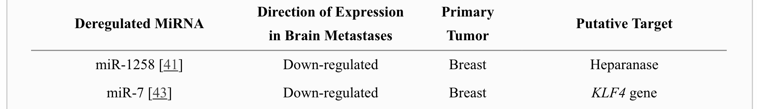
Table 1. Regulation and target of microRNA to where it is preventing metastasis

II. Experiment

- Goal and Hypothesis

This goal of this experiment would be to be able to find empirical data showing that one of the two microRNAs has a statistically significant difference in the prevention in the size of a breast to brain metastasis. I hypothesize that the attachment to the KLF4 gene as a target will be more productive in making fewer and/or small tumors that metastasize. In the experiment, mice with higher content of miR-1258, that attach to the KLF4 gene, will have better metastasis resistance than those with high content of MiR-7. This is because of the function of the KLF4 gene is in mediation of the p53 gene, which is known as a very prevalent and dominate tumor suppressor gene, while Heparanase increases the growth factor of the cell, it is less studied and appears to be less significant in tumor production.

B. Implementation and Study of NSG Mice

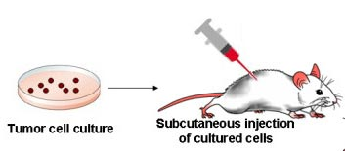
The experiments most important element is the specimen used to study the effectiveness of The type and method of subject use comes from Puchalapalli et al., “NSG Mice Provide a Better Spontaneous Model of Breast Cancer Metastasis than Athymic (Nude) Mice”. (2016) The NSG mice have the correct amount of genes silenced to be good candidates to promote and study tumor growth and spread. NSG mice are changed so that their B and T cells are depleted, they lose their C5 complement (a protein made to fight pathogens) and have lower development of NK cells. This will prove to give better result to zero in on the defenses this experiment is wanting to investigate. This also will reduce the number of confounding variables that will affect the results. NSG mice would have blood samples at the beginning of the experiment, then would have tumors implanted into the breast. An initial blood test of miRNA content will be done and have a statistical analysis of mice statistically significantly high amounts of statistically high in their content of miRNA-7 or miRNA-1258 and put into a respective group of about 25 each. There would also be a control group of 25 NSG mice that do not have statistically significant amounts of either miRNA. Figure 4 shows how tumor cells are cultured then injected in the primary site, in this case the breast. The progression of the tumor growth in the brain will be the one studied because we are learning the growth of the brain tumor after being metastasized from the breast.
Fig 4. Instruction of how tumor is cultured and implemented into mice

The experiment will last 20 days, this length of time was chosen after similar experiments showed tumor insertion experiments lasted similar time frames, with it shortened slightly because of the nature of the NSG mice being much more susceptible to larger tumor growth. Boston University outlines that their maximum size for an allowed tumor is 20mm for the ethical stability of the experiment. Using that rule as a parameter, the experiment would end prematurely if the case were to be that the tumor grew to be too large in too quick of a timeframe. Blood samples will be taken on five-day intervals along the experiment and tested for the respective miRNA content testing. Each blood test would be at 1 milliliter in size on each time of testing. Following similar experiments looking into miRNA content in blood samples, the samples would be centrifuged at 3,000 rotations per minute for 15 minutes then stored at -80 degrees Celsius. The blood tests would also be able to function as a test to see if the mice in the study have a change in miRNA content once the tumors have been inserted and metastasis is possible.

C. Assay and size measurement

At 20 days of the tumor progression, the mice will have their tumors removed and studied for size and weight. The miRNA can be tested for content in a microRNA reverse transcription kit and then can be used in a gene expression kit that includes a PCR. After there is data on all individual mice, the will be divided into separate groups of an “A” group with high amounts of miRNA-7 in their sample and the same with a “B” group with high amounts of miRNA-1258 Lastly, a “C” group of those with average amount, being statistically close to the mean of the amount of both miRNAs. This is the same groups as explained in part A with mice of high statistical significance. Once they are all bought in the average tumor growth of each group would be calculated, this would be done as well with the miRNA content.

III. Discussion

Possible results would look be in a line graph of the a “A” group, “B” group and “C” group in the y axis, and the x axis being the relative volume of the tumor growth. The hope of this study would be to find differing values of microRNA. MiRNA is a relatively new biological study point and we are still learning new and exciting things about it every day, but finding where we should put our energy into is very important. From this, finding a more powerful and receptive MiRNA to be used in tumor suppression can point out eyes in the right direction for which ones are the best for treatment. This would also hope to create more questions if we can answer this one like “What parts of the miRNA make it better than the other?” or “What are all factors that make it so that miRNA is a good candidate to amplify to help in cancer treatment?”

In this experiment, are also possible problems that come into question with the experiment. Too small of a sample size could lead to the wrong results wherein a small sample size could lead to results where the statistics are off leading to misleading results of which of the miRNAs are more effective. A scenario where both of them have no real statistical significance from the mean, which would be valid results, but could be confounding or almost reject the central question of the experiment. Also, so be a scenario that would have it be there is almost no difference in the two, which would make it be needed that there is need for a different kind of experiment to understand, because there has to be a way to tell the differences between the two. Those two would not undermine the experiment, but would rather bring into question the validity of the subjects or the methods used. There are also could be issues in the change of miRNA content as the experiment progresses where subjects put into certain categories change in would group, they would be in the beginning. For example, there could be a mouse that somehow increases the content of miRNA-7 during the experiment to where it is significantly high and inappropriate to be in the control group. Ultimately, this experiment hopes to provide insight, but also add more additional questions on the role of miRNA in cancer metastasis in the hope that gaining an extensive knowledge of the types, function and uses of miRNA can lead to better disease prognosis and diagnosis.

IV. References

- Cancer Statistics. (n.d.). Retrieved from https://www.cancer.gov/about-cancer/understanding/statistics

Puchalapalli, M., Zeng, X., Mu, L., Anderson, A., Glickman, L. H., Zhang, M., . . . Koblinski, J. E. (2016). NSG Mice Provide a Better Spontaneous Model of Breast Cancer Metastasis than Athymic (Nude) Mice. Plos One,11(9). doi:10.1371/journal.pone.0163521

Alsidawi, S., Malek, E., & Driscoll, J. (2014). MicroRNAs in Brain Metastases: Potential Role as Diagnostics and Therapeutics. International Journal of Molecular Sciences,15(6), 10508-10526. doi:10.3390/ijms150610508

Okuda, H., Xing, F., Pandey, P. R., Sharma, S., Watabe, M., Pai, S. K., . . . Watabe, K. (2013). MiR-7 Suppresses Brain Metastasis of Breast Cancer Stem-Like Cells By Modulating KLF4. Cancer Research,73(4), 1434-1444. doi:10.1158/0008-5472.can-12-2037

Zhang, L., Sullivan, P. S., Goodman, J. C., Gunaratne, P. H., & Marchetti, D. (2011). MicroRNA-1258 Suppresses Breast Cancer Brain Metastasis by Targeting Heparanase. Cancer Research,71(3), 645-654. doi:10.1158/0008-5472.can-10-1910

Backes, C., Meese, E., Lenhof, H., & Keller, A. (2010). A dictionary on microRNAs and their putative target pathways. Nucleic Acids Research,38(13), 4476-4486. doi:10.1093/nar/gkq167

Puchalapalli, M., Zeng, X., Mu, L., Anderson, A., Glickman, L. H., Zhang, M., . . . Koblinski, J. E. (2016). NSG Mice Provide a Better Spontaneous Model of Breast Cancer Metastasis than Athymic (Nude) Mice. Plos One,11(9). doi:10.1371/journal.pone.0163521

Zhu, S., Wu, H., Wu, F., Nie, D., Sheng, S., & Mo, Y. (2008). MicroRNA-21 targets tumor suppressor genes in invasion and metastasis. Cell Research,18(3), 350-359. doi:10.1038/cr.2008.24

4 Essential Cancer Charts for 2016. (2016, January 14). Retrieved November 24, 2018, from https://www.cancer.org/latest-news/4-essential-cancer-charts-for-2016.html

Lorenzo, M., Loarca, L., Ivanics, T., & LaRusso, N. (2015). MicroRNAs in the Cholangiopathies: Pathogenesis, Diagnosis, and Treatment. Journal of Clinical Medicine,4(9), 1688-1712. doi:10.3390/jcm4091688}

Bruns, C. J., Harbison, M. T., Kuniyasu, H., Eue, I., & Fidler, I. J. (1999). In Vivo Selection and Characterization of Metastatic Variants from Human Pancreatic Adenocarcinoma by Using Orthotopic Implantation in Nude Mice. Neoplasia,1(1), 50-62. doi:10.1038/sj.neo.7900005

Lee, R. C., Feinbaum, R. L., & Ambros, V. (1993). The C. elegans heterochronic gene lin-4 encodes small RNAs with antisense complementarity to lin-14. Cell,75(5), 843-854. doi:10.1016/0092-8674(93)90529-y

Zhang, L., Sullivan, P. S., Goodman, J. C., Gunaratne, P. H., & Marchetti, D. (2011). MicroRNA-1258 Suppresses Breast Cancer Brain Metastasis by Targeting Heparanase. Cancer Research,71(3), 645-654. doi:10.1158/0008-5472.can-10-1910

Bhaskaran, M., & Mohan, M. (2014). MicroRNAs: History, Biogenesis, and Their Evolving Role in Animal Development and Disease. Vet Pathol,51(4), 759-774. doi:10.1177/0300985813502820

Products. (n.d.). Retrieved from http://dinovapharma.com/products/

Tumor Policy for Mice and Rats. (n.d.). Retrieved from https://www.bu.edu/researchsupport/compliance/animal-care/working-with-animals/procedures/tumor-policy-for-mice-and-rats-iacuc/

