Site map translation of
Bae, Y., Choi, J., Nagy, A., Sung, H., & Kim, J. (2016). Antisenescence effect of mouse embryonic stem cell conditioned medium through a PDGF/FGF pathway. FASEB Journal : Official Publication of the Federation of American Societies for Experimental Biology, 30(3), 1276-86.
Text | Graphics
This article uses embryonic stem cells from mice to treat cellular senescence within human fibroblasts. Their trials ending up being successful in the essence the possibility that you can use embryonic stem cells to treat premature aging or age related diseases. They found a growth factor within the condition medium embryonic stem cells that has an anti-senescence effect, which ultimately they ascertained can be utilized to treat these diseases.  Contents:  Abstract  Introduction  Experiments:  Implications | 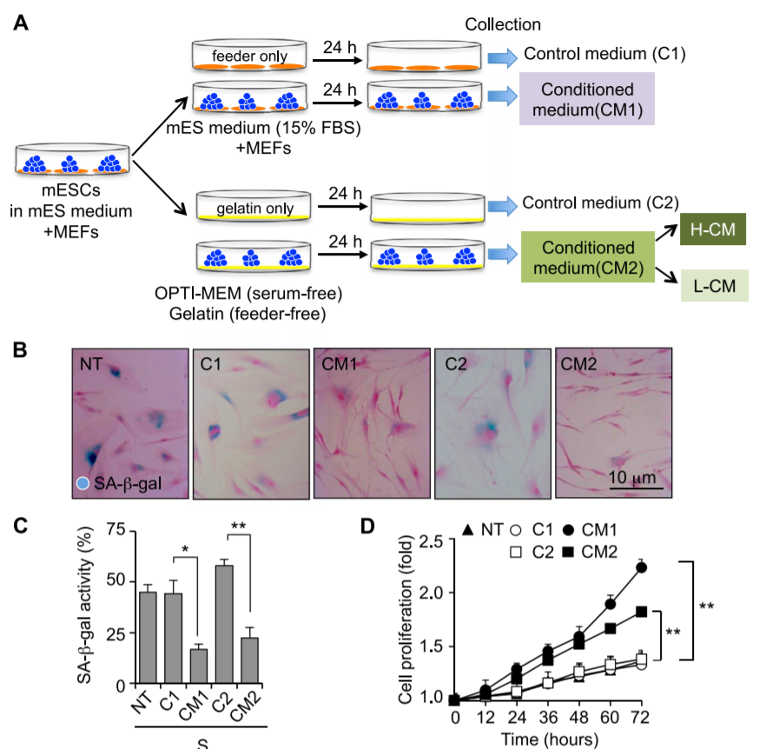

Abstract
Text | Graphics
Cellular senescence is a phenomenon that has always occurred in majority of organisms since the beginning of time. This phenomenon occurs irreversibly as a result of telomere shortening thus resulting in a premature aging along with the possibility of age related diseases. Several procedures were done including culture human fibroblasts and embryonic stem cells taken from mice, staining, cell proliferation and analysis, PCR, western blot analysis, as well as several other physical and statistical analysis were performed. CM1 did not contain anti senescence like characteristics. CM2 did exhibit anti senescence like characteristics, both of which CM1 and CM2 were supported by cell proliferation that was performed. CM2 also showed increased cells in the G2/M and S phases as compared to G1 and G0. The study demonstrate that ESC-CM is well supported to show anti senescence-like effects. To the knowledge of the authors, this is the first report to support that ESCCM demonstrates this. This may be used for chronic wound healing treatments. Ultimately, this can be used to treat age-related diseases, but regulation and practice as well as medical implementation could take years or even decades to occur. | No graphics

Introduction
Text | Graphics
The main question is that is there a way to treat wounds so that they may be able to heal quicker? One may find that there are molecular implementations to solve this solution. Then asking if embryonics stem cells that are conditioned be used to prevent or slow down cellular senescence for human treatment? | No Graphic

Experiment: Culture of human dermal fibroblasts and embryonic stem cells (Stem cells were also prepared and cultured within different mediums.

Text | Graphics
Motivation behind the experiment: dermal human fibroblasts (HDF’s) and embryonic stem cells (ESC’s) were both cultured so that they may be understood within a controllable medium. One of the underlying purposes of this experiment was to test if ESC’s may be utilized to present an anti senescence like effect so that they could be used to treat human wounds as a result of this effect and ultimately, proliferative cell activity.  Description of the procedure: First they obtained HDF’s, then once majority of the fibroblasts, reached confluence, they performed trypsinization which is the process of utilizing an enzyme, Trypsin, to separate cells from the plate that they are initially cultured within (Huang et al, 2010). The cells were then treated with 500 nM of doxorubicin as a preventive measure to premature senescence. This was everything done to culture the HDF’s. Afterwards the culture and preparation of ESCs was performed. This was done by putting the ESCs in a medium with several growth inducing supplements, as well as essential and nonessential amino acids, and several antibiotics to prevent bacterial infection of the cultured cells. The medium was changed with a new medium each day. Then they prepared the ESCs for further experiments by culturing them until they reached 80 to 90 percent confluence. They were then washed each day as well as incubated, centrifuged, and purified through a filter. The concentrated cultured medium (CM) was then spun again.  Description of the result, take the reader through a figure or table: This graphic on the right is a photo of the preparation and optimization of the cultured medium ESC’s. The had two cm ESC’s, one with the feeder from the HDF”s in it, and one without. This feeder is referred to as MEF or mouse embryonic fibroblasts, which are used to secrete growth factors into the medium as well as provide a cell matrix for the ESC’s to grow in so that they overall have a stable and consistent environment. The second set of dishes was also serum free, that serum of which contained several growth factors. | 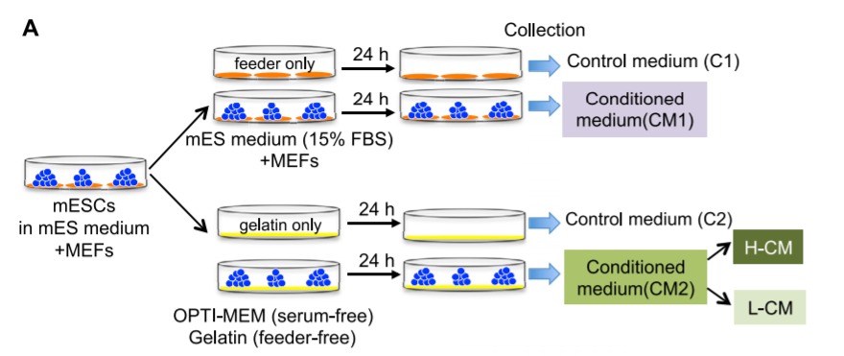

Experiment: Staining of senescence-associated beta-galactosidase

Text | Graphics
Motivation behind the experiment:A way was needed to track whether or not senescence was prevalent within the cells. In order to do so, a staining of Beta-galactosidase was done. Beta-galactosidase activity is only seen in senescent cells (Hall et al, 2017), therefore, they figured that tracking this enzyme activity would help them figure out whether or not senescence is prevalent in the cells they cultured.  Description of the procedure: Staining of beta-galactosidase was performed. They collected images utilizing a LED microscope. The total cell and blue cell count was counted, and the percentage of blue cells was calculated afterwards.  Description of the result, take the reader through a figure or table: The table on the right is a graph made to show the percentage of beta- galactosidase thus reflecting a portion of the blue cells within each group. | 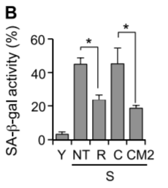

Experiment: Cell proliferation and cell cycle analysis

Text | Graphics
Motivation behind the experiment: An analysis and proliferation was performed so that they could produce more cells as well as look into if the cell cycle were properly occurring the way they intended.  Description of the procedure: The procedure was performed with proliferation first, 20000 cells per well were placed in multiple plates and then treated with CM within the different plates. Some were treated and other plates were not. They were then isolated in the same manner as earlier, with trypsinization. The cells were then counted using a hemocytometer. In the cell cycle analysis, the samples were stained and the intensity of the fluorescence was then measured to determine DNA count estimates.  Description of the result, take the reader through a figure or table: The right graphic is taken from figure 2E. It is mentioned that the CM2 treatment significantly increased the S and G2/M cell population while decreasing the G0/G1 cell population. [Look over this, see exactly what the percentages mean, relate the treatment from CM2 to the results in greater detail] | 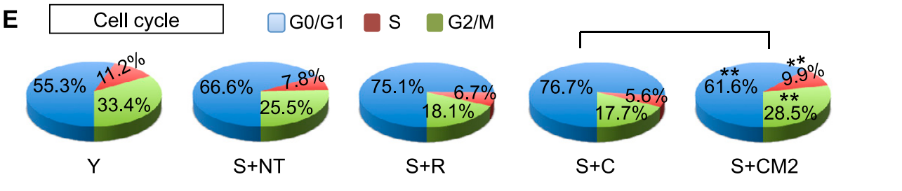

Experiment: Reverse Transcription PCR and real-time PCR
Text | Graphics
Motivation behind the experiment:PDGF stands for platelet-derived growth factor and serves the purpose to regulate cell growth and division (Williams, 1989). The reason they chose this growth factor to amplify was because it actually serves mainly for blood vessel formation (Williams 1989), therefore, since they wanted to find a way to utilize ESC’s to speeden wound healing, they chose to look specifically at how this gene is affected.  Description of the procedure: RNA was extracted and multiple genes were ampllified within the genome, this included the PDGF recepter, PDGFR alpha, PDGFR beta, and glydceraldehyde 3-phosphate dehyrogenase (GAPDH). These were all amplified in the forward and reverse direction along with the utilization of gene-specific DNA primers. The levels of p21 and p53 were also analyzed using primers to amplify the genome.  Description of the result, take the reader through a figure or table: [Figure 5A, go over what this graph indicates and how that relates back to the overall experiment. Find out what the plus and minus signs indicate] | 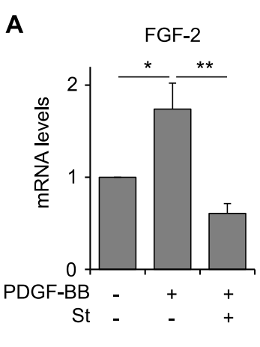

Experiment:Protein Antibody Arrays and ELISA

Text | Graphics
Motivation behind the experiment: Many proteins need to be analyzed for their expression during the process of this experiment, this is why they performed an Antibody Array.  Description of the procedure: An antibody array was performed by staining serveral proteins, including, pRb, p53, AKT, pAKT, ERK, and pERK. They specifically utillized an ELISA which is a type of antibody array that is Enzyme-linked. [Go more into depth as to the purpose of the enzymes within the assay] The final result should show a fluorescent spot  Description of the result, take the reader through a figure or table: [Figure 3A and 3C] Figure 3A shows the analysis from the antibody array. Figure 3C shows the comparison of the images from H-CM (Higher activity controlled medium) and L-CM (Lower activity controlled medium).[What is C? It appears that it might be the control. Analyze the differences between the two, what that means for what was performed as well as the experiment overall. [Describe Figure 3D as well] | 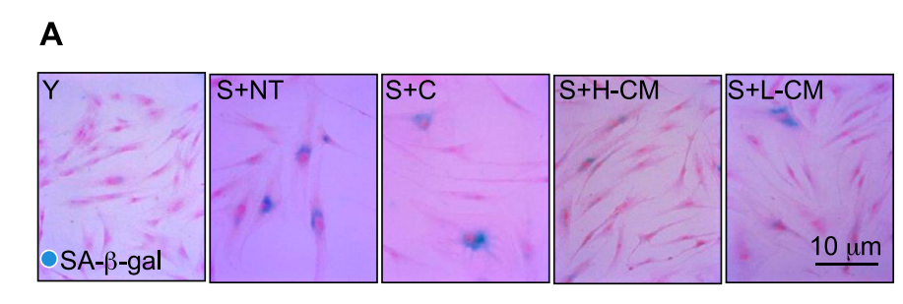  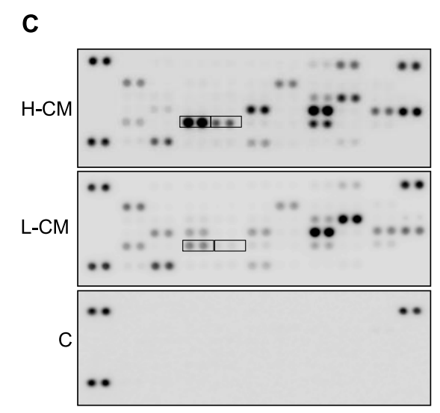  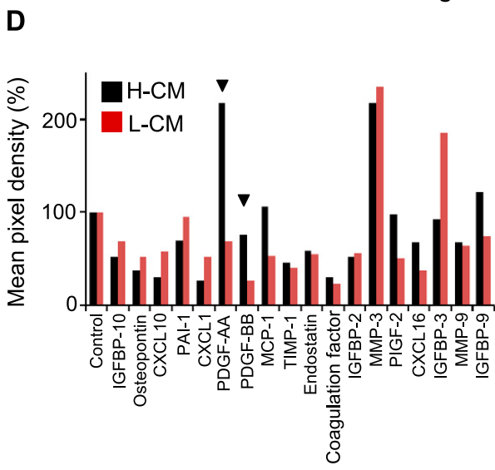

Experiment: In vitro cell and in vivo wound-healing assay
Text | Graphics
Motivation behind the experiment: This part of the experiment they performed both in vitro (usually a glass tube experiment) and in vivo (Female ICR mice, ICR meaning they obtained it from the Institute of Cancer Research within switzerland) wound-healing model assay.  Description of the procedure: The in vitro was performed by photographing the wounds before and after the ESC implementation. [Figure out where in the literature how they performed the in vitro experiment, go into further detail as to how they performed the experiment within the tube). For in vivo, the female mice in which were 6 to 8 weeks old. Incisions were made after anesthetizing the mice, a 6 mm diameter wound was then created utilizing a standard biopsy punch the conditioned medium (CM) was then mixed with a growth factor-reduced BD and spread on the wound. After 3 days, the CM was injected again through a Tegaderm (a material used to cover wounds, while having a membrane that allows oxygen to be supplied to the wound). Following seven days, photos of the wound were taken.  Description of the result, take the reader through a figure or table: | 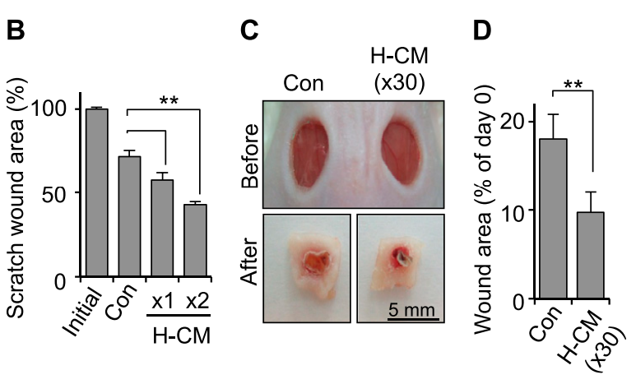

Experiment: Histologic and immunohistochemical analysis
Text | Graphics
Motivation behind the experiment:Histology is the study of the microstructure of tissues. With an incision, some of the tissue was torn. With this, a histologic and immunohistochemical analysis was performed.  Description of the procedure:First, wound sections were stained with hematoxylin and eosin to make general observations regarding morphology. In order to observe collagen deposits, the tissue was also stained with Masson trichrome stain, the slides were then incubated with actin. Immunostaining was then performed afterwards.  Description of the result, take the reader through a figure or table: Figure 6E. [Go over the figure and what it means.] | 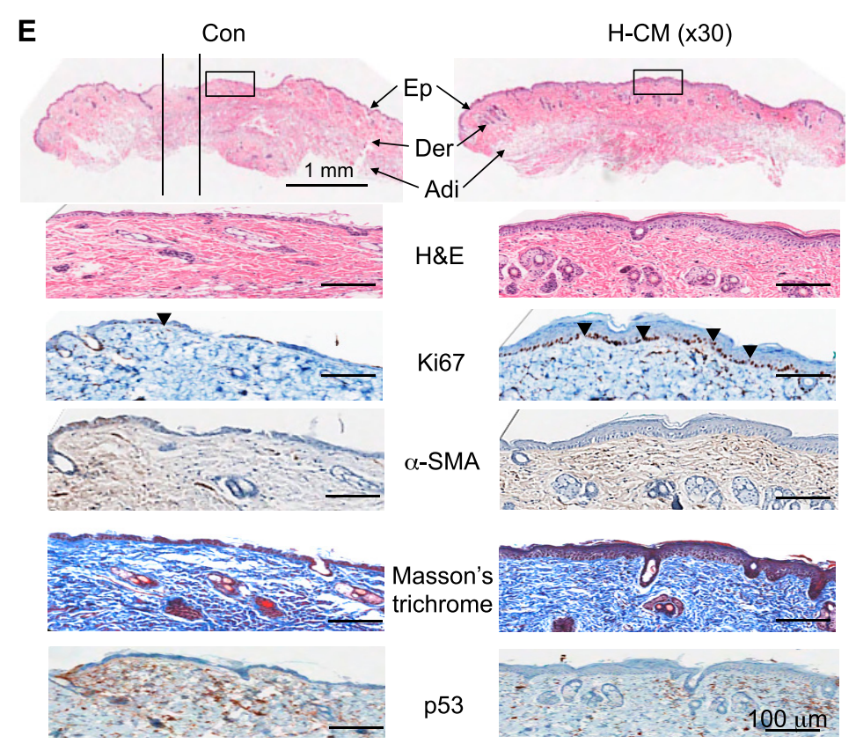

Experiment: Immunofluorescence staining
Text | Graphics
Motivation behind the experiment:Ki67 is a protein marker for cell proliferation, by staining this marker, one would be able to see how many cells experienced cell proliferation, and how many cells did not.  Description of the procedure: They stained antibodies against Ki67 and then counted them in a double blind manner. The percentage of Ki67 was then ca  Description of the result, take the reader through a figure or table: [Figue 6G, Go over in detail what the percentage indicates, higher percentage indicates more cell proliferation, thus supporting that the CM helped wound healing] | 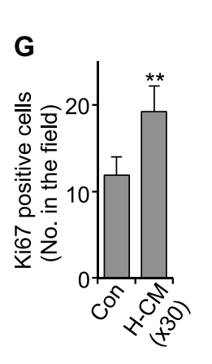

Experiment: intracellular reactive oxygen species measurement
Text | Graphics
Motivation behind the experiment: Staining was also done of a H2DCF marker presenting whether or not the cells undergo oxidative stress during the experiment. intracellular reactive oxygen species measurement. [A little more detail in the motivation]

Description of the procedure:A staining was performed then a cytometer was used to measure the fluorescence intensity within the 10,000 cells of each sample.

Description of the result, take the reader through a figure or table:

Experiment: Statistical analysis
Text | Graphics
Motivation behind the experiment: To see if the results are significant as a result of standard statistical procedure.

Description of the procedure: A standard two tail P test was done.

Description of the result, take the reader through a figure or table: A result lower than 0.05 would be considered a significant impact or difference from the control as a result of the experiment. [Go over what stats they went over and what this means for the experiment overall]

References
Hall, BM, Balan, V, Gleiberman, As, Strom, E, Krasnov, P, Virtuoso, Lp, . . . Gudkov, Av. (2017). P16(Ink4a) and senescence-associated beta-galactosidase can be induced in macrophages as part of a reversible response to physiological stimuli. Aging-Us, 9(8), 1867-1884.
Lin Cheng-Wen, Lin Szu-Ting, Lu Ying-Chieh, Wu Chieh-Lin, Lyu Ping-Chiang, Chan Hsin-Tsu, . . . Chan Hong-Lin. (2010). Trypsin-induced proteome alteration during cell subculture in mammalian cells. Journal of Biomedical Science, 17(1), 36.
Williams, L. (1989). Signal transduction by the platelet-derived growth factor receptor. Science (Washington), 243(4898), 1564-1570.

