“CMYA5 and schizophrenia: Y2H analysis of mutant myospryn”

Mentor: Rita Shiang, Ph.D.

**I. Introduction**

CMYA5 (cardiomyopathy associated 5) is a protein coding gene whose variants have recently been found to be associated with schizophrenia5. Along with CMYA5, DTNBP1 (dystrobrevin-binding protein 1) is also a schizophrenia susceptibility gene known to have an effect on the development of the prefrontal cortex19. CMYA5 codes for myospryn, a protein found mostly in cardiac and skeletal muscle, and is speculated to play role in protein kinase A (PKA) signaling and vesicular trafficking24. DTNBP1 codes for dysbindin, a protein found on pre/post-synaptic sites where it regulates neurotransmitter release, receptor signaling, and neuronal development.

I.A Genetic Analyses of CMYA5

CMYA5 codes for myospryn, a protein known to be specific to muscle cells24, similar to desmin21. Recently, a study published by Anting Hsiung, Ph.D. and directed by Rita Shiang Ph.D. in 2017 provided first evidence of myospryn and desmin expression in the brain11. CMYA5 gene expression from the RNA-Seq transcriptome data base of the mouse brain showed CMYA5 expression is at its greatest in astrocytes11. Astrocytes are responsible for K+ ion and neurotransmitter control in the extracellular space of synapses and secreting thrombospondin glycogens (TSP) that induce neurons to form synapses1. The significance of these factors suggests that dysfunctional astrocytes may lead to dysfunctional neurotransmitters11.

CMYA5 gene has been identified as a schizophrenia susceptibility gene5. Population studies have revealed a strong association between three candidate variants in the CMYA5 gene and schizophrenia11. The variants are rs3828611 (H3358Q), rs10043986 (P4063L) and rs4704591 in the 3’ region5. These variants are separately associated with schizophrenia in various racial and ethnic groups which suggests that CMYA5 gene may express ethnic heterogeneity. For example, rs4704591 shows significant association with schizophrenia in European samples5 and rs3828611 is strongly associated with schizophrenia in Chinese samples17.

I.B DTNBP1 and Schizophrenia

DTNBP1 is a schizophrenia susceptibility gene that codes for dysbindin, a protein characterized by its association with the dystrophin-associated protein complex (DPC). Dysbindin is a subunit of the biogenesis of lysosome-related organelles complex 1 (BLOC-1). This protein is known to play a role in intracellular trafficking and lysosome-related organelle biosynthesis4 as mutated forms of dysbindin show strong association with the lysosome-related bleeding pigmentation disorder Hermansky-Pudlak syndrome type 718.

The pathogenesis of schizophrenia is evidenced to have roots in neuronal development2, which is indicated by various schizophrenia susceptibility genes that are factors affecting neuronal development19. Disrupted-In-Schizophrenia-1 (DISC1)12 is one example of these genes. Dysbindin seems to be a factor in neurite outgrowth through its involvement in the p53 pathway19. Actin binding protein Coronin 1b and GTPase Rab13 are target genes of tumor suppressor protein p53 and are essential for neurite outgrowth and axon regeneration9. Independent gene knockdown procedures performed separately on p53 and dysbindin yielded very similar results, showing a significant reduction in mRNA levels of Coronin 1b/Rab13 and a decrease in neurite lengths19.

Neurite outgrowth occurs through the exocytosis of intracellular vesicles21. Lysosomes play a significant role in proper neurite outgrowth because of their ability to store Ca2+ 21. Ca2+ is released from lysosomes in dendrites (branched extensions of nerve cells) as the lysosomes fuse with the plasma membrane resulting in the release of Cathepsin B, a lysosomal cysteine protease17. Cathepsin B recruits the activity of matrix metalloproteinase 9 (MMP-9), an enzyme that functions to shape the extracellular matrix and regulate synaptic plasticity21. MMP-9 is a target gene for nuclear factor kappa B (p65/p50)21. Dysbindin regulates NF-kB by binding to its p65 subunit, allowing for proper MMP-9 production8. When dysbindin is dysfunctional or has little presence as a result of a gene knock down, MMP-9 transcription is repressed8. If a defect is present among these metabolic pathways and their associated proteins, then the result may be faulty neuronal 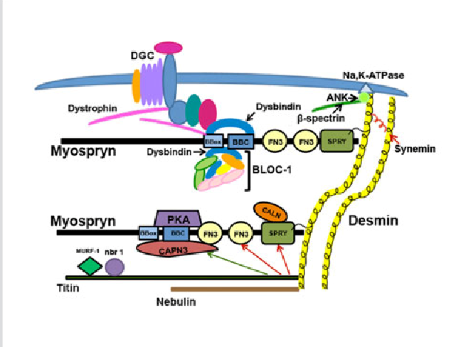development and dysbindin appears to be a significant factor in this. Myospryn and dysbindin are binding partners. Though several functions of dysbindin have been identified, no concrete functions of myospryn have been established. The role of dysbindin in the p53 pathway was identified through a gene knockdown protocol, and so a similar experiment with CMYA5 could help reveal a function of myospryn.

**Figure 1.** Graphical representation of myospryn, its domains, and the proteins/complexes that associate with them. The upper myospryn is binding to the Dysbindin subunit of BLOC-1 at the BBox domain while also binding to desmin at its C-terminal. (from Ref. 26).

I.C Desmin’s Relationship with Myospryn and Dysbindin

Many proteins in muscle, including myospryn, are reliant on the intermediate filament desmin for proper localization around the nucleus14. The desmin intermediate filament (IF) is an important factor in organelle positioning in cells14, with lysosomes being the most significant organelle in relation to this study. Myospryn relies on desmin for proper localization around the cell nucleus14 and the dysbindin subunit of BLOC-1 is a myospryn ligand14. Desmin co-immunoprecipitates with dysbindin and pallidin (another protein in BLOC-1) and myospryn (**Fig. 2**), and since dysbindin is a myospryn ligand, the relation could potentially have been mediated by myospryn10.

**Figure 2.** Western blot analysis demonstrating the presence of myospryn, dysbindin and pallidin in the desmin immune complex. This was done through Coimmunoprecipitation using anti-desmin antibodies. The positions of the three proteins are determined by how they correspond to the heart homogenate lane. (from Ref. 14).

I.D Summary of Relevant Research

**Functional Study of CMYA5 A Candidate Gene for Schizophrenia** Anting Hsiung

Schizophrenia is a disorder that has a wide variety of genetic factors contributing to its pathology. There are 108 loci identified by the Psychiatric Genomics Consortium but a new candidate gene that is not seen in the data, cardiomyopathy associated 5 or CMYA5, has been proposed. The protein expressed by CMYA5 gene is named myospryn, a protein historically understood to be muscle-specific. Myospryn is co-localized with the type III intermediate filament desmin, an essential protein in muscles involved with muscle development and muscular integrity, which localizes myospryn in the periphery of the nucleus. There are three variants of CMYA5 that have been associated with schizophrenia and the SNP’s are rs3828611, rs10043986, and rs4704591. A. Hsiung performed this study to determine whether myospryn and desmin are expressed in the brain, and performed experiments focused on the functional variant rs10043986, a missense polymorphism that changes a proline to a leucine in the 4063rd amino acid position of myospryn. Using the yeast-two-hybrid system and confocal laser scanning microscopy along with western blotting protocols, various tests were performed on these proteins. The tests measured the binding affinity and localization of the proteins myospryn and desmin so that evidence regarding the potential significance of myospryn in relation to the pathology of schizophrenia could be uncovered. The results of the study show that CMYA5 and DES (desmin coding gene) are both expressed in the brain and that the leucine from the missense variant of CMYA5 has a higher binding affinity to desmin than the highly conserved proline.

The author of the study investigated the binding affinity of the rs10043986 polymorphism of CMYA5 to desmin compared to the non-mutant gene. This was done by obtaining the DNA sample of a subject who was heterozygous for the desired CMYA5 allele, allowing the PCR system to produce both the standard form and missense variant of CMYA5. These alleles were cloned through PCR and the products were further cloned through pBluescript SK+, a cost-effective standard cloning vector. The primers for the polymerase chain reaction contain restriction endonuclease sites for the endonucleases Ncol and EcoRI. The endonuclease sites were used to insert the primers into an artificial yeast chromosome vector to employ directional cloning into Y2H vectors. The alleles of CMYA5, both CMYA5 C (proline) and CMYA5 T (leucine), were cloned into one yeast vector that acted as the activation domain, and the fragment of desmin responsible for binding to CMYA5 was cloned into a DNA-binding domain. The two vectors are meant to act as “bait” or “prey” and attract each other. The purpose and significance of this interaction is that it results in the activation of a reporter gene, and the magnitude of this gene’s activation is an indicator of the binding affinities of the two vectors. The procedure here utilized The Matchmaker Two-Hybrid System 2 and a reporter β-galactosidase, or lactase for short, was to be used to indicate interaction. The lactase was used in a solid colony-lift filter assay using X-Gal, or 5-bromo-4-chloro-indolyl-β-D-galactopyranoside, and a liquid culture assay using ONPG, or ortho-Nitrophenyl-β-galactoside. The DNA- binding domain vector was first transformed into yeast, followed by the activation domain vector. Once they interacted, a reporter gene contained on the “prey” vector was activated, producing lactase. The colonies were then assayed to measure lactase activity. In the liquid culture assay, four to five colonies were assayed in triplicate three times. And the colony-lift filter assay was also performed with two control groups, one negative control group, one positive control group, and one test group. A two-tailed t-test was used to determine whether the activation of lactase was significantly different between the two CMYA5 alleles in the liquid culture assay.

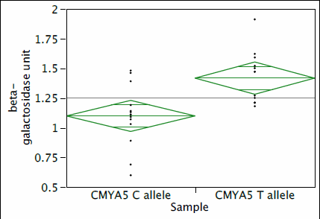 The experiment results showed that both the highly conserved proline allele CMYA5 C and the minor CMYA5 T bind to desmin. This was determined by observing the presence and magnitude of lactase activity in both cases through a colony lift filter assay. Further study showed, that the major allele had weaker binding compared to the minor allele (**Fig. 3**) indicated by a p-value of 0.0019 suggesting a significant difference in binding strength.

**Figure 3.** The average activities of β-galactosidase in the liquid culture assay between CMYA5 C and CMYA5 T. CMYA5 C is significantly different with its 1.10 units compared to 1.42 with CMYA5 T. (from Ref. 11).

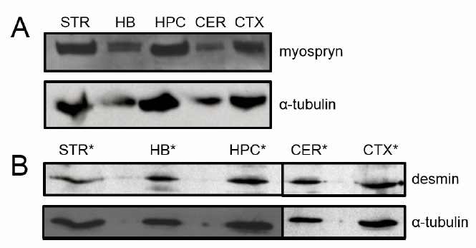 The rs10043986 SNP changes a proline to a leucine in the 4063rd amino acid position of the myospryn protein, resulting in a shift in residue size and hydrophobicity in the C-terminus of the protein5, and as the results of this experiment have demonstrated, significant increase in binding strength between myospryn and desmin. Considering that myospryn transcripts are expressed in the brains of mammal embryos (**Fig. 4**), it is important to understand the functions of myospryn in the brain.

Disruption of neuronal development is linked to the development of schizophrenia15 16 and dysbindin appears to play a role in such a process. It seems that desmin can only coimmunoprecipitate with dysbindin through myospryn14. Considering the potential significance of this interaction, performing a knockout of myospryn through a CRISPR/Cas9 protocol may provide valuable information for this investigation.

**Figure 4.** Western blot analysis of myospryn and desmin indicating expression in regions like the hippocampus and the cortex. (from Ref. 11).

**II. Experiment**

The purpose of this experiment is to identify whether and how myospryn could affect neuronal development. In order to do this, CMYA5 will be suppressed in mice so that neurite outgrowth seen in the cells of knockout mice could be compared to what is seen in wild type mice. The knockout will be performed through the CRISPR/Cas9 protocol. The hypothesized results from this experiment would suggest that myospryn plays a significant role in how the neural systems of mice develop.

II.A. What is CRISPR/Cas9?

CRISPR, or clustered regularly interspersed short palindromic repeats, is a popular and efficient technique used to modify a targeted gene. The process involves the employment of the CRISPR-associated protein 9 (Cas9), that induces a double stranded break in a specific target area that it is able to identify through the use of a guide RNA7. The gRNA is an RNA sequence composed of two parts, the scaffold and the spacer (**Fig. 5**). The scaffold is responsible for binding to the Cas9 protein and so it isn’t of much concern in CRISPR but the spacer is what acts as the target identifier that leads Cas9 to the target gene7. The spacer region of the gRNA is a ~20 nucleotide sequence that is determined by the researcher to give the best results based on a few factors7. The most significant of the factors is the presence of a Protospacer Adjacent Motif (PAM) on the target DNA, adjacent to the target7. This sequence is essential for the binding of Cas9 and the desired experiment could not be performed otherwise7. The desired PAM sequence varies between the variants of Cas9 and the species they come from, but the standard *Streptococcus pyogenes* 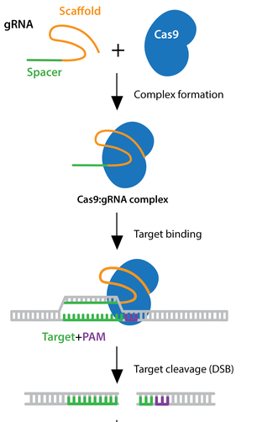and its required PAM sequence of 3’NGG is the most popular form7. Another significant factor is the GC content of the spacer sequence. Considering the sheer magnitude and variability seen in mammalian genomes, the possibility of the spacer sequence being attracted to undesired loci, otherwise known as off-targets, is always prevalent and an appropriate GC content can increase the likelihood that the sequence is unique to the target7.

An experiment performed by Kherraf et al. outlines the general process of generating knockout mice. This experiment breaks down their CRISPR/Cas9 method into three steps. To start, a target sequence must be selected and the plasmids containing the data required for the gRNA and Cas9 protein must be ordered or prepared manually. Then the plasmids are injected into the zygotes and the embryos that develop are transferred into pseudopregnant female mice. Finally, after a few generations of breeding, the genotype and phenotype of the mice are documented so that the mice in which the knockout is successful can undergo further analysis.

**Figure 5.** The Scaffold segment of the gRNA forms a complex with the Cas9 protein. The spacer then leads the Cas9:gRNA complex to the target sequence where a double stranded break is made. (from Ref. 7).

II.B. What is Being Measured?

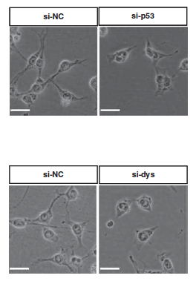 The experiment being proposed is meant to give us an idea of what myospryn’s function in the brain seems to be. I’ve hypothesized that the knockout of CMYA5 could have a deleterious effect on neurite outgrowth, and so, I would seek to measure this. The methods employed by Ma et al. did just that (**Fig. 6**).

The method first involves the preparation of mouse cortex cultures. This was done by withdrawing cortical cells after digestion with an enzyme like trypsin, and seeding them into well plates and culturing them using a medium. Once this was done, the cells were observed through a microscope and the longest neurite length of each cell as well as neurite length averages were measured using the ImageJ software, and statistical analyses were performed through a one-way analysis of variance (ANOVA) to determine if there is a significant difference between the mean lengths of the groups of cells.

**Figure 6.** Microscopic inspections of neurite outgrowths. Images on the left show control groups and the right shows knockout groups. Neurite outgrowths are similarly lacking in both test groups but appear normal in the control. (from Ref. 19).

II.C. Experimental Procedure

**i.** To start, I attempted to find a viable gRNA in the CMYA5 gene in *Mus musculus* (mouse). I started by doing a search of a report for CMYA5 in ncbi.gov and clicked on the option to view the GenBank file for the gene (outlined below). 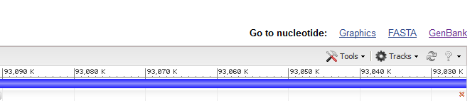

Following this, I searched for multiple nucleotide sequences within the GenBank file by looking for 3’NGG PAM sequences (purple). Once I had a pool of sequences to choose from, I used the Cas-OFFinder tool found on [www.rgenome.net](http://www.rgenome.net) as a guide to narrow down which sequence could be a better option for the experiment. This tool simply takes in a sequence put in by the user and runs the sequence against the genome of the chosen species to find off-target sites. I decided on the sequence below to be the spacer sequence (green) for the gRNA as it seemed to have a balanced GC content of 50% and showed to have few or no off-targets as suggested by the aforementioned tool.



The plasmid containing this sequence and the desired Cas9 system can be ordered from a service provider such as GenScript.

For the following procedures, one group of mice will be the control group consisting of wild types and the other will be treated with the gRNA/Cas9 plasmids.

**ii.** Once the plasmids are in possession, lab mice must also be obtained. The lab mice can be obtained either through a service provider or by VCU. For the test group, Female mice will first be injected with PMSG and HCG hormones to induce super-ovulation, a technique to stimulate greater egg production in mice25. The mice will be placed in an appropriate environment where females and males could mate so that the zygotes produced can be collected the next day13. This will be done as shown in Modzelewski et al. by dissecting the female mouse and identifying the ovaries behind the intestines. The oviduct will then be dissected and the oocytes will be extracted. The embryos will be placed in a holding medium designed to maintain embryos. Here the gRNA/Cas9 plasmids will be microinjected into the zygotes. After this process, the embryos will be transferred into pseudopregnant females. To perform the oviduct transfer, the surrogate will be treated with anesthetic and a small incision will be made on the back, proximal to the ovary, and using a glass pipette, the extracted embryos will be injected into the oviduct. In the following weeks, a healthy number of knockout mice will be generated.

**iii.** The offspring will be genotyped via Sanger sequencing so that knockout mice can be identified. Once completed, neurons from the hippocampi of both knockout and wild type groups will be digested in a 0.5% trypsin solution and disassociated19. These cells will then be cultured with a medium designed to induce neurite outgrowth. There will be four cell cultures will knockouts and one with controls; this is to see if there is any variance among test groups as well as the control group. The cell cultures will then be observed through a microscope and the longest neurite length of each cell will be measured. The averages of each cell culture will be measured with standard error taken into account. These numbers will then be analyzed through one-way ANOVA tests which will be done through SAS.

**III. Discussion**

The null hypothesis in this study states that the one-way ANOVA tests performed on the neurite lengths of the test and control groups gives a significance level of P >= 0.05, meaning there is no significant difference in neurite lengths to suggest a role for myospryn in neurite outgrowth. If the null hypothesis is rejected, however, that could not only further cement CMYA5 as a schizophrenia susceptibility gene, but it could also provide first evidence on what the role of myospryn in mammalian brains could be.

One of the most significant problems with this procedure is the potential of a miscarriage by the surrogate female as myospryn is expressed during embryonic development11. In order to attempt a work around, instead of a microinjection of the plasmid, *in utero* electroporation could act as a solution to this issue. Another issue is time because not only will it take months to gather most of the data but it would also take many more just to learn how to effectively perform the procedures20.

There are still many issues surrounding this experiment, even if the desired outcome is achieved. For one, the effect myospryn would have on neurite lengths could indicate a role for myospryn but it would do very little to account for how desmin and dysbindin play into it. This limits how the results of this experiment can be interpreted. As mentioned previously19, dysbindin seems to play a role in the p53 pathway. Further experimentation regarding abundance the p53 targets Coronin 1b and Rab13 in CMYA5 knockouts would be more effective at studying the connection between myospryn and dysbindin. On top of this, dysbindin and desmin localization should also be looked at in knockouts to provide a better idea of whether myospryn plays a role in the localization of those proteins.

Though there are some issues and oversights with this experiment, if the hypothesized results are yielded, they may allow us to take the next step in understanding the factors that give rise to schizophrenia. If enough is known about the subject, and our methods for utilizing the CRISPR/Cas9 system improve, then we could possibly make efforts towards detecting and eliminating illnesses like schizophrenia before they manifest.

**References**

1. Barres, B. A. (2008). The Mystery and Magic of Glia: A Perspective on Their Roles in Health and Disease. Neuron, 60(3), 430-440.
2. Beneyto, M., & Lewis, D. A. (2011). Insights into the neurodevelopmental origin of schizophrenia from postmortem studies of prefrontal cortical circuitry. International Journal of Developmental Neuroscience, 29(3), 295-304.
3. Benson MA, Newey SE, Martin-Rendon E, Hawkes R, Blake DJ. (2001). Dysbindin, a novel coiled-coil-containing protein that interacts with the dystrobrevins in muscle and brain. J Biol Chem. 276(26):24232-41.
4. Benson MA, Tinsley CL, Blake DJ. (2004). Myospryn is a novel binding partner for dysbindin in muscle. J Biol Chem. 279(11):10450-8.
5. Chen X, Lee G, Maher BS, Fanous AH, Chen J, Zhao Z, Guo A, van den Oord E, Sullivan PF, Shi J, Levinson DF, Gejman PV, et al. (2011). GWA study data mining and independent replication identify cardiomyopathy-associated 5 (CMYA5) as a risk gene for schizophrenia. Mol Psychiatry. 16(11):1117-29.
6. Cmya5 cardiomyopathy associated 5 [Mus musculus (house mouse)] - Gene - NCBI. (n.d.). Retrieved from https://www.ncbi.nlm.nih.gov/gene/76469
7. CRISPR Guide. (n.d.). Retrieved from https://www.addgene.org/crispr/guide/
8. Fu, C., Chen, D., Chen, R., Hu, Q., & Wang, G. (2015). The Schizophrenia-Related Protein Dysbindin-1A Is Degraded and Facilitates NF-Kappa B Activity in the Nucleus. Plos One, 10(7).
9. Giovanni, S. D., Knights, C. D., Rao, M., Yakovlev, A., Beers, J., Catania, J., et al. (2006). The tumor suppressor protein p53 is required for neurite outgrowth and axon regeneration. The EMBO Journal, 25(17), 4084-4096.
10. Hnia K, Ramspacher C, Vermot J, Laporte J. (2015). Desmin in muscle and associated diseases: beyond the structural function. Cell Tissue Res. 360(3):591-608.
11. Hsiung, A. (2017). Functional study of CMYA5, a candidate gene for schizophrenia (Doctoral dissertation, Virginia Commonwealth University) [Abstract].
12. Kamiya, A., Tomoda, T., Chang, J., Takaki, M., Zhan, C., Morita, M, et al. (2006). DISC1- NDEL1/NUDEL protein interaction, an essential component for neurite outgrowth, is modulated by genetic variations of DISC1. Human Molecular Genetics, 15(22), 3313- 3323.
13. Kherraf, Z., Conne, B., Amiri-Yekta, A., Kent, M. C., Coutton, C., Escoffier, J., . . . Ray, P. F. (2018). Creation of knock out and knock in mice by CRISPR/Cas9 to validate candidate genes for human male infertility, interest, difficulties and feasibility. Molecular and Cellular Endocrinology, 468, 70-80.
14. Kouloumenta A, Mavroidis M, Capetanaki Y. (2007). Proper perinuclear localization of the TRIM-like protein myospryn requires its binding partner desmin. J Biol Chem. 282(48):35211-21.
15. Levitt P, Eagleson KL, Powell EM. (2004). Regulation of neocortical interneuron development and the implications for neurodevelopmental disorders. Trends Neurosci. 27(7):400-6.
16. Levitt P. (2005). Disruption of Interneuron Development. Epilepsia. 46 Suppl 7:22-8.
17. Li M, Luo XJ, Zhang X, Yang ZH, Xiang K, Xiao X, Su B, Zhao YL, Shen Y, Xu Q, Chen XN, Chen JC, Liu XY, Yin LD, Ma XY, Yang SY, et al. (2011). A common variant of the cardiomyopathy associated 5 gene (CMYA5) is associated with schizophrenia in Chinese population. Schizophr Res. 29(2-3):217-9.
18. Li, W., Zhang, Q., Oiso, N., Novak, E. K., Gautam, R., Obrien, E. P., et al. (2003). Hermansky-Pudlak syndrome type 7 (HPS-7) results from mutant dysbindin, a member of the biogenesis of lysosome-related organelles complex 1 (BLOC-1). Nature Genetics, 35(1), 84-89.
19. Ma, X., Fei, E., Fu, C., Ren, H., & Wang, G. (2011). Dysbindin-1, a schizophrenia-related protein, facilitates neurite outgrowth by promoting the transcriptional activity of p53. Molecular Psychiatry, 16(11), 1105-1116.
20. Modzelewski, A. J., Chen, S., Willis, B. J., Lloyd, K. C., Wood, J. A., & He, L. (2018). Efficient mouse genome engineering by CRISPR-EZ technology. Nature Protocols, 13(6), 1253-1274.
21. Padamsey, Z., Mcguinness, L., Bardo, S. J., Reinhart, M., Tong, R., Hedegaard, A., et al. (2017). Activity-Dependent Exocytosis of Lysosomes Regulates the Structural Plasticity of Dendritic Spines. Neuron, 93(1), 132-146. doi:10.1016/j.neuron.2016.11.013
22. Paulin D, Li Z. (2004). Desmin: a major intermediate filament protein essential for the structural integrity and function of muscle. Exp Cell Res. 301(1):1-7.
23. Arantes, R. M. (2006). A Role for Synaptotagmin VII-Regulated Exocytosis of Lysosomes in Neurite Outgrowth from Primary Sympathetic Neurons. Journal of Neuroscience, 26(17), 4630-4637.

24. Sarparanta J. (2008). Biology of myospryn: what's known? J Muscle Res Cell Motil.

29(6-8):177-80.

25. Shinmyo, Y., & Kawasaki, H. (2017). CRISPR/Cas9-Mediated Gene Knockout in the Mouse Brain Using In Utero Electroporation. Current Protocols in Neuroscience.

26. Tsoupri E, Capetanaki Y. (2013). Μyospryn: a multifunctional desmin-associated protein. Histochem Cell Biol.140(1):55-63.