Furin deletion in B cells alters ADAM10 prodomain processing and the downstream effects on allergic asthma.
INTRODUCTION:
Asthma is a major economic issue in the United States. Asthma costs in the US are over 56 billion dollars annually. Approximately 1 in 12 adults has asthma and 1 in 10 children (AAAAI, 2017). These rates are only continuing to grow. There is no cure for asthma, only treatments. The most common treatment for severe asthma, steroids, has severe side effects (NHLBI, NIH, 2014). With prolonged use these side effects can include: thrush (fungal infection in the mouth), high blood pressure in the eye or glaucoma (fluid build up in the eye), osteoporosis (decreased bone thickness), and cataracts (cloudy eye lens) (Zhang, Prietsch, & Ducharme, 2014). The search for better treatments and even cures for asthma are essential. A Disintegrin and Proteinase (ADAM) 10 has been recently shown to be important in the immune system in regulating allergic disease. ADAM 10 is a key director of cellular processes by cleaving and shedding extracellular domain of a multitude of transmembrane receptors and ligands (Chaimowitz et al., 2011). ADAM10 is a member of a family of metalloproteinases that are responsible for the proteolytic processing of transmembrane receptors and ligands (David, Gibbs (2010)). ADAM10 was originally discovered for its role in onset of Alzheimer’s disease and only recently has been implicated in asthma and allergy(Kim et al., 2009). ADAM10 is most famous for cleavage of the substrate Notch. Notch is important in development and because of this, deleting ADAM10 in a mouse, completely, is lethal in the embryonic stage. Cell specific deletion of ADAM10 has been developed to study its function in various systems. In the immune system, macrophages, dendritic cells, and B cells have all shown distinct phenotypes when it comes to ADAM10 deletion. Most importantly, ADAM10’s deletion from the B cell has shown reduced airway symptoms when these mice are subjected to the model of mouse asthma. This phenotype has been shown to be mediated through a multitude of substrates of ADAM10, but most importantly the Inducible Costimulator (ICOS) ligand (ICOSL). This ligand regulates T cell responses and antibody production that is essential for the devastating symptoms that result in asthmatic exacerbation. Sheddase’s essentially cleave/shed extracellular portions of transmembrane proteins to either up regulate or down regulate the activity of the substrate it is cleaving(“Need help at the cell surface?" ). In the case of ADAM10, ADAM10 is the primary sheddase of ICOSL and when inhibited, has been associated with high levels of ICOSL which leads to the downregulation of surface T cell ICOS expression through internalization of ICOS (Joseph Cornelius Lownik, Luker, Martin, Damle, & Conrad, 2017). Down regulation of T cell ICOS is key to the reduction/severity of an allergic response (Woodfolk, 2007). Yet, since ADAM10 deletion is embryonic lethal, a drug to inhibit it completely is a risky prospect.
When proteins are first synthesized, many tend to be inactive due to chains of amino acids blocking their activity. Proprotein convertases remove those amino acid chains and activate the proteins (Turpeinen, Ortutay, & Pesu, 2013). Furin (also known as PACE “Paired basic Amino acid cleaving”) is a proprotein convertase protein coding gene, which encodes for a type 1 membrane bound protease that is found in multiple forms of tissue, including the liver, gut and the brain (Seidah, 2011). Furin is one of the convertases that activates ADAM10 through cleavage of the prodomain. The prodomain of ADAM10 keeps the metalloprotease(part that cleaves proteins) site of ADAM10 inactive through a cystine switch which acts as an activation mechanism (Van Wart & Birkedal-Hansen, 1990). Proprotein convertases cleave the prodomain from the rest of the ADAM10 protein making it available for catalytic activity (Seals & Courtneidge, 2003). Without cleavage of the prodomain, ADAM10 is inactivated and cannot function (David, Gibbs (2010)). PC-7 (proprotein convertase) is also able to cleave the prodomain of ADAM10(Anders, Gilbert, Garten, Postina, & Fahrenholz, 2001). Since a deletion of Furin will result in a possible partial loss of ADAM10, it may possibly be a more beneficial drug target for asthma therapy. I propose that Furin deletion from B cells will result in the abrogation of airway hyperresponsiveness (AHR) in a mouse model of asthma through ADAM10 and ICOSL.

The Experiment
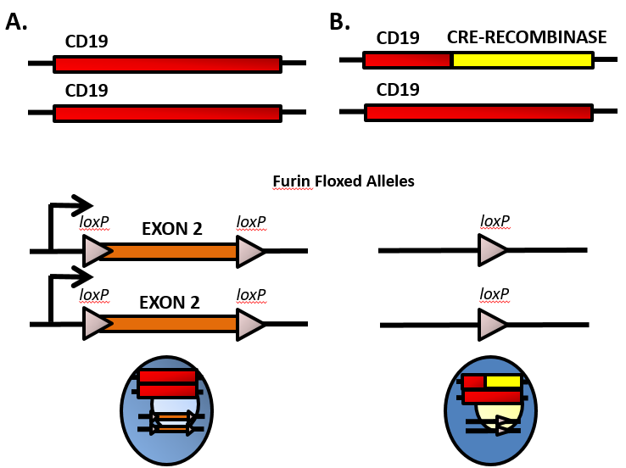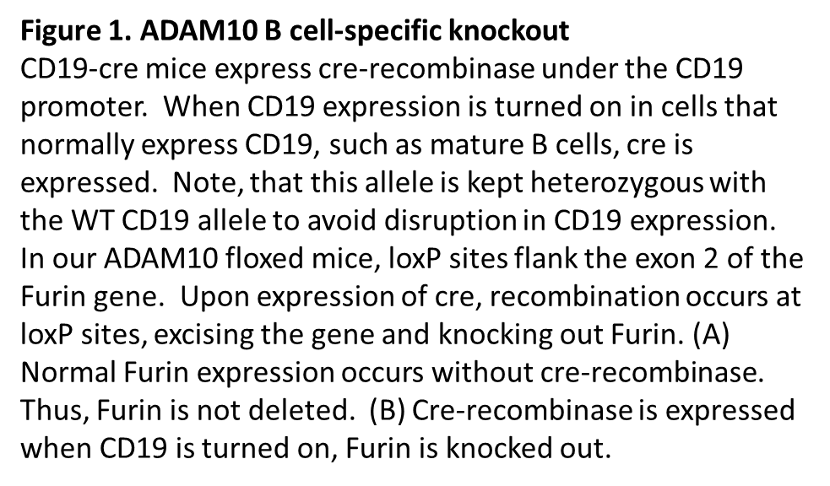
First, I will procure mice that have exon 2 of the furin gene flanked with lox-p(locus of crossing([x-ing]-over)of bacteriophage P1) sites (fur^{fl/fl}) (Roebroek et al, 2004). These lox-p sites will facilitate a looping out and deletion of exon 2 of the DNA in cells that express the protein cre-recombinase(CD19-cre). The whole process begins with the cre gene, (cyclization recombination) which can recombine DNA when it locates specific loxP sequences. Each loxP site is 34 base pairs long and attract the cre-recombinase to recombine surrounding DNA. When cells that have loxP sites in their genome and express the cre gene, the DNA sequence between the 2 loxP sites is excised (Alfred Pechisker, 2004). The loxP sequence does not occur naturally in any known genome other than P1 phage, so the insertion of loxP sites in a DNA sequence allow for very specified manipulations (A Max Juchheim, 2015). Two loxP sites will be inserted on exon 2 of the furin gene through the CRISPR/Cas9 system utilizing sgRNAs to target exon 2 of the furin gene (Bishop et al., 2016). This will essentially delete furin from those cells(Roebroek et al., 2004). Germline deletion of furin is embryonically lethal and therefore cell-specific functionality of furin is still being examined. These mice have been bred to mice expressing T cell-expressing cre-recombinase (Pesu et al., 2008), but never B cell cre-recombinase. Cre-recombinase is essential for the recombination of DNA between the flanked lox-p sites. I propose to breed these mice to CD19-cre mice. CD19 is a transmembrane glycoprotein which is a biomarker for B cells and is critical for B cell signaling (Wang, Wei, & Liu, 2012). CD19 is also expressed at the earliest stages and throughout B cell development and differentiation (Rickert, Roes, & Rajewsky, 1997). In order to develop CD19-cre expression mice, a cre expression cassette will be inserted into the second exon of CD19 by homologous recombination in embryonic stem cells (Rickert et al., 1997). Homozygous mice are CD19-deficient, so heterozygous mice are phenotypically normal and can be used for specific deletion of floxed genes (“004126 - C.Cg-Cd19 Igh/J,” n.d.). CD19-cre mice express cre-recombinase when the CD19 promoter is turned on (expressing CD19), which is only in B cells. Once these mice are bred to homozygousity for fur^{fl/fl} and heterozygousity for CD19-cre, they will be fur^{Bcell-/-} mice. A PCR (polymerase chain reaction) will be run to verify that, the furin gene has been knocked out with primers obtained from Jackson Laboratories. The PCR will amplify any instances of the furin gene between the loxP sites to verify that mouse is homozygous for fur^{fl/fl} (“PCR Amplification,” n.d.). Lastly, a western blot will be performed on a secondary lymphoid organs to determine if the furin gene is being expressed (Mahmood & Yang, 2012).

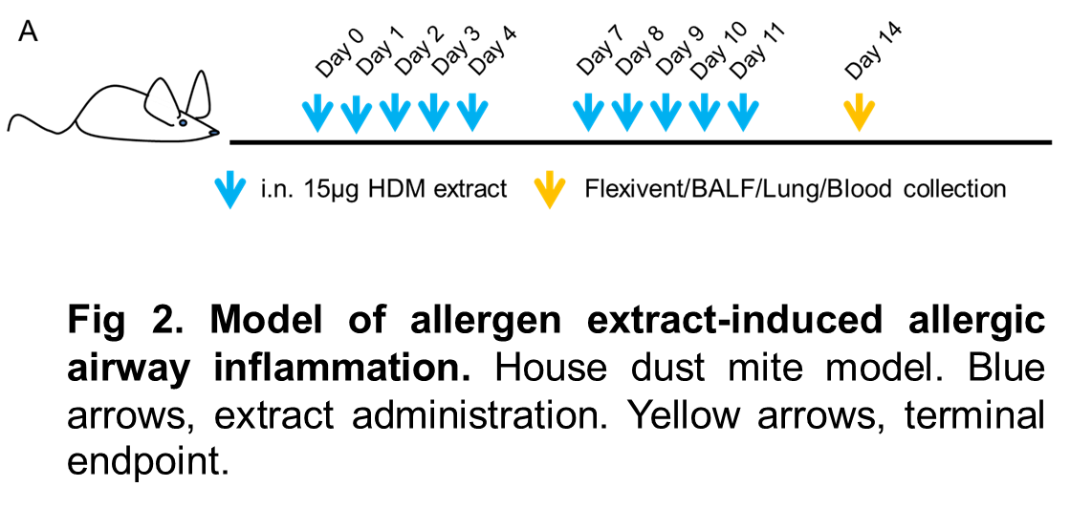
Next, I propose to test these mice in a mouse model of airway hyperresponsiveness (AHR). This is a mouse asthma model. To do this, first house dust mite (HDM) extract is intranasally administered daily for ten days with two, two day breaks (fig 2.) . These mice will be our experimental mice and will be exposed to the allergen for 10 days before the experiment is over. Then, mice are subjected to a Flexivent apparatus that measures the responsiveness of the airway to methacholine(“flexiVent | SCIREQ,” n.d.). Methacholine is a drug which is used to diagnose bronchial hyperreactivity, through the bronchial challenge test. The drugs introduction results in bronchoconstriction and if the mice display a pre-existing hyperreactive airway, such as asthma, a lower dose of the methacholine is needed to stimulate a response (“Methacholine,” 2010). I propose airway resistance will be examined at increasing doses of methacholine(2.5,5,10, 12.5,25, 50, and 100 mg/mL).This procedure can tell if the mice have developed restricted airways in the model or not, as compared to control mice that have not had furin deleted from B cells, as well as to saline controls. In previous studies, ADAM10 inhibition significantly alleviated airway hyperreactivity proposing that increased ADAM10 activity may be a predisposing factor to allergic disease(Cooley et al., 2015).
At the end of the 14-day experiment and the Flexivent procedure, lungs will be removed from the mice after euthanasia and histology will be performed to measure the cell infiltration (with hematoxylin and eosin staining) into airways and also the mucus production (with Periodic acid-Schiff) (“Why Pick PAS for Histology? - Bitesize Bio,” n.d.). Both of these are good indicators of asthma in mice and humans. In addition, spleens will be removed and ICOSL levels will be examined by flow cytometry on B cells and ICOS levels on T cells. This will support the mechanism.

Discussion
The hypothesized result is that inhibiting furin will lead to a less severe allergic response. Compelling evidence suggests that suppressing ADAM10 will alleviate airway hyperactivity. Though the effects of ADAM10 are well known, PC7 is also a large factor that comes into play when studying allergies. PC7 has been found to cleave the prodomain of enough ADAM10 without involvement of furin (Anders et al., 2001). With this in mind, the inhibition of furin may not have a large enough impact on ADAM10 to display the effects of asthma, though the studies may prove otherwise as the effects of furin inhibition have not been tested on ICOS/ICOL. Future experimentation with the inhibition of furin and PC7 may lead to interesting results.
The ICOS/ICOSL response will also be one of the main focuses for this experiment. Recent studies have shown that a deficiency of ICOS or ICOSL terminates T-dependent humoral immune responses. ADAM10 was found to be a relevant ICOSL sheddase and was found to increase ICOSL levels when not present in B cells. This also leads to an increase in B cell ICOSL levels which results in downregulation of T cell ICOS. Increased ICOSL leads us to enhanced T_{H}1 and T_{H}17 cell activation. Shedding of ICOSL is necessary for proper T cell responses (Joseph C Lownik et al., 2017). I hypothesize that the inhibition of furin will lead to a similar regulation of ICOSL if sufficient amounts of ADAM10 remain inactivated.
Furin is responsible for the activation of the zymogen ADAM10, though not all ADAMS contain the consensus sequence for activation by furin. ADAM8 has recently been associated with allergic airway inflammation. ADAM8 contains a non-perfect consensus cleavage sequence for furin, so even in high concentrations, furin inhibitors did not inhibit processing of ADAM8. ADAM8 levels have been found to be increased in airway inflammatory cells in mice and human asthma patients (Knolle & Owen, 2009). Although furin inhibition may lead to a decrease in ADAM10, ADAM8 is still a confounding variable that may have an unforeseen effect on inflammation.

References
004126 - C.Cg-Cd19 Igh/J. (n.d.). Retrieved December 9, 2017, from https://www.jax.org/strain/004126
A Max Juchheim. (2015). Plasmids 101: Cre-lox. Retrieved from http://blog.addgene.org/plasmids-101-cre-lox
Alfred Pechisker. (n.d.). TARGETING YOUR DNA WITH THE CRE/LOX SYSTEM | SCQ. Retrieved December 9, 2017, from https://www.scq.ubc.ca/targeting-your-dna-with-the-crelox-system/
Anders, A., Gilbert, S., Garten, W., Postina, R., & Fahrenholz, F. (2001). Regulation of the alpha-secretase ADAM10 by its prodomain and proprotein convertases. FASEB Journal : Official Publication of the Federation of American Societies for Experimental Biology, 15(10), 1837–9. Retrieved from http://www.ncbi.nlm.nih.gov/pubmed/11481247
Asthma Statistics | AAAAI. (n.d.). Retrieved October 22, 2017, from http://www.aaaai.org/about-aaaai/newsroom/asthma-statistics
Bishop, K. A., Harrington, A., Kouranova, E., Weinstein, E. J., Rosen, C. J., Cui, X., & Liaw, L. (2016). CRISPR/Cas9-Mediated Insertion of loxP Sites in the Mouse Dock7 Gene Provides an Effective Alternative to Use of Targeted Embryonic Stem Cells. G3 (Bethesda, Md.), 6(7), 2051–61. https://doi.org/10.1534/g3.116.030601
Chaimowitz, N. S., Martin, R. K., Cichy, J., Gibb, D. R., Patil, P., Kang, D.-J., … Conrad, D. H. (2011). A disintegrin and metalloproteinase 10 regulates antibody production and maintenance of lymphoid architecture. Journal of Immunology (Baltimore, Md. : 1950), 187(10), 5114–22. https://doi.org/10.4049/jimmunol.1102172
Cooley, L. F., Martin, R. K., Zellner, H. B., Irani, A.-M., Uram-Tuculescu, C., El Shikh, M. E., & Conrad, D. H. (2015). Increased B Cell ADAM10 in Allergic Patients and Th2 Prone Mice. PloS One, 10(5), e0124331. https://doi.org/10.1371/journal.pone.0124331
flexiVent | SCIREQ. (n.d.). Retrieved November 23, 2017, from http://www.scireq.com/flexivent
How Is Asthma Treated and Controlled? - NHLBI, NIH. (n.d.). Retrieved November 22, 2017, from https://www.nhlbi.nih.gov/health/health-topics/topics/asthma/treatment
Kim, M., Suh, J., Romano, D., Truong, M. H., Mullin, K., Hooli, B., … Tanzi, R. E. (2009). Potential late-onset Alzheimer’s disease-associated mutations in the ADAM10 gene attenuate {alpha}-secretase activity. Human Molecular Genetics, 18(20), 3987–96. https://doi.org/10.1093/hmg/ddp323
Knolle, M. D., & Owen, C. A. (2009). ADAM8: a new therapeutic target for asthma. Expert Opinion on Therapeutic Targets, 13(5), 523–40. https://doi.org/10.1517/14728220902889788
Lownik, J. C., Luker, A. J., Damle, S. R., Cooley, L. F., El Sayed, R., Hutloff, A., … Conrad, D. H. (2017). ADAM10-Mediated ICOS Ligand Shedding on B Cells Is Necessary for Proper T Cell ICOS Regulation and T Follicular Helper Responses. Journal of Immunology (Baltimore, Md. : 1950), 199(7), 2305–2315. https://doi.org/10.4049/jimmunol.1700833
Lownik, J. C., Luker, A., Martin, R., Damle, S., & Conrad, D. H. (2017). ADAM10 regulates the ICOS:ICOSL axis. The Journal of Immunology, 198(1 Supplement).
Mahmood, T., & Yang, P.-C. (2012). Western blot: technique, theory, and trouble shooting. North American Journal of Medical Sciences, 4(9), 429–34. https://doi.org/10.4103/1947-2714.100998
Methacholine. (2010). Retrieved from https://www.drugbank.ca/drugs/DB06709
Need help at the cell surface? Ask your local sheddase.: R&amp;D Systems. (n.d.). Retrieved December 8, 2017, from https://www.rndsystems.com/resources/articles/need-help-cell-surface-ask-your-local-sheddase
PCR Amplification. (n.d.). Retrieved December 9, 2017, from https://www.promega.com/resources/product-guides-and-selectors/protocols-and-applications-guide/pcr-amplification/
Pesu, M., Watford, W. T., Wei, L., Xu, L., Fuss, I., Strober, W., … O’Shea, J. J. (2008). T-cell-expressed proprotein convertase furin is essential for maintenance of peripheral immune tolerance. Nature, 455(7210), 246–250. https://doi.org/10.1038/nature07210
Rickert, R., Roes, J., & Rajewsky, K. (1997). B lymphocyte-specific, Cre-mediated mutagenesis in mice. Nucleic Acids Research, 25(6), 1317–1318. https://doi.org/10.1093/nar/25.6.1317
Roebroek, A. J. M., Taylor, N. A., Louagie, E., Pauli, I., Smeijers, L., Snellinx, A., … Creemers, J. W. M. (2004). Limited redundancy of the proprotein convertase furin in mouse liver. The Journal of Biological Chemistry, 279(51), 53442–50. https://doi.org/10.1074/jbc.M407152200
Seals, D. F., & Courtneidge, S. A. (2003). The ADAMs family of metalloproteases: multidomain proteins with multiple functions. Genes & Development, 17(1), 7–30. https://doi.org/10.1101/gad.1039703
Seidah, N. G. (2011). The Proprotein Convertases, 20 Years Later (pp. 23–57). https://doi.org/10.1007/978-1-61779-204-5_3
Turpeinen, H., Ortutay, Z., & Pesu, M. (2013). Genetics of the first seven proprotein convertase enzymes in health and disease. Current Genomics, 14(7), 453–67. https://doi.org/10.2174/1389202911314050010
Van Wart, H. E., & Birkedal-Hansen, H. (1990). The cysteine switch: a principle of regulation of metalloproteinase activity with potential applicability to the entire matrix metalloproteinase gene family. Proceedings of the National Academy of Sciences of the United States of America, 87(14), 5578–82. Retrieved from http://www.ncbi.nlm.nih.gov/pubmed/2164689
Wang, K., Wei, G., & Liu, D. (2012). CD19: a biomarker for B cell development, lymphoma diagnosis and therapy. Experimental Hematology & Oncology, 1(1), 36. https://doi.org/10.1186/2162-3619-1-36
Why Pick PAS for Histology? - Bitesize Bio. (n.d.). Retrieved November 25, 2017, from https://bitesizebio.com/13413/why-pick-pas-for-histology/
Woodfolk, J. A. (2007). T-cell responses to allergens. Journal of Allergy and Clinical Immunology, 119(2), 280–294. https://doi.org/10.1016/j.jaci.2006.11.008
Zhang, L., Prietsch, S. O., & Ducharme, F. M. (2014). Inhaled corticosteroids in children with persistent asthma: effects on growth. In L. Zhang (Ed.), Cochrane Database of Systematic Reviews. Chichester, UK: John Wiley & Sons, Ltd. https://doi.org/10.1002/14651858.CD009471.pub2

