Measurement of Protein Aggregation Levels in Mutant scs2 gene of Yeast to Determine whether the Ubiquitination Proteasome System of the Unfolded Protein Response can be Inhibited

I. Introduction

Amyotrophic lateral sclerosis (ALS) is a progressive neurodegenerative disease that affects both upper and lower motor neurons. The gradual degeneration/death of motor neurons is the main cause of ALS. Motor neurons are a specific type of nerve cell which is associated with voluntary movement. This includes anything from walking to talking and chewing. They are located in the brain and they go from the spinal cord to the muscles in the body. The primary function of the motor neurons are to provide pathways for communication between the brain and the voluntary muscles of the body.^{[1][2]}

ALS patients typically develop muscle weakness as well as paralysis. The muscle weakness or paralysis can be in either the limbs (limb onset) or in the bulbar muscles (bulbar onset). The limb onset of ALS is more prevalent with 80% of cases having upper or lower limb symptoms. Patients with the bulbar onset of ALS have symptoms more along the lines of dysarthria and dysphagia (slurred or slow speech and difficulty swallowing), though limb symptoms may also occur during the course of the disease. The onset of the disease is typically around 55 years of age and progresses at a quick rate. The average life span of a patient diagnosed with ALS is around 3-5 years after the onset, though there are cases where the disease progresses at a somewhat slower rate.^{[1]} According to the NIH, the disease occurs in 2 to 5 per 100,000 individuals worldwide (Fig 2).^{[2]}
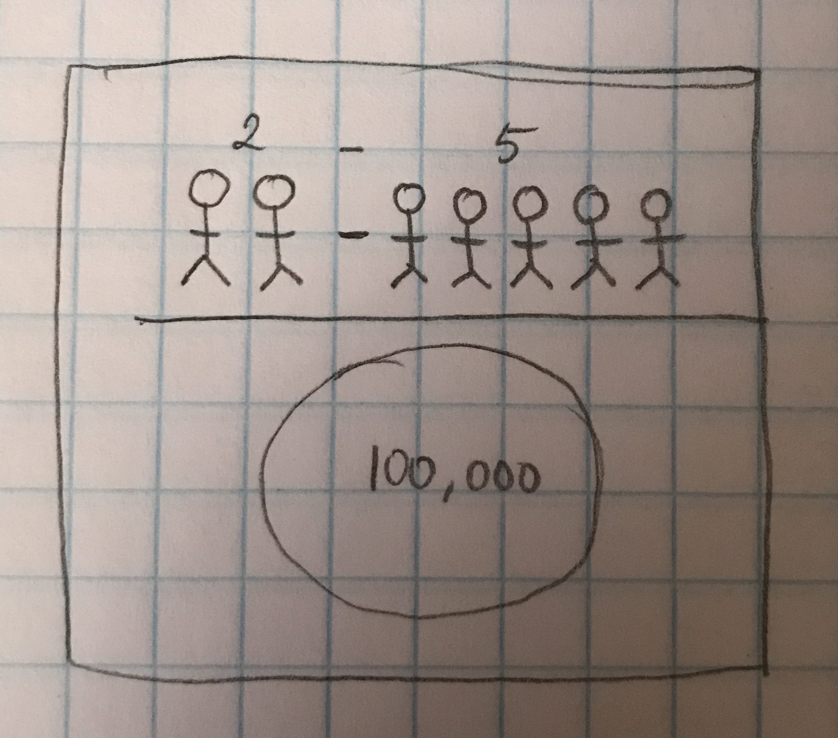
Figure 2. ALS occurs in 2 to 5 people per 100,00 people worldwide

ALS has two forms of genetic onset. The first type is called sporadic ALS (sALS) and has about 90% of all cases, making it the most common type. Sporadic ALS means that the onset is caused by a random mutation in the proteins associated with the motor neurons and there is no hereditary background of ALS in the affected person. The second type is called familial (fALS) and has about 10% of all cases. Familial ALS means that the onset is due to it being hereditary with one of the parents being a carrier of the mutant gene causing the disease.^{[1]}

Each fALS case is caused by a mutation in a different gene. Many fALS cases are due to mutations in the SOD1 (20%), C90RF72 (30%), and TARDB and FUS (4-5%) genes. There are, however, a number of cases associated with mutations in other genes such as the vesicle associated membrane protein associated protein B (VAPB).^{[1][3]} The VAPB protein is an integral membrane protein located in the endoplasmic reticulum (ER). It has many functions including protein folding, lipid transport, vesicle movement between cells, as well as the unfolded protein response (UPR) which detects the unfolded/misfolded proteins, degrades the misfolded proteins^{[3]} via the ubiquitination proteasome system (UPS)^{[11]}, and attempts to correct the proteins by increasing the production of molecular chaperones which are involved in protein folding.^{[3]}
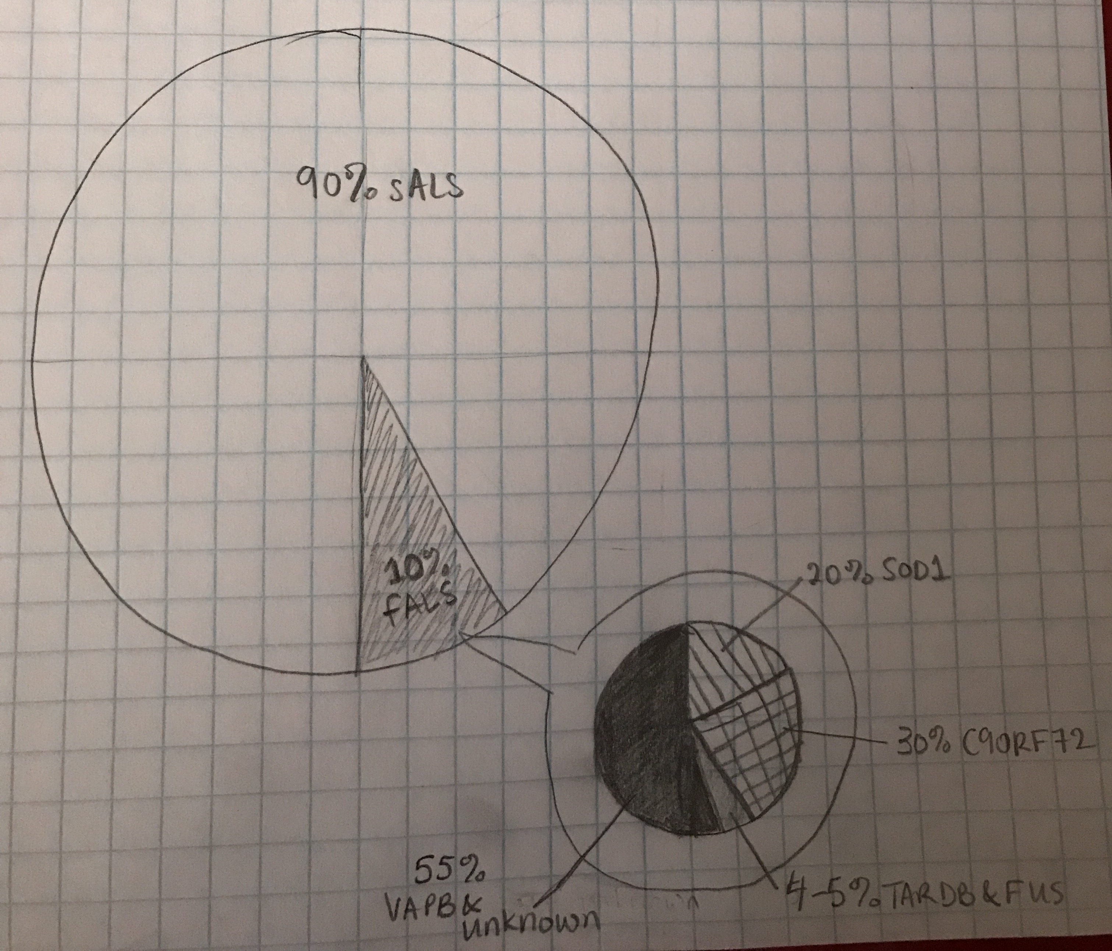
Figure 3. Percentage of sALS vs fALS and percentage of fALS caused by most prominent mutations

The fALS caused by mutations in the VAPB protein is called ALS8 and was first found in a large Brazilian family with many members, both male and female, affected across four generations.^{[1][4]} The mutation found in the VAPB gene showed that an amino acid called proline was being replaced by another amino acid called serine at the codon number 56.^{[1][4]} This mutation caused an increase in the number of unfolded or misfolded proteins in the ER and caused an aggregation of protein to form. The aggregation of proteins is a common sign in neurodegenerative diseases. The aggregation, under normal circumstances, would be taken care of by the UPR and UPS systems. This would use the UPS to degrade misfolded proteins and increase molecular chaperone proteins that would fold the unfolded proteins via the UPR system. In the mutated form, the aggregates are not removed or fixed and continue to accumulate. Theoretically, this accumulation of the aggregates would interfere with the UPS of the UPR system and ultimately cause the motor neurons degeneration^{[1]}. The Qiu et al (2012) experiment showed that an increase the amount of protein aggregation did not interfere with the overall function of the UPR/UPS system. This was specifically in the P56S mutation of VAPB^{[1]}.

In humans and other animals, the VAPB protein and its function is conserved. Another organism that carries a protein that functions in a similar way to VAPB is yeast. Yeast carries a homologue of VAPB called scs2. Scs2 function the same way as VAPB does in mammals and mutation in this gene produces the same results as mutation in the VAPB gene^{[7]}. Forcing mutations in scs2 would create a new library of possible mutations within that gene. The purpose of the experiment described in this proposal would be to test whether one of the mutations from the library of forced mutations would produce protein aggregates that would interfere with the UPS of the UPR system and would ultimately cause aggregate accumulation leading to ALS8.

II. Experiment

The experiment’s purpose is to determine the level of protein aggregation that would cause the onset of ALS8 via interference of the UPS of the UPR system in the mutant scs2 gene and to compare this to the amount of protein aggregation that would normally occur in the original gene of scs2. If the level of protein aggregation was higher than the normal level present in the original scs2 gene, then I would expect there to be an interference in the UPS of the UPR system, signifying the onset of ALS8.

II.A Creating Scs2 Mutants

In order to determine the levels of protein aggregation in the mutant scs2 strands, mutant scs2 strands need to be created. The mutations of the scs2 gene will be site-directed mutagenesis. Polymerase chain reaction (PCR) is the traditional method to create mutants via site-directed mutagenesis (Fig). PCR will allow me to create a library of possible scs2 mutants to use in the measuring of the protein aggregates.^{[15]}
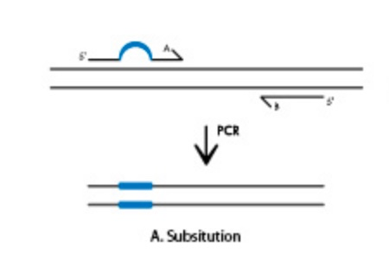
Figure 4. Depiction of Site-Directed Mutagenesis that is created by Polymerase Chain Reaction (PCR)

II.B Measuring the Protein Aggregation

In the experiment done by Qiu et al (2012), transgenic mice VAPB were used in the process of measuring the protein aggregation levels. They also tagged the mutated VAPB with a 3xFLAG-tag at the N-terminus in order to differentiate between the two VAPB proteins. They then determined the VAPB aggregation levels of each using Western blot. While there are other ways to determine protein aggregation levels, using Western blot allowed them to see the amount of fluorescence formed by both the wild types and the mutants.^{[1]}

In my experiment, however, I am using the yeast homologue of VAPB called scs2. This means that I will be using a slightly different measuring tool called Fluorescent dye ProteoStat (simply known as ProteoStat) in order to measure the level of aggregated proteins within each mutated scs2 gene. ProteoStat allows for a homogenous assay to monitor the aggregation of proteins within a solution and is related to more traditional techniques such as Thioflavin T (ThT), another fluorescent dye which attaches itself into the crevices of beta sheets and displays fluorescence to depict the aggregation of protein. The ProteoStat technique is able to detect a much broader range of protein aggregates, has a brighter signal, and can detect small concentrations of protein aggregates in a concentrated solution.^{[13]}

II.C Using the Newly Created Mutant scs2 and Measuring for Protein Aggregation

Mutant genes for scs2 will be created via site-directed mutagenesis through the use of PCR. These mutant genes will be placed in a solution in the ProteoStat tool and the aggregation level of the protein will be measured through the level of the fluorescent dye present. These levels will then be compared to levels of aggregation of the wild type protein to see whether an adequate amount of aggregation accumulation has developed. This will then help determine whether the onset of ALS8 would potentially occur.

III. Discussion

Assuming the experiment goes smoothly, the protein aggregation levels of the mutant scs2 gene strains will be higher than those of the original scs2 gene. This would confirm that an interference has occurred and the UPS of the UPR is not properly degrading the proteins that are accumulating. Using these results, I could potentially state that due to the interference of the protein aggregates in the UPS of the UPR system of the mutant scs2 gene, the onset of ALS8 would occur.^{[1]} This conclusion, however, may not be possible due to the fact that scs2 is a yeast homologue of the VAPB gene in humans. This means that I would never see how these mutations would affect the VAPB gene in humans as there are other factors that contribute to the development of motor neuron dysfunction or survival in ALS8 patients.

In their experiment, Qiu et al (2012) stated that the levels of protein aggregation in the P56S mutation of the VAPB gene were not enough to show that aggregation alone caused ALS8.^{[1]} The possibility of getting a better level of protein aggregation in these other mutations seems better as the technique yields higher fluorescence which would help detect the level of aggregation.^{[13]} Another part of this experiment for the future would be to test the P56S mutation once more with the ProteoStat technique and see whether the yield is higher to determine whether protein aggregation levels can determine the onset of ALS8.^{[1][13]}

References

1. Chen, S., Sayana, P., Zhang, X., & Le, W. (2013). Genetics of amyotrophic lateral sclerosis: an update. Retrieved from https://www.ncbi.nlm.nih.gov/pmc/articles/PMC3766231/
2. Amyotrophic lateral sclerosis - Genetics Home Reference. (2016). Retrieved from https://ghr.nlm.nih.gov/condition/amyotrophic-lateral-sclerosis#statistics
3. VAPB gene - Genetics Home Reference. (2016). Retrieved November, from https://ghr.nlm.nih.gov/gene/VAPB
4. Nishimura, Agnes L., et al. “A common founder for amyotrophic lateral sclerosis type 8 (ALS8) in the Brazilian population.” SpringerLink, Springer-Verlag, 27 Sept. 2005, https://link.springer.com/article/10.1007%2Fs00439-005-0031-y.
5. Suzuki, H, et al. “ALS-Linked P56S-VAPB, an aggregated loss-of-Function mutant of VAPB, predisposes motor neurons to ER stress-Related death by inducing aggregation of co-Expressed wild-Type VAPB.” Journal of neurochemistry., U.S. National Library of Medicine, Feb. 2009, www.ncbi.nlm.nih.gov/pubmed/19183264/.
6. Larroquette, F, et al. “Vapb/Amyotrophic lateral sclerosis 8 knock-in mice display slowly progressive motor behavior defects accompanying ER stress and autophagic response.” Human molecular genetics., U.S. National Library of Medicine, 15 Nov. 2015, www.ncbi.nlm.nih.gov/pubmed/26362257/.
7. “SCS2.” SCS2 | SGD, 2000, www.yeastgenome.org/locus/SCS2.
8. Blokhuis, Anna M., et al. “Protein aggregation in amyotrophic lateral sclerosis.” Acta Neuropathologica, Springer-Verlag, June 2013, www.ncbi.nlm.nih.gov/pmc/articles/PMC3661910/.
9. Gregoire, Simpson, et al. “Techniques for Monitoring Protein Misfolding and Aggregation in Vitro and in Living Cells.” The Korean journal of chemical engineering, U.S. National Library of Medicine, June 2012, www.ncbi.nlm.nih.gov/pmc/articles/PMC3615250/.
10. Qiu, Linghua, et al. “Widespread aggregation of mutant VAPB associated with ALS does not cause motor neuron degeneration or modulate mutant SOD1 aggregation and toxicity in mice.” Molecular Neurodegeneration, BioMed Central, 2013, www.ncbi.nlm.nih.gov/pmc/articles/PMC3538568/.
11. Ding, Wen-Xing, et al. “Linking of Autophagy to Ubiquitin-Proteasome System Is Important for the Regulation of Endoplasmic Reticulum Stress and Cell Viability.” The American Journal of Pathology, American Society for Investigative Pathology, Aug. 2007, www.ncbi.nlm.nih.gov/pmc/articles/PMC1934546/.
12. Genevini, Paola, et al. “Amyotrophic Lateral Sclerosis-Linked Mutant VAPB Inclusions Do Not Interfere with Protein Degradation Pathways or Intracellular Transport in a Cultured Cell Model.” PLoS ONE, Public Library of Science, 2014, www.ncbi.nlm.nih.gov/pmc/articles/PMC4237408/.
13. “PROTEOSTAT® Protein aggregation assay.” PROTEOSTAT® Protein aggregation assay - ENZ-51023 - Enzo Life Sciences, 14 Nov. 2016, www.enzolifesciences.com/ENZ-51023/proteostat-protein-aggregation-assay/.
14. Yang, Bin, et al. “Widespread aggregation of mutant VAPB associated with ALS does not cause motor neuron degeneration or modulate mutant SOD1 aggregation and toxicity in mice.” Molecular Neurodegeneration, BioMed Central, 3 Jan. 2013, https://molecularneurodegeneration.biomedcentral.com/articles/10.1186/1750-1326-8-1.
15. Sabel, Jaime, and Nicola Brookman-Amissah. “Integrated DNA Technologies.” Methods for site-Directed mutagenesis, IDT, www.idtdna.com/pages/decoded/decoded-articles/core-concepts/decoded/2012/01/10/methods-for-site-directed-mutagenesis.

