Mouni Talari
BNFO300
Research Proposal Draft
26 November 2017

- Introduction
Psoriasis is a chronic autoimmune inflammatory disease that affects approximately 8 million people in the United States and more than 100 million people worldwide. It is a fairly common skin condition during which skin cells are rapidly and prematurely replaced with new skin cells, causing buildup on the surface of the epidermis. This buildup of new skin cells forms scale-like rashes that cause irritation, itching, and pain. Symptoms of psoriasis include red patches of skin covered in thick, silvery or yellow colored scales, dry and cracked skin with intermittent bleeding. The areas of affected epidermis can often have sensations of itching, burning, or soreness. Psoriasis can also affect nails, causing them to become very thick, pitted, and ridged. Stiff, swollen joints are another symptom of psoriasis.
There are multiple forms of psoriasis. Plaque psoriasis is the most common form and affects anywhere from 85-90% of people with psoriasis. This type of psoriasis is normally exhibited by raised regions of aggravated and inflamed skin covered with silver, white, or yellow “scales”, or flakes of skin. These raised areas are known as plaques and are most regularly found on the elbows, knees, scalp, and backs of affected individuals. When this form of psoriasis goes untreated, it can turn into psoriatic erythroderma, which is another type of psoriasis with increased severity. Psoriatic erythroderma involves extremely widespread inflammation and peeling or scaling of the skin. This type of psoriasis can cause severe burning, itching, swelling, and pain. Psoriatic erythroderma can also occur as a result of withdrawal from systemic glucocorticoids, which are a type of systemic steroid hormones. Topical steroid creams which are used to treat psoriasis, such as corticosteroids, can also cause withdrawal symptoms and result in the development of psoriatic erythroderma. This form of psoriasis can be very fatal, since the extreme irritation and peeling of the skin can disturb the body’s capacity to control temperature and perform barrier function.
The causes of psoriasis are still not completely understood, but can be attributed to a faulty immune system. The human body produces T cells which travel throughout the body in order to identify and attack foreign substances such as viruses and bacterial infections. In psoriasis-inflicted individuals, these T-cells unfortunately fail to recognize that cells are healthy, and decide to attack them instead. This in turn causes the production of more healthy cells, which form layers on top of the already existing, healthy cells. These overactive T cells, which suspect an infection or foreign body when one does not exist, can also cause the production of even more T cells as well as neutrophils, which are a type of white blood cell, to help protect the body against this supposed “infection”. As a result, these excess T cells and neutrophils cause a further, rapid increase in new skin cells, as well as redness and pus formation. T cells and neutrophils travel throughout the blood vessels, causing them to expand, which results in warmth and redness to the psoriatic skin lesions. This entire process becomes a positive feedback cycle, which does not cease until proper treatment is provided. In addition to T cell irregularities, psoriasis can also be hereditary; roughly 33% of people afflicted by psoriasis report a family history of the disease as well. Research has also shown that environmental activations of certain mutations in genes, such as the CARD14 gene, can result in some forms of psoriasis. CARD14 mutations can result in plaque psoriasis. Moreover, recent research has revealed that there are nine different loci on chromosomes which are associated with psoriasis, known as PSORS1 through PSORS9. Variations and mutations of these genes are commonly found in patients that show symptoms of psoriasis. There are also immune system genes such as interleukin-12, which are involved in T cell differentiation. This interleukin producing genes is currently the most widely researched for preventative psoriasis treatments.
There are multiple forms of post-diagnostic treatments for psoriasis. The most common treatment is the use of topical corticosteroids. These corticosteroids reduce inflammation and lessen any burning, itching, or soreness associated with psoriatic lesions. There are two downfalls to this type of post-diagnostic treatment. The first is that it can only be used to treat mild to moderate forms of psoriasis, and the second being that it can cause thinning of the epidermis with long term use. Recent studies have also shown that the body can also build up a resistance to topical corticosteroids over time. Other post-diagnostic treatments such as Vitamin D analogues and the medication Anthralin can help slow skin cell growth. Anthralin can even remove the “scales” and make the epidermis much smoother. However, both vitamin D analogues and anthralin can cause skin irritation as a side effect and are typically only used for mild to moderate psoriasis. Another form of treatment is the usage of calcineurin inhibitors, such as Prograf or Elidel, which reduce inflammation and Plaque buildup, but can potentially cause an increased risk of skin cancer and lymphoma. These medications can also only be used in small amounts in very small areas, such as around the eyes. Phototherapy (light therapy) uses natural or artificial UV light to treat mild to moderate forms of psoriasis. However, exposing the skin to ultraviolet radiation can cause long term skin cancer as well as short term side effects such as redness, itching, and even more dry skin. Lastly, certain drugs known as biologics, such as Humira, Enbrel, and Stelara, can alter the immune system, treating moderate to severe psoriasis. However, these drugs must be used with caution since they can have strong and often deleterious side effects on the immune system, making users prone to infections.
Most treatments of this currently incurable disease that are utilized today are post-diagnosed, as aforementioned. While there is past, current, and ongoing research that emphasizes post-diagnostic treatments, research that focuses on preventative measures for psoriasis is severely lacking. Only recently has research started concentrating on preventative measures such as gene therapy, which can result in a possible cure for this “incurable”, chronic disease.
Ceramides have been the focus of some recent research regarding cancer therapies, but can also provide promising correlations and possible treatments for psoriasis. Ceramides are lipids that consist of a sphingosine and a fatty acid that varies in length. Their functions include various forms of cell signaling that include but are not limited to differentiation, proliferation, and programmed cell death/apoptosis. One of the most studied functions of ceramide molecules is its function as a proapoptotic molecule, which can be pertinent for its potential as a possible chemotherapeutic agent. However, ceramide also composes 50% of the stratum corneum layer of the epidermis in human skin cells. It helps with the barrier function of the human skin, and helps with water impermeability. Ceramides also act as a protective layer against the epidermis to prevent excessive water loss due to evaporation. They can also prevent the entry of microorganisms such as bacteria that can cause infections. Mammalian ceramides are synthesized by 6 known ceramide synthases (labeled CerS1 through Cers6). Of these 6 ceramides synthases, CerS3 (also referred to as longevity assurance homologue 3), synthesizes ceramides that have carbon chains longer than 24 carbons. These ceramides are found mainly in the skin and the testis, and are known to help maintain the barrier qualities of the skin. They are found most extensively in keratinocytes, and their prominence increases during keratinocyte differentiation. The chart below shows the different ceramide synthases, the chromosome location on which their coding gene is found, the gene size, protein size, and the tissues in which they are most prevalent. CerS3’s encoding gene is found on chromosome 15. CerS3 is mostly found encoded by mRNA found in the testis and skin.
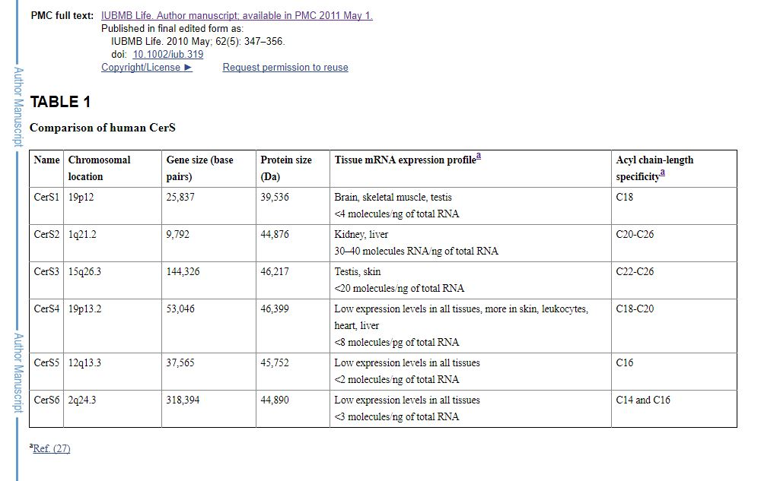
Although there is copious evidence compiled over the past few years that suggests that psoriasis is mainly due to T-cell malfunction, recent studies have endorsed that pathogenesis of the disease may be influenced by the interruption of ceramide synthases. Interferon-gamma (INFγ) is a cytokine, which is a cell signaling protein produced by immune cells. The synthesis of this cytokine helps the mammalian immune system adapt and recognize viral and bacterial infections. A proper maintenance of INFγ homeostasis is needed in the body’s immune system, as downregulated or upregulated INFG genes (which code for INFγ) can cause either hypoactive or hyperactive autoimmune disorders. A study by Chisato et al revealed that increased levels of IFNγ have resulted in decreased levels of ceramide synthases, causing disorders such as atopic dermatitis and psoriatic skin lesions in cultured human keratinocytes. This study also determined that the specific ceramide synthase involved in psoriasis and atopic dermatitis (AD) was CerS3. Moreover, the specific ceramides which were found to have decreased levels in psoriasis were the C45-C48 ceramides (shown in graph (i) in the figure below). The experiment examined levels of healthy human keratinocytes (control), and compared certain ceramide levels in the control to ceramide levels in human keratinocytes affected by psoriasis and AD. Graph (i) shows that there is a significant decrease in the amount of the C45-C48 ceramides in psoriasis, indicating that there is a correlation between a decrease in these levels and the disease.
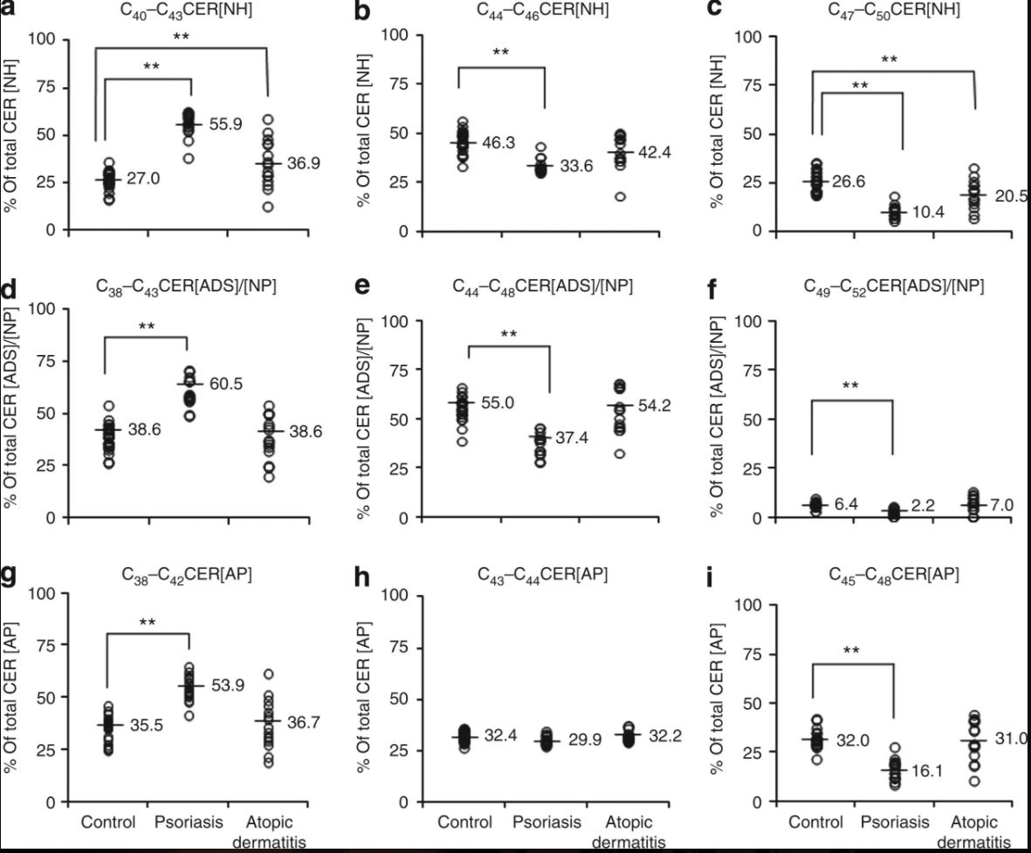
This study concludes that increased expression of the ING gene causes increased levels of IFNγ. When IFNγ was exposed to human keratinocytes, the expression levels of CerS3 decreased by 52%. The reduction of CerS3 levels result in a decrease of long chain ceramides, and low levels of these long chain ceramides was found in keratinocytes affected by psoriasis.
With this sequential logic, it can be understood that increasing IFNγ decreases long chain ceramides, particularly ceramide48, 49, and 50. It would be useful to investigate whether or not the downregulation of the IFNγ encoding gene IFNG could result in an increase to normal ceramide production levels. However, due to the sensitive homeostatic nature of functional IFNγ cytokine production, it may be more suitable to attempt to increase levels of CerS3, thereby increasing levels of long chain ceramides despite having overexpressed IFNG. The increase of these long chain ceramides could potentially help improve or prevent psoriatic pathogenesis, since the decrease or absence of these ceramides was found in psoriatic keratinocytes.
- Experiment
The following table shows how different stimuli change the expression of CerS3 in
various cell tissues. IFNγ is shown to decrease CerS3 expression in normal human epidermal keratinocytes (NHEK), as previously determined. Sphingoid bases and dietary sphingolipids increased CerS3 expression in normal human foreskin keratinocytes (NFEK) and hairless skin damaged mouse models respectively. The combination of L-165,041, trogalitazone and TO901317 also upregulated the expression of CerS3 in NHEK.
The aim of this experiment would be to determine whether or not certain stimuli will help increase expression of CerS3, thereby increasing production of long chain ceramides in order to prevent, treat, or lessen the effects of psoriasis. The goal of this experiment is to also determine which stimuli (Sphingoid bases, dietary sphingolipids, or the L-165,041-trogalitazone-TO901317 combination) produces the most effective results in terms of increasing desired ceramide production, as well as lessening the symptoms of psoriasis.
In the study by Mizutani et al, treatment of keratinocytes with an activator for PPARβ/δ, PPARγ, or LXR strongly induced the expression of CerS3 mRNAs. However, these results were dose dependent. Normal human epidermal keratinocytes isolated from neonatal skin were grown in a growth medium and differentiated. These keratinocytes were treated with selective transcriptional activators, such as PPARβ/δ and L-165,04, or PPARγ and troglitazone, or LXR and TO901317 (abbreviated as Pβ/δ/L, PγT, and LXRTO9). The RNA from these keratinocytes was cultured using a FastPure RNA kit. It was then converted to cDNA using a PrimeScript RT reagent kit, and then PCR was performed using specific gene primers for CERS3. siRNAs for human CerS3 and PPARβ/δ and control siRNA were applied to the appropriate keratinocytes, and knockdown of the target gene was evaluated by using real-time quantitative PCR. Elongation assays were performed, followed by in situ hybridization. Total cell lysates prepared from keratinocytes were then subjected to SDS-Page and transferred to PVDF membranes, followed by reactions with anti-CerS3, which were then labeled and detecting by using ECL Western Blotting.
The experiment revealed that the mRNA expression for CerS3 was rapidly induced following exposure to the PPAR γ as well as the PPARβ/δ activators. However, this was dose and time dependent, as can be seen in the following figure (graphs a and b only).
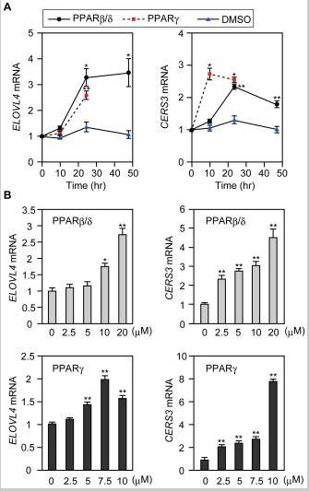
For both activators, expression levels of the CerS3 mRNA reached peak levels 24 hours after application. It is important to note that the effective dosage for PPARβ/δ was lower than the effective dosage for PPAR-gamma. The LXR activator also stimulated CerS3, but not nearly as much as the other two activators.
- Discussion
The results from the previous experiment suggest that PPAR-gamma is a potential activator that can upregulate CerS3 expression, increasing ultra long chain (ULC) ceramide levels. This could hopefully enable ceramides 48,49, and 50 to be produced. The effects of the increase in production of these ceramides can possibly provide a treatment to psoriatic pathogenesis or symptoms.
Various other experimentations should also be conducted using dietary sphingolipids and sphingoid bases in order to determine which of the three methods increase the production of the necessary ceramides to decrease the effects or pathogenesis of psoriasis. The implementation of upregulators of CerS3 can potentially be used in mouse embryos that contain mutations in the INFG gene with increased INF-gamma production. Theoretically, this could prevent mice from developing psoriasis all together. The implementation of these upregulators can also be observed in mice with existing psoriatic disease in order to determine whether or not increasing long chain ceramide production will lessen the effects of psoriasis.
One major limitation of the experiment is that CerS3 has significant involvement in the testes for sperm formation and androgen production. CerS3 gene expression is highly upregulated during testicular maturation, in the same way it is highly regulated in keratinocyte differentiation. Increasing the expression of CerS3 could potentially bring about changes in juvenile testicular maturation, though these effects have not yet been researched. Therefore, it may be useful to compare the effects of CerS3 upregulation in male versus female mice to investigate if the increased gene expression causes deleterious effects in males.

- References
  - Gordon, K. B., Feldman, S. R., Koo, J. Y., Menter, A., Rolstad, T., & Krueger, G. (2005). Definitions of Measures of Effect Duration for Psoriasis Treatments. Archives of Dermatology, 141(1). doi:10.1001/archderm.141.1.82
  - Krueger, G. G., Feldman, S. R., Camisa, C., Duvic, M., Elder, J. T., Gottlieb, A. B., . . . Day, R. M. (2000). Two considerations for patients with psoriasis and their clinicians:. Journal of the American Academy of Dermatology, 43(2), 281-285. doi:10.1067/mjd.2000.106374
  - Motta, S. (1994). Abnormality of water barrier function in psoriasis. Role of ceramide fractions. Archives of Dermatology, 130(4), 452-456. doi:10.1001/archderm.130.4.452
  - Levy M, Futerman AH. Mammalian ceramide synthases. IUBMB life. 2010. 62:347–356. doi: 10.1002/iub.314.
  - M.S. Wegner, S. Schiffmann, M.J. Parnham, G. Geisslinger, S. Grosch. The enigma of ceramide synthase regulation in mammalian cells. Progress in Lipid Research, 63 (2016), pp. 93-119
  - Tawada, C., Kanoh, H., Nakamura, M., Mizutani, Y., Fujisawa, T., Banno, Y., & Seishima, M. (2014). Interferon-γ Decreases Ceramides with Long-Chain Fatty Acids: Possible Involvement in Atopic Dermatitis and Psoriasis. Journal of Investigative Dermatology, 134(3), 712-718. doi:10.1038/jid.2013.364
  - Garidel P, Fölting B, Schaller I, Kerth A (2010). "The microstructure of the stratum corneum lipid barrier: mid-infrared spectroscopic studies of hydrated ceramide:palmitic acid:cholesterol model systems". Biophysical Chemistry. 150 (1–3): 144–156. doi:10.1016/j.bpc.2010.03.008.
  - Feingold KR (2007). "Thematic review series: skin lipids. The role of epidermal lipids in cutaneous permeability barrier homeostasis". Journal of Lipid Research. 48 (12): 2531–2546. doi:10.1194/jlr.R700013-JLR200.
  - Duan, J., Sugawara, T., Hirose, M., Aida, K., Sakai, S., Fujii, A., & Hirata, T. (2012). Dietary sphingolipids improve skin barrier functions via the upregulation of ceramide synthases in the epidermis. Experimental Dermatology, 21(6), 448-452. doi:10.1111/j.1600-0625.2012.01501.x
  - Mizutani, Y., Sun, H., Ohno, Y., Sassa, T., Wakashima, T., Obara, M., . . . Igarashi, Y. (2013). Cooperative Synthesis of Ultra Long-Chain Fatty Acid and Ceramide during Keratinocyte Differentiation. PLoS ONE, 8(6). doi:10.1371/journal.pone.0067317
  - Rabionet M, van der Spoel AC, Chuang CC, von Tümpling-Radosta B, Litjens M, Bouwmeester D, Hellbusch CC, Körner C, Wiegandt H, Gorgas K, Platt FM, Gröne HJ, Sandhoff R (2008). "Male germ cells require polyenoic sphingolipids with complex glycosylation for completion of meiosis: a link to ceramide synthase-3". J. Biol. Chem. 283 (19): 13357–69. doi:10.1074/jbc.M800870200.

