Introduction
With increasing quantities of “superbugs” or bacteria that are resistant to more antibiotics, there is an increasing need for understanding the biological structure of them to find more efficacious treatment methods. Gram negative bacteria have an outer membrane that is an asymmetric bilayer with an inner leaflet composed of phospholipids and an outer leaflet composed of lipopolysaccharide(LPS). In Escherichia coli, the LPS has six fatty acyl chains with many more sugars attached. When there are divalent cations, LPS molecules band together to give a gel barrier for gram negative bacteria and provide the ability to survive in harsh climates and to not allow antibiotics into the cell (Freinkman 2011). In E. coli most of the outer membrane proteins have been found to generally have a beta barrel structure which could contribute to the structure. This protective property has been found to be a determinant of virulence for certain bacterial strains and thereby an important factor to consider for therapeutic interventions against bacteria (Polissi 2014).
Lipopolysaccharides are essential for bacterial growth by causing major alterations to the membrane and thereby affecting the membrane properties. LPS has three main structural domains: Lipid A, a core oligosaccharide, and a highly variable O-antigen. LPS is also a known potent activator of immune responses and endotoxins as an example of the modifications (Polissi 2014). The individual LPS components tend to be toxic to the cell in uncontrolled quantities. Too little or too much can induce apoptosis and tend to be regulated by LPS assembly pathway enzymes such as LpxC and LpxD (Wong 2010).
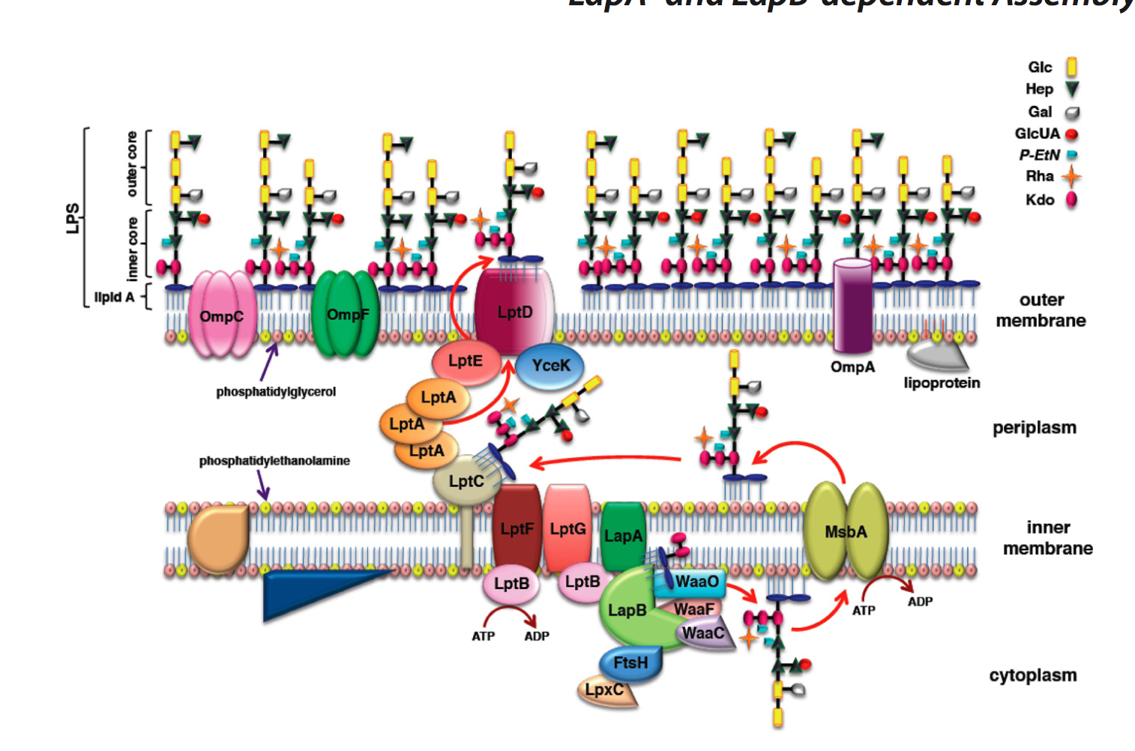
LPS assembly is the biogenesis pathway important for developing the outer membrane structure. LPS is synthesized from the inner membrane then transported through the periplasmic space to the outer membrane. This particular pathway is well characterized however not so much about how these large molecules are then transported across the periplasm to the cell surface (Freinkman 2011). The assembly process begins with Lipid A is a lipid precursor that is produced by the fatty acetylation of UDP-N-acetylglucosamine, a nucleotide and sugar, by the LpxA enzyme (Mahalakshmi 2014). In E. coli the biogenesis process proceeds from lipid A that has two residues of 3-deoxy-alpha-D-manno-oct-2-ulosonic acid (Kdo) attached. This ensures the conversion of the tetraacyclated lipid to a hexaacetylated lipid. All of the intermediate synthesis steps involved are required for the viability of bacteria. Additional sugars are then added to support the growth of E.coli while minimizing the structural complexity necessary (Klein 2014).
There are two accepted models that describe LPS transport or export pathways: (1) a chaperone-mediated transit across the periplasm as well as (2) transenvelope bridge model spanning both the inner membrane and outer membrane. There are three subdivisions to LPS transport (Lpt) machinery: LptBFGC, LptA, and LptDE. The first model indicates that LptA would carry the LPS from the LptBFGC section and diffuse across the periplasm while protecting any exposed hydrophobic sections of the LPS. Ultimately, the LPS would travel from the LptBFGC to the LptDE by assistance of LptA. The second model suggests that a bridge-like structure is formed by the combination of individual cellular structures between the inner and outer membrane. This transport machinery is similar to efflux pump structures in other parts of the bacteria (Polissi 2014). Both are important steps in understanding and characterization of the LPS pathways and relate to the proposed structure in Figure 1 above.
One component of this membrane pathway is Lipopolysaccharide Assembly Protein A (LapA), which is an inner membrane protein that is embedded into the inner membrane that provides a bridging aspect from constructed proteins to the outer membrane (Klein 2014). Mutations in this gene helped characterize the yciS and yciM gene, which were found to be a conserved nucleotide repeat involved in regulating lipid A biosynthesis. Mahalakshmi and colleagues (2014) found that in the absence of the yciM gene, there were increases in the enzyme LpxC and increases in LPS that ultimately lead to cell death due to the toxicity of the molecules. Modest increases in the yciM gene transcript significantly reduced LpxC and ultimately lead to reduced LPS quantities (Mahalakshmi 2014). Despite having some significant effects by mutation analysis for yciM and LapB, yciS and and LapA have not been well characterized. Understanding the molecular interactions through functional genomic analysis is therefore crucial to improve the characterization of the LPS assembly pathway. This proposal aims to determine the involved interactions and interaction sites with LapA and yciS relative the the suggest LPS assembly pathway. It is also being hypothesized that yciS is directly involved in LPS biogenesis by association with LapA as well and we expect to find multiple active sites involved between the inner and outer membrane relative mechanisms of the protein.

Experimental Approach
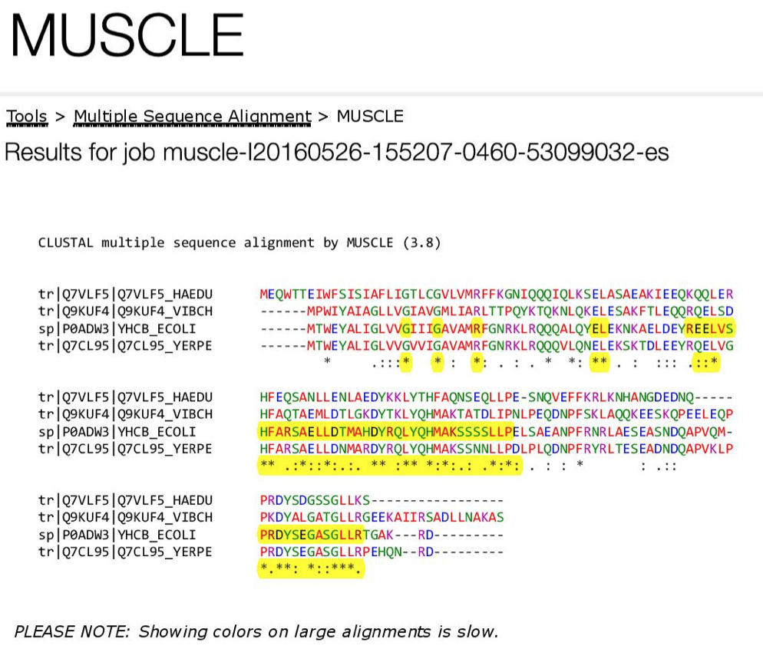
- Site Directed Mutagenesis
To map the interaction site(s) of yciS, mutants of yciS will be constructed. The gene sequence will be divided into different regions and specific residues will be mutated at each position. Using multiple sequence alignment, the mutations will be chosen and constructed as shown in figure to the right. Only the conserved residues of yciS will be mutated in a similar process as shown. The mutant DNA sequences encoding specific mutants will be synthesized as Geneart strings (ThermoFisher pvt Ltd.).

- Gateway Cloning
The geneart strings (as sequences) will be cloned into pDONR/Zeo plasmids using a BP clonase reaction of Gateway cloning (Invitrogen). The transformants with the desired sequences will be confirmed using sequencing of at least two different clones. The open reading frames (ORFs) will be further cloned into bacterial two hybrid (B2H) vectors. The desired proteins will be further cloned into another bacterial two hybrid vector. The ORFs for the desired bait and prey proteins will be cloned into the Gateway compatible B2H vectors using an LR reaction (Invitrogen) to transfer the ORFs into the destination vectors. The plasmids required will be prepared using the Macherey Nagel Nucleospin colum kit (Supplier). Further details on vectors and the exact protocol will be followed from Mehla et al. (2017).

- Co-Transformation
The bait and prey proteins will be co-transformed into the E.coli BTH101 strain and selected clones will be further screened for interactions against prey proteins. This protocol is the bacterial two screening as described by Mehla et al. (2017).

- Bacterial Two Hybrid Screening
The bacterial two hybrid screening protocol will be done as described previously by Mehla et al. (2017). The expression constructs or ORFs of the LapA protein from the co-transformation protocol will be screened on indicator plates for positive or negative interactions as indicated by a phenotypic reaction such as blue colonies on an LB-X-Gal media or red on a MacConkey-maltose media. A beta-galactosidase assay will also be used to screen for the mutants. This screening process will analyze the wild-type strain as a control, a negative control of non-transformed cells will also be analyzed, and a positive control of a known interaction will be used as well. The controls will determine if the proper transformants have been selected and characterized as well as for false positives or false negatives.

Discussion
The expected results would include images of the interaction assays which would indicate the direct interactions of LapA and provide insight into the associated mechanisms. Further comparison analysis with the known mutations will correspond to the interaction sites directly on the gene transcript. It is expected to find the involved amino acids and direct changes that correspond to the interaction sites being mapped. Other results would include the sequence of the verified plasmid clone with the LapA and mutant genes.
Some expected pitfalls include possible issues with the cloning vectors and properly getting the transformants of interest. This process is a bit tricky to pick out the correct clones due to the multiple clones involved in the reaction. This can be isolated through selection process by antibiotic resistance but can sometimes have false positives that do not contain the gene of interest. Troubleshooting may be required when using the co-transformed bacteria such as altering quantities of the entry vector to the destination vector depending on copy number of the vectors. Multiple samples will be required through multiple transformations to attain the mutants of interest however failed co-transformation can be detected earlier with sequencing analysis and alternate methods of plasmid isolation.
This study aims to determine the functionality of the LapA protein and yciS gene independently but may not be indicative of the function relative to the universal system. LapA possibly has multiple roles in the LPS assembly system and may not be detected through this isolated approach. A future analysis approach would be to observe the possible multiple roles in the LPS assembly process by isolated sectional analysis of the interaction proteins. Another alternative approach could be by multiple mutational analysis looking at if two mutated proteins that are known for interaction be involved simultaneously in the biogenesis pathway. Both methodologies could provide insight into the involvement of multiple proteins in the LPS assembly pathway by indicating interactions in vivo with respect to an LPS molecule.

References

Freinkman, E., Chng, S., & Kahne, D. (2011). The complex that inserts lipopolysaccharide into the bacterial outer membrane forms a two-protein plug-and-barrel. Preceedings of the National Academy of Sciences, 108(6), pp. 2486-2491. doi: 10.1073/pnas.1015617108

Frirdich, E., & Whitfield C. (2005). Lipopolysaccharide inner core oligosaccharide structure and outer membrane stability in human pathogens belonging to the Enterobacteriaceae. Journal of Endotoxin Research, 11(3), pp. 133-144. doi: 10.1179/096805105X46592

Gronow, S., & Brade, H. (2001). Lipopolysaccharide biosynthesis: which steps do bacteria need to survive?. Journal of Endotoxin Research, 7(1), pp. 3-22.

Klein, G., Kobylak, N., Lindner, B., Stupak, A., & Raina, S. (2014). Assembly of Lipopolysaccharide in Escherichia coli Requires the Essential LapB Heat Shock Protein. Journal of Biological Chemistry, 289(21), pp. 14829-14853. doi: 10.1074/jbc.M113.539494

Kotra, L.P., Golemi, D., Amro, N.A., Liu, G., Mobashery, S. (1999). Dynamics of Lipopolysaccharide Assembly on the Surface of Escherichia coli. Journal of American Chemical Society, 121(38), pp. 8707-8711. doi: 10.1021/ja991374z

Mahalakshmi, S., Sunayan, M.R., SaiSree, L., & Reddy, M. (2014). yciM is an essential gene required for regulation of lipopolysaccharide synthesis in Escherichia coli. Molecular Microbiology, 91(1), pp. 145-157. doi: 10.1111/mmi.12452

Missiakas, D., Betton, J.M., & Raina, S. (1996). New components of protein folding in extracytoplasmic compartments of Escherichia coli SurA, FkpA, and Skp/OmpH. Molecular Microbiology, 21(4), pp. 871-884. doi: 10.1046/j.1365-2958.1996.561412.x

Polissi, A., & Sperandeo, P. (2014). The Lipopolysaccharide Export Pathway in Escherichia coli: Structure, Organization and Regulated Assembly of the Lpt Machinery. Marine Drugs, 12, pp. 1023-1042. doi: 10.3390/md12021023

Raetz, C.R.H., & Whitfield, C. (2002). Lipopolysaccharide Endotoxins. Annual Review of Biochemistry, 71, pp. 635-700. doi: 10.1146/annurev.biochem.71.1106001.135414

Ruiz, N., Kahna, D., & Silhavy, T.J. (2009). Transport of lipopolysaccharide across the cell envelope: the long road of discovery. Nature Reviews Microbiology, 7(9), pp. 677-683. doi: 10.1038/nrmicro2184

Sampson, B.A., Misra, R., & Benson, S.A. (1989). Identification and Characterization of a New Gene of Escherichia Coli K-12 Involved in Outer Membrane Permeability. Genetics, 122(3), pp. 491-501.

