The Role of G_{αs} and G_{βγ} in Adenylyl Cyclase Super Activation
Following Chronic Opioid Exposure
- Introduction

For decades, opioids have been used in healthcare as the primary pain reliever for chronic or severely debilitating pain. From morphine to oxycodone to street drugs such as heroin and fentanyl, opioids are available in pills, liquids, and shots and are extremely widespread and accessible.
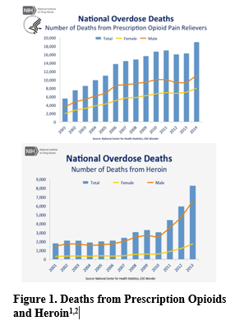
Drug overdose is now the leading cause of accidental death in the United States with over 50,000 drug overdose deaths in 2015, 32,000 of those relating to opioid overdose¹. As powerful and helpful opioids may be in a controlled healthcare setting, the risk of opioid abuse and dependency is relatively high compared to most drugs, with 23% of individuals using heroin once, forming an eventual opioid addiction.² The volume of total prescribed opioids has increased 600% from 1997 to 2007.³ Similarly, the prescribing rate for opioids among adolescents and young adults nearly doubled from 1994 to 2007.⁴
While the over prescribing of opioids in the medical field is a separate issue, when attempting to understand the opioid abuse epidemic in the United States today, the two main culprits causing routine and increased drug abuse is the tolerance and withdrawal effects that follow chronic opioid exposure. Opioid’s have a high tolerance, meaning that the dose required one day to provide analgesic effects will be much higher on the following days as the body becomes tolerant to the analgesic effects of opioids.⁵ Thus, those prescribed opioids feel the need to take more of their medication or seek medication through illegal avenues. Furthermore, when an individual ceases opioid use after chronic use, the withdrawal effects are severe and include vomiting, diarrhea, muscle aches and shaking, as well as suicidal ideations. These symptoms usually peak 2-3 days after the last dose, and usually take over a week to fully subside.⁶
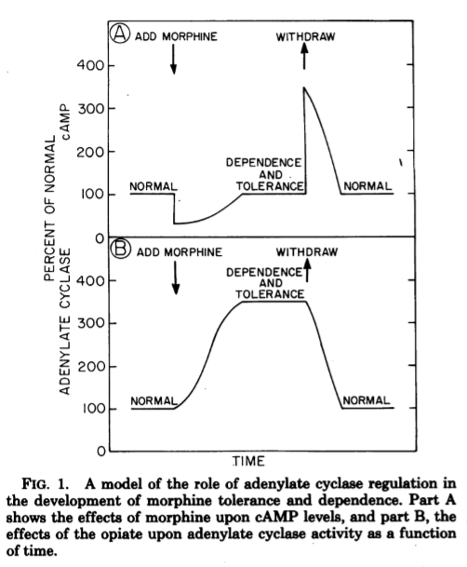
Combined together, opioid tolerance and withdrawal symptoms are powerful agents leading to opioid drug abuse, leading researchers to look at the molecular pathways that mediate opioid tolerance and withdrawal. One of the proposed major mechanisms of tolerance and withdrawal is the cAMP-protein kinase A (PKA) pathway. This mechanism for tolerance through the cAMP-PKA pathway was first suggested by Sharma et al. (1975). Sharma et al. hypothesized that the dependence and tolerance of opiates could be the result from an increase in adenylate cyclase or the continued presence of an adenylyl cyclase effector that inhibits cAMP production initially but with chronic opioid exposure, later leads to adenylate cyclase superactivation leading to cAMP overshoot following opioid withdrawal.⁷ This dependency and tolerance hypothesis came from the fact that is was known that Adenylate Cyclase converted ATP to cyclic AMP (cAMP), a secondary messenger molecule used to activate Protein Kinase A, which was responsible for activating a multitude of intracellular pathways that may be responsible for the creation of tolerance such as neurotransmitter release.^{5,7}
Figure 1⁷ from Sharma et al. outlines the hypothesized effect of opioid receptor binding on Adenylate Cyclase and cAMP levels that Sharma et al. set out to prove by exposing cell cultures to morphine and measuring cAMP levels. The results showed that the addition of morphine inhibited cAMP levels by more than 90% throughout a 4 hour incubation period. This explained the acute effects of morphine, but the study also looked at incubation that lasted 48 hours. The results showed that after chronic opioid exposure that the addicted cells had built a tolerance to the morphine in 48 hours that allowed adenylate cyclase to create enough cAMP to return to basal levels. When naloxone, an opioid antagonist, was added. cAMP greatly increased past the control levels, almost 500% greater, which suggested that the morphine still inhibits the adenylate cyclase activity but the inhibition is masked by a compensatory increase in the activity of adenylyl cyclase that returns cAMP levels to basal levels acutely and ultimately causes cAMP overshoot after chronic use.⁷ The overshoot of cAMP levels causes PKA pathways to lose their regulation and leads to the physiological withdrawal symptoms.
This idea was furthered by Avidor-Reiss et al. (1996) who found that opioid withdrawal and tolerance were attenuated by Gα₀ inhibition. Reiss et al. sought to find which Gα subunits including Gα₀, Gα_{i1}, Gα_{i2}, and Gαi_{3,} all of which are adenylyl cyclase inhibitors⁸, were involved in adenylyl cyclase super activation and found that only inhibition Gα₀ resulted in no adenylyl cyclase super activation and thus cAMP overshoot.⁸ Furthermore, Avidor-Reiss et al. (1996) suggested that super activation of adenylate cyclase may involve a secondary mechanism through G_{βγ} via a mechanism that remains to be determined.⁸
This proposal seeks to determine whether or not adenylate cyclase super activation is mediated through G_{βγ} stimulation of G_{αs}, which is the primary activator of adenylyl cyclase. The proposal also seeks to find if knockout of G_{αs} and G_{βγ} attenuate opioid withdrawal through lack of adenylate cyclase super activation and thus lack of cAMP overshoot.

- Experiment

The aim of this experiment is to determine if adenylate cyclase super activation is mediated through G_{βγ} stimulation of G_{αs} following chronic opioid use and if inhibition of the G_{βγ} can cause attenuation of tolerance by preventing adenylate super activation and thus cAMP overshoot upon opioid withdrawal.
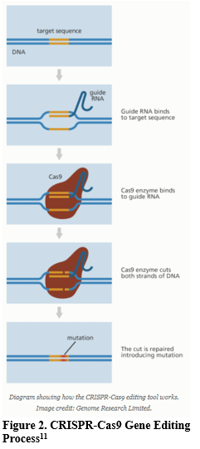
This will be accomplished by measuring cAMP levels over time in a cell culture exposed to chronic morphine in order to create the control levels to be compared to. Then another cell culture will also be exposed to chronic morphine doses but will also have G_{βγ} knockout, meaning the cell will not have active G_{βγ.} Both cell cultures will have their cAMP levels charted over time in order to find the time-dependent super activation of adenylate cyclase and to see whether or not adenylate cyclase super activation and thus cAMP overshoot can be attenuated following a G_{βγ} knockout.
cAMP will be measured through a cAMP assay as demonstrated by Gilman (1970). The cell cultures from the plates are placed in a suspension and centrifuged, with each supernatant fraction being placed in an elution column to elute cAMP. Each dried sample was then assayed to measure cAMP. The assay uses cAMP dependent protein kinase along with an inhibitor of cAMP-dependent Protein Kinase that increased the affinity for cAMP in the kinase.⁹
The cAMP that was eluted is placed in the assay where it binded to the kinases that had already previously bonded to [H₃]cAMP, displacing the [H₃]cAMP. The amount of [H_{3]}cAMP that was displaced is measured and cross references with standard curves for the cAMP assay, where known different quantities of cAMP were added and the displaced [H₃]cAMP was charted to create a standard curve.⁹
The G_{βγ} knockout will be created the CRISPR/Cas9 genome editing to deactivate the selected G protein subunit, in this case G_{βγ.} This process is outlined in Figure 2. The guide RNA is composed of RNA bases that are complementary to those of the target DNA sequence in the genome. Once the guide RNA is bound to the appropriate site, Cas9, an enzyme, splits the double stranded DNA so that the DNA can be edited in order to express an inactive form of G_{βγ.}
The genome edited cells will then be exposed to chronic morphine exposure for 48 hours, and will then be exposed to an opioid antagonist in order to simulate withdrawal. The control group will be left exposed to the chronic morphine for the same time and will be exposed to an opioid antagonist at the same time as the G_{βγ} knockout cell culture. Each group will have their cAMP measured at various time intervals in order to create a cAMP accumulation chart similar to Figure 1⁷ from Sharma et al. (1975).

III. Discussion

The possible results expected from this experiment are a time-based graph yielding the control cAMP measured levels to be cross-referenced using the time-based cAMP graph from the G_{βγ} knockout cells. If G_{βγ} is involved in the mediation of G_{αs} activation and thus adenylate cyclase super activation, then the time-based cAMP graph will show that the initial inhibition of cAMP never returns to basal levels as G_{βγ} has been deactivated and stop the mechanism supporting adenylate cyclase super activation from occurring. Another possible result is that the cAMP levels return to near basal levels meaning that G_{βγ} is only responsible for a secondary mechanisms that causes adenylate cyclase super activation, which is being inhibited and preventing full basal levels from being reached and possibly attenuating the cAMP overshoot as well. Finally, it is also possible that the knockout of G_{βγ} has no effect on the cAMP/AC mediated pathway and the cAMP levels will match those from the control cells.
The implication from these possible results is that if cAMP overshoot and adenylate cyclase super activation never occur, then the main mechanisms for adenylate super activation following chronic opioid exposure is dependent on G_{βγ.} The exact mechanism would be yet to be determined but it would lean strongly towards G_{βγ} activating a downstream kinase that phosphorylates G_{αs}, the main activator of adenylate cyclase. This experiment would also serve to shed light on the time-dependent nature of adenylate super activation. Through a time-dependent graph, it may provide new information as to when adenylate super activation starts.
There are a few drawbacks and issues with this experiment. First, the results of this experiment and new information on the G_{βγ} pathway and its effects on adenylate cyclase super activation may not have any immediate drug uses. Inhibition of G_{βγ} may likely lead to unintended side effects and disruptive changes in the cAMP pathway, however, further information to the mechanism may lead to future research that is able to pinpoint a step in the mechanism that could be inhibited or treated without leading to severe side effects. Furthermore, the question remains to be seen which opioid receptors this pathway is specific to if any, considering there are 3 main opioid receptors, the mu receptor, kappa receptor, and delta receptor.¹⁰ In the case of this experiment, only the mu opioid receptor is being targeted by morphine. Furthermore, it is possible that the entire cAMP pathway, and more specifically the adenylate cyclase super activation is mediated by multiple mechanisms that could be disrupted by the G_{βγ} leading us to draw inaccurate conclusions from the results.
Ultimately, this experiment seeks to provide results that shed light on the role of G_{βγ} in adenylyl cyclase super activation following chronic opioid exposure for future drug use that may lead to attenuation of opioid tolerance and withdrawal symptoms in an effort to decrease opioid abuse.

References

1. National Institute on Drug Abuse. (2015). Drugs of Abuse: Opioids. Bethesda, MD: National Institute on Drug Abuse. Available at http://www.drugabuse.gov/drugs-abuse/opioids.

2. National Institute on Drug Abuse. (2014). Drug Facts: Heroin. Bethesda, MD: National Institute on Drug Abuse. Available at http://www.drugabuse.gov/publications/drugfacts/heroin.

3. Centers for Disease Control and Prevention Grand rounds: Prescription Drug Overdoses: A U.S. Epidemic. http://www.cdc.gov/mmwr/preview/mmwrhtml/mm6101a3.htm

4. Fortuna RJ, Robbins BW, Caiola E, Joynt M, Halterman JS. Prescribing of controlled medications to adolescents and young adults in the United States. Pediatrics. 2010;126(6):1108-1116. https://www.ncbi.nlm.nih.gov/pubmed/21115581

5. Bie, B et al “CAMP-Mediated Mechanisms for Pain Sensitization during Opioid Withdrawal.” Journal of Neuroscience 25.15 (2005): 3824–3832. doi:10.1523/jneurosci.5010-04.2005. https://www.ncbi.nlm.nih.gov/pubmed/15829634

6. U.S. National Library of Medicine: MedlinePlus. (2016). Opiate and Opioid Withdrawal. https://medlineplus.gov/ency/article/000949.htm

7. Sharma, S K, W A Klee, and M Nirenberg. “Dual Regulation of Adenylate Cyclase Accounts for Narcotic Dependence and Tolerance.” Proceedings of the National Academy of Sciences of the United States of America 72.8 (1975): 3092–3096. Print. https://www.ncbi.nlm.nih.gov/pmc/articles/PMC432926/

8. Avidor-Reiss, Tomer, et al. “Chronic Opioid Treatment Induces Adenylyl Cyclase V Superactivation.” Journal of Biological Chemistry, vol. 271, no. 35, 1996, pp. 21309–21315., doi:10.1074/jbc.271.35.21309. https://www.ncbi.nlm.nih.gov/pubmed/8702909

9. Gilman, Alfred G. “A Protein Binding Assay for Adenosine 3′:5′-Cyclic Monophosphate.” Proceedings of the National Academy of Sciences of the United States of America 67.1 (1970): 305–312. Print. https://www.ncbi.nlm.nih.gov/pmc/articles/PMC283204/

10. Feng, Yuan et al. “Current Research on Opioid Receptor Function.” Current Drug Targets 13.2 (2012): 230–246. Print. https://www.ncbi.nlm.nih.gov/pmc/articles/PMC3371376/

11. “What Is CRISPR-Cas9?” YourGenome, The Public Engagement Team at the Wellcome Genome Campus, 19 Dec. 2016, www.yourgenome.org/facts/what-is-crispr-cas9

