Examining the Role of Diacylglycerol in the Protein Kinase C Pathway in Lipid-Induced Insulin Resistance

By Samhitha Dhandamudy
Introduction:

Insulin resistance is a common condition that causes Type 2 diabetes and has been linked to obesity for a long time (Perry, Samuel et al. 2014). In the liver, intracellular accumulation of lipids like diacylglycerol (DAG), causes the activation of Protein Kinase C (PKC) with subsequent impairments in insulin signaling. Insulin resistance often happens before beta cell deterioration (Gerich 2000). The cause of the disorder can be attributed to the body’s cells not responding properly to insulin. As a result, glucose cannot enter the cells as easily, causing accumulation in the bloodstream. An increase in glucose will lead to an increase in DAG a messenger protein, causing an increase in PKC via increasing the PKC’s affinity for calcium ions (Saini 2010). The cellular mechanisms are not as well understood despite the crucial role insulin resistance has in pathogenesis of many disorders.

As the beta cells start to lose their function by deteriorating, they no longer are able to make enough insulin to fight insulin resistance (Samuel and Shulman 2012). This causes the blood sugar levels to rise above the normal range. For cells with insulin resistance, the amount of insulin receptors on the cell is very low which creates many free-floating insulin and glucose molecules to be present in the cytosol (Gutch, Kumar et al. 2015). This prevents glucose from entering the cell and causes glucose levels to rise in the bloodstream. Beta cells are responsible for storing and releasing insulin, when glucose levels get too high in the bloodstream, beta cells release insulin to regulate glucose levels in the bloodstream. They secrete insulin while simultaneously producing insulin at the same time. The entire process takes around ten minutes. As beta cell dysfunction and insulin resistance worsen, hyperglycemia become a bigger problem, which makes type 2 diabetes progress.

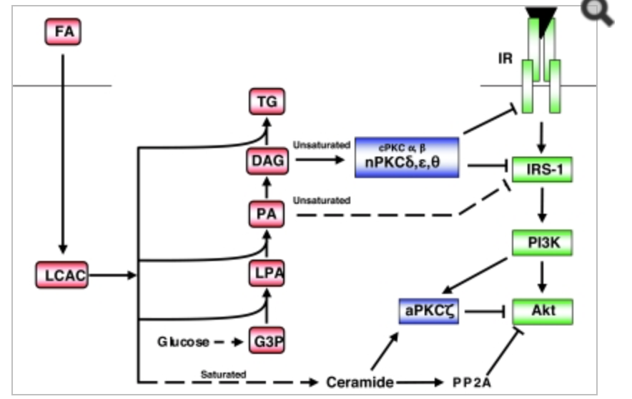
Figure 1 (Schmitz-Peiffer and Biden 2008)

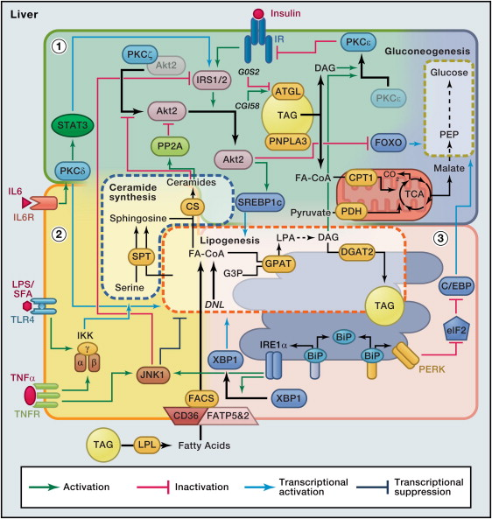
Figure 2: The pathway of Insulin Resistance (Samuel and Shulman 2012)
PKC’s cover many types of protein kinase enzymes, which control the function of other proteins through the phosphorylation of hydroxyl groups of serine and threonine amino acid residues. The PKC enzymes are activated by signals such as increases in DAG concentration and calcium ion concentration. For this reason, they play an important role in several signal transduction cascades. When DAG or Ca2+ activates the PKC pathway, the insulin resistance tyrosine kinase pathway gets inhibited and this causes obesity, which can lead to type 2 diabetes.

The studies done in mice and humans have created an important role for DAG signaling in the liver, for the activation of PKC in triggering insulin resistance. The strongest predictors of hepatic insulin resistance in liver biopsies that were retrieved from the individuals are hepatic DAG content and PKC activation (Yamamoto, Watanabe et al. 2010). Hepatic insulin resistance is almost always linked with increases in DAG concentrations, which leads to PKC activation and subsequent inhibition of Insulin Receptor Tyrosine Kinase (IRTK) activity. The DAG hypothesis of hepatic insulin resistance has been proven with humans with Non-Alcoholic Fatty Liver Disease (NAFLD). There have not been studies done where the presence or absence of calcium ions will impact DAG to activate PKC pathway, which will lead to hepatic insulin resistance.

Insulin resistance worsens type 2 diabetes. Several risk factors are obesity, sedentary lifestyle, body fat distribution, age and hyperinsulinemia. These factors are possible signs of insulin resistance. Insulin resistance can predict the development of type 2 diabetes even in individuals with normal glucose tolerance. It has been supported by evidence that elevated plasma free fatty acid levels are responsible for most of the insulin resistance that is there in obese subjects (Itani, Ruderman et al. 2002). An increase in lipid availability is strongly correlated with both beta cell dysfunction and insulin resistance (Schmitz-Peiffer and Biden 2008).

Experimental Methods:

In this experiment, it will be seen if the absence of presence of calcium ions will impact DAG ability to activate the PKC pathway in the liver, which will lead to hepatic insulin resistance. For this experiment, the mice will be fasted for four to six hours, and then placed in a cage with only water present. The blood samples will be taken from the tail with a scalpel and the weight in grams will be recorded. The baseline glucose will be recorded before injection of 20% glucose solution with a scalpel and the drop of blood taken from the tail will be placed on the blood glucose meter test strip. In order to maintain plasma glucose levels at around 90 to 100mg/dl, 20% glucose solution will be injected into all of the mice. The volume of the injected solution will calculated by ten times the body weight of the mice in grams. The blood glucose levels will be measured at 15, 30, 60, and 120 minutes after the 20% glucose injection (Yamamoto, Watanabe et al., 2010). Then calcium ion channels will be inhibited by statins in the experimental group and not inhibited in the control group. To see if there is a direct cause and effect relationship between DAG and PKC activation, an in vitro assay will be done. For the in vitro assay, the mice will be killed and the liver will be extracted and submerged in a buffer solution. A PKC assay will be done to check for its activation and then insulin resistance will be calculated with the HOMA-IR equation.

Discussion:

If Ca2+ channel is inhibited and protein kinase C still gets activated that means insulin resistance can happen regardless of the presence of Ca2+. This would show that DAG is enough to activate the protein kinase C pathway. If protein kinase C does not get activated when Ca2+ is inhibited, then that means insulin resistance is not happening. Insulin resistance can happen as a result of many ways. The most common way for it to happen is through the protein kinase C pathway with accumulation of DAG. Insulin resistance is reversible unlike beta cell deterioration, which is non-reversible. Drugs that target insulin resistance will be needed to reverse its effects and prevent the start of type 2 diabetes.

REFERENCES

Gerich, J. E. (2000). "Insulin resistance is not necessarily an essential component of type 2 diabetes." The Journal of Clinical Endocrinology & Metabolism 85(6): 2113-2115.

Gutch, M., S. Kumar, S. M. Razi, K. K. Gupta and A. Gupta (2015). "Assessment of insulin sensitivity/resistance." Indian journal of endocrinology and metabolism 19(1): 160.

Itani, S. I., N. B. Ruderman, F. Schmieder and G. Boden (2002). "Lipid-induced insulin resistance in human muscle is associated with changes in diacylglycerol, protein kinase C, and IκB-α." Diabetes 51(7): 2005-2011.

Perry, R. J., V. T. Samuel, K. F. Petersen and G. I. Shulman (2014). "The role of hepatic lipids in hepatic insulin resistance and type 2 diabetes." Nature 510(7503): 84-91.

Saini, V. (2010). "Molecular mechanisms of insulin resistance in type 2 diabetes mellitus." World journal of diabetes 1(3): 68.

Samuel, V. T. and G. I. Shulman (2012). "Mechanisms for insulin resistance: common threads and missing links." Cell 148(5): 852-871.

Schmitz-Peiffer, C. and T. J. Biden (2008). "Protein kinase C function in muscle, liver, and β-cells and its therapeutic implications for type 2 diabetes." Diabetes 57(7): 1774-1783.

Yamamoto, T., K. Watanabe, N. Inoue, Y. Nakagawa, N. Ishigaki, T. Matsuzaka, Y. Takeuchi, K. Kobayashi, S. Yatoh and A. Takahashi (2010). "Protein kinase Cbeta mediates hepatic induction of sterol-regulatory element binding protein-1c by insulin." Journal of lipid research 51(7): 1859-1870.

