Examining the Role of Diacylglycerol in the Protein Kinase C Pathway in Lipid-Induced Insulin Resistance

By Samhitha Dhandamudy

Introduction:

Insulin resistance is a common condition caused by type 2 diabetes and has been linked to obesity for a long time (Samuel et al, 2010). In the liver, intracellular accumulation of lipids like diacylglycerol (DAG), causes the activation of Protein Kinase C (PKC) with subsequent impairments in insulin signaling (Samuel et al, 2010). Insulin resistance often happens before beta cell deterioration. The cause of the disorder can be attributed to the body’s cells not responding properly to insulin. As a result, glucose cannot enter the cells as easily, causing accumulation in the bloodstream. An increase in glucose will lead to an increase in DAG a messenger protein, causing an increase in PKC via increasing the PKC’s affinity for calcium ions. The cellular mechanisms are not as well understood despite the crucial role insulin resistance has in pathogenesis of many disorders (Samuel et al, 2010).

The mechanism of a defective insulin-stimulated glucose transport activity can be due to increases in intramyocellular lipid metabolites such as Acyl-CoA-binding protein
and DAG which activates the serine/threonine kinase cascade, which leads to defects in insulin signaling through the serine/threonine phosphorylation of the insulin receptor substrate-1 (Saini, 2010).
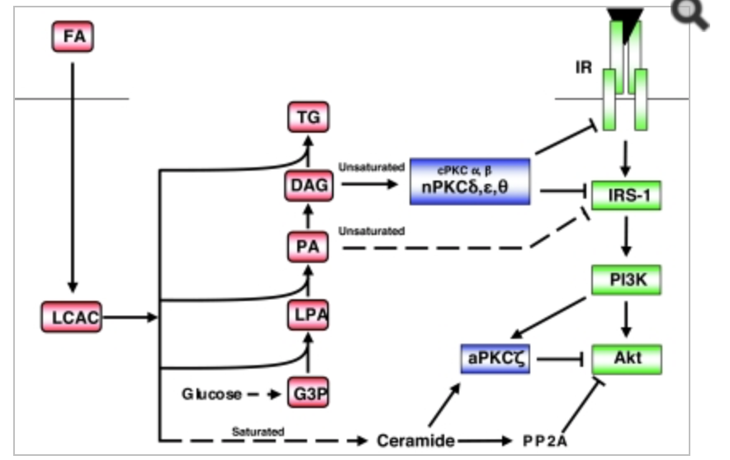

The Figure above shows Pathway of Insulin Resistance.

The studies done in mice and humans have created an important role for DAG signaling in the liver, for the activation of PKC in triggering insulin resistance. The strongest predictors of hepatic insulin resistance in liver biopsies that were retrieved from the individuals are hepatic DAG content and PKC activation. Hepatic insulin resistance is almost always linked with increases in DAG concentrations, which leads to PKC activation and subsequent inhibition of Insulin Receptor Tyrosine Kinase (IRTK) activity. The DAG hypothesis of hepatic insulin resistance has been proven with humans with Non-Alcoholic Fatty Liver Disease (NAFLD) (Varman et al, 2010).

Insulin resistance worsens type 2 diabetes. Several risk factors are obesity, sedentary lifestyle, body fat distribution, age and hyperinsulinemia. These factors are possible signs of insulin resistance. Insulin resistance can predict the development of type 2 diabetes even in individuals with normal glucose tolerance. It has been supported by evidence that elevated plasma free fatty acid levels are responsible for most of the insulin resistance that is there in obese subjects (Itani et al, 2002). An increase in lipid availability is strongly correlated with both beta cell dysfunction and insulin resistance (Schmitz-Pfieffer et al, 2008).

Methods:

PKC activity will be measured in the presence of DAG. For this experiment, ten healthy mice will fast overnight for eighteen hours and then placed into an empty cage with only water present. The blood samples will be taken from the tail with a scalpel and the weight in grams will be recorded. The baseline glucose will be recorded before injection of 20% glucose solution with a scalpel and the drop of blood taken from the tail will be placed on the blood glucose meter test strip. In order to maintain plasma glucose levels at around 90 to 100mg/dl, 20% glucose solution will be injected into all of the mice. The volume of the injected solution will calculated by ten times the body weight of the mice in grams. The blood glucose levels will be measured at 15,30,60, and 120 minutes after the 20% glucose injection. Then the mice will be killed and the PKC activity will be measured in the presence of DAG. First the PKC will be solubilized in detergents and the activity will be measured using Signa Test Protein Kinase C (PKC) Assay System (Promega) (Yamamoto et al, 2010).

Discussion:

An increase in DAG content means an increase in PKC activity, which is due to an increase in glucose levels in the blood. Accumulation of DAG in the liver and PKC activity causes insulin resistance, which is a cause of type 2 diabetes. It should be expected for the results to show that diacylglycerol content increased because of an increase in PKC activity as a result of the 20% glucose injection as the time doubled when compared to the baseline glucose level.

Citations

Leiker, T. J., Barkley, R. M., & Murphy, R. C. (2011). Analysis of Diacylglycerol Molecular Species in Cellular Lipid Extracts by Normal-Phase LC-Electrospray Mass Spectrometry. International Journal of Mass Spectrometry, 305(2-3), 103–109. http://doi.org/10.1016/j.ijms.2010.09.008

Powell, D. R., Gay, J. P., Wilganowski, N., Doree, D., Savelieva, K. V., Lanthorn, T. H., … Zambrowicz, B. (2015). Diacylglycerol Lipase α Knockout Mice Demonstrate Metabolic and Behavioral Phenotypes Similar to Those of Cannabinoid Receptor 1 Knockout Mice. Frontiers in Endocrinology, 6, 86. http://doi.org/10.3389/fendo.2015.00086

Yamamoto, T., Watanabe, K., Inoue, N., Nakagawa, Y., Ishigaki, N., Matsuzaka, T., … Shimano, H. (2010). Protein kinase Cbeta mediates hepatic induction of sterol-regulatory element binding protein-1c by insulin. Journal of Lipid Research, 51(7), 1859–1870. http://doi.org/10.1194/jlr.M004234

Schmitz-Peiffer, C., & Biden, T. J. (2008). Protein Kinase C Function in Muscle, Liver, and β-Cells and Its Therapeutic Implications for Type 2 Diabetes. Diabetes, 57(7), 1774–1783. http://doi.org/10.2337/db07-1769

Perry, R. J., Samuel, V. T., Petersen, K. F., & Shulman, G. I. (2014). The role of hepatic lipids in hepatic insulin resistance and type 2 diabetes. Nature, 510(7503), 84–91. http://doi.org/10.1038/nature13478

John E. Gerich; Insulin Resistance Is Not Necessarily an Essential Component of Type 2 Diabetes, The Journal of Clinical Endocrinology & Metabolism, Volume 85, Issue 6, 1 June 2000, Pages 2113–2115, https://doi.org/10.1210/jcem.85.6.6646

Saini, V. (2010). Molecular mechanisms of insulin resistance in type 2 diabetes mellitus. World Journal of Diabetes, 1(3), 68–75. http://doi.org/10.4239/wjd.v1.i3.68

Gutch, M., Kumar, S., Razi, S. M., Gupta, K. K., & Gupta, A. (2015). Assessment of insulin sensitivity/resistance. Indian Journal of Endocrinology and Metabolism, 19(1), 160–164. http://doi.org/10.4103/2230-8210.146874

Schmitz-Peiffer, C., & Biden, T. J. (2008). Protein Kinase C Function in Muscle, Liver, and β-Cells and Its Therapeutic Implications for Type 2 Diabetes. Diabetes, 57(7), 1774–1783. http://doi.org/10.2337/db07-1769

Yamamoto, T., Watanabe, K., Inoue, N., Nakagawa, Y., Ishigaki, N., Matsuzaka, T., … Shimano, H. (2010). Protein kinase Cbeta mediates hepatic induction of sterol-regulatory element binding protein-1c by insulin. Journal of Lipid Research, 51(7), 1859–1870. http://doi.org/10.1194/jlr.M004234

