Amanda Atrash
Disruption of NDEL1 via knockout of DISC1 stunts dendritic spine structure in the hippocampus region of mice
- Introduction
Schizophrenia is a chronic, debilitating mental disorder that currently affects around 1% of the world’s population. Symptoms vary throughout individuals, however, they are all categorized in about the same three categories: positive, negative, and cognitive. Examples of positive symptoms include hallucinations and delusions, while negative symptoms are more along the lines of social withdrawal and lack of motivation. Lastly, cognitive symptoms include impairment of memory and attention. Because of the wide, variety of symptoms, many patients have high rates of homelessness, violence, and suicide (World Health Organization). These prognoses seriously impact the economy and society - costing upwards of $62 billion dollars per year (Ellaithy et al., 2015). It is for this reason that the World Health Organization ranks this disorder among the top 10 causes of disability in the world (Ellaithy et al., 2015).

While schizophrenia is such a prevalent and debilitating mental illness to individuals and the population, most drug therapy aimed at treating schizophrenia does a very poor job. While typical antipsychotic drugs are effective against positive symptoms, they also demonstrate a limited efficacy against negative symptoms and cognitive impairments - which have been shown to contribute to functional impairment and predict poor prognosis (Ellaithy et al., 2015, Moreno et al., 2011). These drugs were introduced into clinical practice in the early 1900s and despite the increasing research on schizophrenia, they have not changed much in their chemical structure since then. The limitations of the presently available drugs underscore the need for identification of new antipsychotic compounds aiming at new molecular targets.

One such target, that has been heavily studied, is Disrupted-in-Schizophrenia-1, a gene-encoding protein that is identified as a genetic risk factor across a spectrum of psychiatric disorders. DISC1 is present at the intersection of several neurodevelopmental pathways and acts as a scaffold - binding a number of other proteins together, which have all been shown to be independent risk factors for major mental illnesses as well (Duan et al., 2007, Soares et al., 2011). Recent studies have suggested a link between DISC1 genotypes and elements of neurocognitive function (Duan et al., 2007). However, much about DISC1 is not known and thus represents a challenge to drug target due to the absence of a solved structure (Soares et al., 2011). Thus, drug therapies involved with DISC1 would need to focus on modulate interaction of DISC1 with one of its many binding partners.

One of DISC1’s many binding partners includes Nuclear Distribution Element-like 1 (NDEL1). NDEL1 is a centrosomal protein that is involved in mitosis, neuronal migration, neuroplasticity, and neurogenesis during brain development (Burdick et al., 2008). Neural plasticity refers to the brain’s ability to make changes to itself throughout its lifetime. A recent study has demonstrated that NDEL1 expression is decreased in the hippocampus region of those suffering with schizophrenia (Burdick et al., 2008). This suggests that the plasticity of the brain, or it’s ability to adapt, can lead to changes in cognition and behavior. Cognitive deficits, such as those talked about above as a symptom of schizophrenia, may then be a result and consequence of deficits in neural plasticity (Voineskos et al., 2013). As well, an intact NDEL1-DISC1 interaction has been shown to be critical to multiple developmental processes such as neural outgrowth (Nicodemus et al., 2010, Voineskos et al., 2013). Both of these aspects suggest the importance of NDEL1 and DISC1 in understanding a new aspect and relationship in schizophrenia.

While there have been some studies examining the relationship between NDEL1 and DISC1, much still has to be studied and understood. Does knockout of one protein affect the function of the other? How does the knockout of the protein lead to changes in plasticity and changes in the formation of dendrites in the brain? The purpose of this experiment is to answer similar questions by testing whether knockout of DISC1 impacts the function of NDEL1 in the spine formation of the hippocampus region.

- Experiment
The aim of this experiment is to understand the relationship between the proteins NDEL1 and DISC1 in the development of the spine structure in the hippocampus region of the brain. Samples of the mutant protein DISC1 will be injected inside pre-developmental mice to gather and measure the dendritic spine growth and formation within the hippocampus region. In these samples, DISC1 will be knocked out to test how it’s silence impacts the function of NDEL1, a protein known to play a role in neurogenesis. I would expect that the level of spine formation within the hippocampus be similar to that with a NDEL1 knockout, i.e. under conditions that would negatively impact the cell.

  - Co-immunoprecipitation
Co-immunoprecipitation is a popular technique used on protein-protein interactions by using target protein-specific antibodies to capture and pull down proteins that are bound to a specific target protein. This method was employed by Moreno et al. (2012) to detect mGlu2 with an anti-HA antibody by capturing 5-HT2A with an anti-c-Myc antibody. Co-immunoprecipitation methods will be employed similarly to Moreno et al. (2012) in this experiment.
Co-immunoprecipitation primarily works by utilizing antibodies, or large Y-shaped proteins, and using them as ‘tags’ on the proteins of interest. In Moreno et al. (2012), the antibodies were used to tag the serotonin 2A receptor, 5-HT2A. By tagging this integral protein, they were able to detect if mGlu2 was in a relationship with this receptor in the cell. Similarly, in our experiment, an antibody specific tag for DISC1 would be used to detect presence of NDEL1. In Kayima et al. (2006), the antibodies used against DISC1 were raised in rabbits against amino acids 360-374 of rodent DISC1 and affinity-purified. The antibody for DISC1, then, would be rabbit polyclonal anti-DISC1 antibody and will be purchased online. After collecting samples of the hippocampus region of an adult mice brains, solubilizing them, and incubating them with this specific antibody, we would also want to incubate them with protein beads. These protein beads are vital for the experiment and co-immunoprecipitation as they allow us to pull down the proteins through centrifugation and make the protein complex we are hoping to identify heavier than the other proteins in the cell, as seen in Figure 1. Protein A/G beads tend to be utilized for co-immunoprecipitation, and were utilized in Moreno et al. (2012). These beads will also be purchased online through Thermo Fisher Scientific.
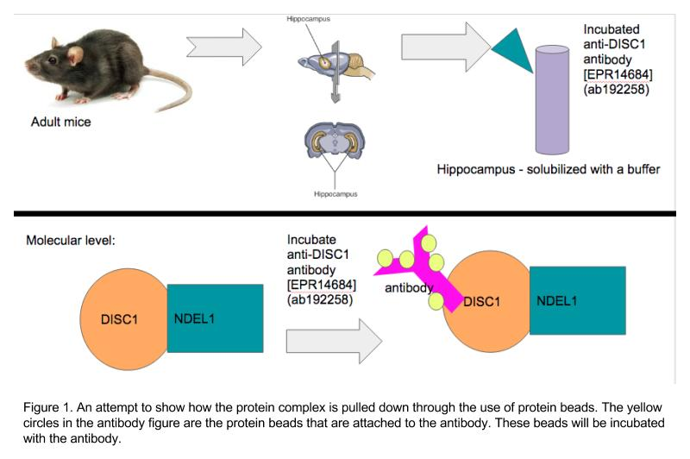
After the sample has been incubated with the anti-DISC1 antibody and the protein beads and centrifuged, the sample will be run through a Western blot. Moreno et al. (2012), also utilized a Western blot to identify the proteins in their complex. The Western blot will begin with a gel electrophoresis which will separate the proteins by size. Then, they will be moved to a membrane that has been incubated with antibodies for the target protein that we are looking to identify. The membrane used will be a polyvinylidene difluoride membrane as it provides better mechanical support and allow the blot to be reprobed and stored (Mahmood, T., & Yang, P.-C., 2012). Through our earlier steps, we will know DISC1 is involved in the protein complex that has been pulled down from the co-immunoprecipitation. Thus, we will use NDEL1 specific antibodies to confirm that there is a relationship between the two proteins and that they are involved in the same complex. The antibody for NDEL1 is mouse monoclonal antibody, clone OTI1G10 and will be purchased online. To prevent this primary antibody from binding with any membrane nonspecifically, 5% BSA will be used as a blocker. After the Western Blot is run and washed, the signal it produces will be captured on film and developed in a dark room. This signal will be produced by the antibody and an enzyme that will detect the target protein. The enzyme that will be used here will be horseradish peroxidase (HRP), because of it’s smaller size, greater stability, and availability.
The results will produce a single band that will correlate to NDEL1, and the thickness of the band will help us determine how much of the protein is included in the protein complex. Figure 2 highlights how this band is a semi-qualitative result since the thickness of the band correlates to amount of protein.
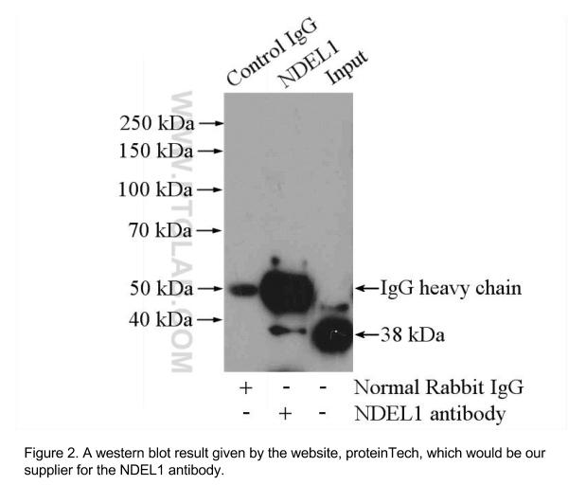

  - Knockout of DISC1
The knockout of DISC1 in the NDEL1-DISC1 protein-protein relationship will occur to understand how DISC1 impacts NDEL1 and spine formation. The original plan was to knockout the NDEL1 protein, however, further research has shown that knockout of NDEL1 can lead to embryonic lethality and is not viable for life (Sasaki et al., 2005). This is primarily due to the various roles NDEL1 plays in modulate dynein function, coupling of the centrosome and nucleus during neuronal migration, and in determining neuronal positioning (Sasaki et al., 2005, Toth et al., 2008). NDEL1 would also not have been ideal to knockout or knockdown due to our understanding of the role it plays in neural growth. Since we understand how vital this protein is in dendrite growth, it would be more beneficial to understand how DISC1’s relationship with NDEL1 affects its function.
DISC1 serves a number of functions in the cell and is involved in a number of protein complexes, as stated earlier. For this reason, a complete knockout of DISC1 also serves as an issue for the cell (Jaaro-Peled, 2009). Jaaro-Peled (2009) collected various approaches to generate a knockout of this protein without creating lethality. One method that was discussed in his work was employed by Li et al. (2007). Their work focuses on using transgenic mice to understand more of the roles DISC1 plays in the body and in schizophrenia-like symptoms. Li et al (2007) focused on creating a knockout of DISC1 that inhibits its binding with NUDEL and Lis1, where NUDEL is a common alias for NDEL1 and Lis1 is an enzyme that is known for regulating the motor protein Dynein. The regions of DISC1 that are known to bind to these two protein complexes are residues 671-852, meaning that these transgenic mice contain DISC1 that are mutant in these regions. So, Li et al (2007) do not generate a conventional knockout method for DISC1, because they do create a mutant version of this protein for the gene. However, the protein is expressed only for a short amount of time - no more than 6 hours, which is necessary since the protein cannot be completely knocked out from the mice. The reason this mutant form is not expressed for a full amount of time is because the mutant protein is fused to a mutant ligand-binding domain (LBD). The mutant form of LBD prevents DISC1 from binding to estrogen. Instead, this ligand form is activated by tamoxifen, which allows the protein to undergo a conformational switch that allows the protein to be functional, while also allowing tamoxifen to be quickly metabolized. The quick metabolization of the inducer causes the protein to be non-functional again, as shown in Figure 4. In other words, the mutant protein with the mutant receptor allows the protein to be expressed for a short amount of time - but only a short amount of time. Through immunoprecipitation and Western blotting, Li et al (2007) were able to highlight that the protein is only functional for a short amount of time.
While this method will not generate a full knockout of the DISC1 protein, in that the protein is functional for a short period of time during pre-development stages in mice, it still allows us to highlight the effects a non-functional DISC1 protein plays in adult mice. Similar methods will be employed in this experiment. Transgenic mice will be used with mutant DISC1 that binds to LBD to produce a functional protein for a short period of time. Because Li et al (2007) employed a specific method that prevents binding with NDEL1, this method would be ideal for the experiment.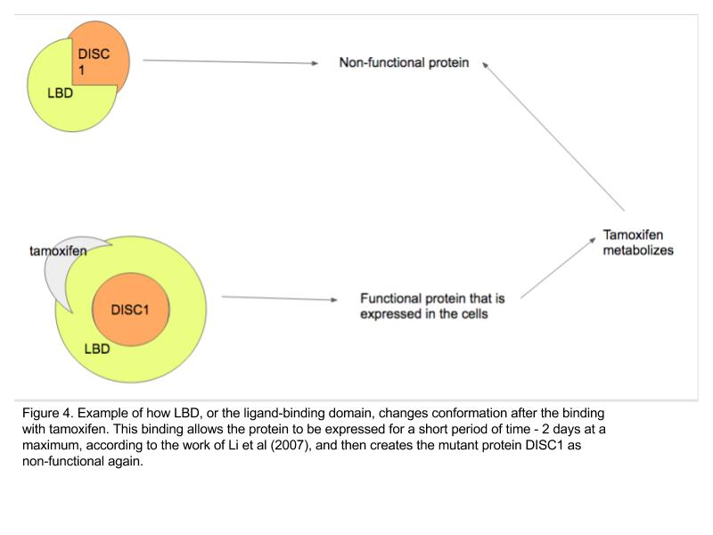
  - Confocal Imaging
Estimation of dendritic spine structure will occur through confocal imaging. This method was employed by Golden et al. (2013) to acquire images of a spine analysis. Images were acquired on a confocal LSM 710 for morphological analysis. Neurons were randomly selected. Dendritic segments were then imaged using a hundred times lens and a zoom of 2.5. A total of ~2,500 dendritic spines were analyzed, with about 2 dendrites per neuron, with 5 neurons per mouse being analyzed. This particular experiment utilized Neuron studio, a program that classifies spines as thin, mushroom, or stubby on the basis of various values, such as diameter, aspect ratio, and head-to-neck ratio. A similar analysis will be done in this experiment.

- Discussion
If all goes well, the confocal images of the spine formation will exhibit clear differences between DISC1 knockout and no DISC1 knockout. Similar to the results exhibited from Golden et al. (2013), the confocal images hope to show an increase of stubby and thin dendritic spines (Figure 3). These results may lead me to the conclusion of the importance in NDEL1 in schizophrenia and the importance of DISC1 in NDEL1 function, ultimately leading me to suggest a possible new drug therapy that targets these two proteins. Unfortunately, those perfect results are not guaranteed - and even more so, if they were, much more research would need to be done focusing on finding more information on DISC1 and NDEL1 separately.

Another result that could present is that there is no dendritic spine changes - or, that it is actually more ‘mushroom’ dendritic observances seen in those with the knockout of DISC1. The first results - of no change or difference - would be disheartening in that it would show this relationship is not important or vital for schizophrenia. However, it will still bring us closer to where we started. The other set of results, that the knockout actually positively impacts spine formation in the hippocampus region would be more so revolutionary since the evidence thus far does not suggest that. Ultimately, though, it would lead to a bigger conversation on the relationship between these two proteins and schizophrenia, which could serve as insight on what is still to come.

Interpreting these results, too will be difficult. A majority of these results are qualitative-based, which makes it much harder to be objective. As you can see from Figure 3, interpreting results from confocal imaging specifically, can be a little more difficult. It adds room for bias in being able to look at the image and seeing the outcome you want. While they have various systems and programs in place to assist with this, so as to stay objective in science, it can still be a little more difficult to truly know that your results are what you think they are.

Despite these possible problems and results, DISC1 and NDEL1 are important proteins that can help us learn more about schizophrenia and neuroplasticity within the brain. With appropriate attention, they can open doors to new drug therapies that may help those suffering with schizophrenia in bettering their prognosis. These advancements would not only save our economy money, but also give thousands of people the opportunity to live better, more full lives.
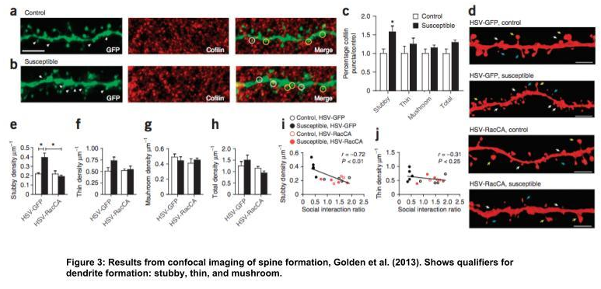

- References

- Golden, S. A., Christoffel, D. J., Hodes, G. E., Heshmati, M., Magida, J., Davis, K., … Russo, S. J. (2013). Epigenetic regulation of synaptic remodeling in stress disorders. Nature Medicine, 19(3), 337–344. http://doi.org/10.1038/nm.3090 (https://www.ncbi.nlm.nih.gov/pmc/articles/PMC3594624/)
- Fribourg, M., Moreno, J. L., Holloway, T., Provasi, D., Baki, L., Mahajan, R., … Logothetis, D. E. (2011). Decoding the Signaling of a GPCR Heteromeric Complex Reveals a Unifying Mechanism of Action of Antipsychotic Drugs. Cell, 147(5), 1011–1023. http://doi.org/10.1016/j.cell.2011.09.055 (https://www.ncbi.nlm.nih.gov/pmc/articles/PMC3255795/)
- Moreno, J. L., Muguruza, C., Umali, A., Mortillo, S., Holloway, T., Pilar-Cuéllar, F., … González-Maeso, J. (2012). Identification of Three Residues Essential for 5-Hydroxytryptamine 2A-Metabotropic Glutamate 2 (5-HT2A·mGlu2) Receptor Heteromerization and Its Psychoactive Behavioral Function. The Journal of Biological Chemistry, 287(53), 44301–44319. http://doi.org/10.1074/jbc.M112.413161 (https://www.ncbi.nlm.nih.gov/pmc/articles/PMC3531745/)
- Namba, T., Ming, G.-l., Song, H., Waga, C., Enomoto, A., Kaibuchi, K., Kohsaka, S. and Uchino, S. (2011), NMDA receptor regulates migration of newly generated neurons in the adult hippocampus via Disrupted-In-Schizophrenia 1 (DISC1). Journal of Neurochemistry, 118, 34–44. doi:10.1111/j.1471-4159.2011.07282.x (http://onlinelibrary.wiley.com/doi/10.1111/j.1471-4159.2011.07282.x/full)
- Soares, D. C., Carlyle, B. C., Bradshaw, N. J., & Porteous, D. J. (2011). DISC1: Structure, Function, and Therapeutic Potential for Major Mental Illness. ACS Chemical Neuroscience, 2(11), 609–632. http://doi.org/10.1021/cn200062k (https://www.ncbi.nlm.nih.gov/pmc/articles/PMC3222219/)
- Katherine E. Burdick, Atsushi Kamiya, Colin A. Hodgkinson, Todd Lencz, Pamela DeRosse, Koko Ishizuka, Sarah Elashvili, Hiroyuki Arai, David Goldman, Akira Sawa, Anil K. Malhotra; Elucidating the relationship between DISC1, NDEL1 and NDE1 and the risk for schizophrenia: Evidence of epistasis and competitive binding . Hum Mol Genet 2008; 17 (16): 2462-2473. doi: 10.1093/hmg/ddn146 (https://academic-oup-com.proxy.library.vcu.edu/hmg/article/17/16/2462/article)
- Kim, J., Liu, C., Zhang, F., Duan, X., Wen, Z., Song, J., Feighery, E., Lu, B., Rujescu, D., St Clair, D., Christian, K., Callicott, J., Weinberger, D., Song, H., and Ming, G. (2012), Interplay between DISC1 and GABA Signaling Regulates Neurogenesis in Mice and Risk for Schizophrenia. Cell Press, 148(5), 1051 - 1064. doi : http://dx.doi.org/10.1016/j.cell.2011.12.037 (http://www.cell.com/cell/abstract/S0092-8674(12)00159-6?_returnURL=http%3A%2F%2Flinkinghub.elsevier.com%2Fretrieve%2Fpii%2FS0092867412001596%3Fshowall%3Dtrue)
- Ellaithy, A., Younkin, J., Gonzalez-Maeso, J., & Logothetis, D. E. (2015). Positive Allosteric Modulators of Metabotropic Glutamate 2 Receptors in Schizophrenia Treatment. Trends in Neurosciences, 38(8), 506–516. http://doi.org/10.1016/j.tins.2015.06.002 (https://www.ncbi.nlm.nih.gov/pmc/articles/PMC4530036/)
- Moreno, J. L., Kurita, M., Holloway, T., López, J., Cadagan, R., Martínez-Sobrido, L., … González-Maeso, J. (2011). Maternal influenza viral infection causes schizophrenia-like alterations of 5-HT2A and mGlu2 receptors in the adult offspring. The Journal of Neuroscience : The Official Journal of the Society for Neuroscience, 31(5), 1863–1872. http://doi.org/10.1523/JNEUROSCI.4230-10.2011 (https://www.ncbi.nlm.nih.gov/pmc/articles/PMC3037097/)
- Voineskos, D., Rogasch, N.C., Rajji, T. K., Daskalakis, Z. (2013). A Review of Evidence Linking Disrupted Neural Plasticity to Schizophrenia. Canadian journal of psychiatry. PubMed, 58(2), 86 - 92. doi : 10.1177/070674371305800205 (https://www.researchgate.net/publication/235739948_A_Review_of_Evidence_Linking_Disrupted_Neural_Plasticity_to_Schizophrenia)
- Keshavan, M., Mehta, U., Padmanabhan, J., & Shah, J. (2015). Dysplasticity, metaplasticity, and schizophrenia: Implications for risk, illness, and novel interventions. Development and Psychopathology, 27(2), 615-635. doi:10.1017/S095457941500019X
- González-Maeso, J., Ang, R., Yuen, T., Chan, P., Weisstaub, N. V., López-Giménez, J. F., … Sealfon, S. C. (2008). Identification of a Novel Serotonin/Glutamate Receptor Complex Implicated in Psychosis. Nature, 452(7183), 93–97. http://doi.org/10.1038/nature06612 (https://www.ncbi.nlm.nih.gov/pmc/articles/PMC2743172/)
- Duan, X., Chang, J., Faulkner, R., Kim, J., Kitabatake, Y., Liu, X., Yang, C., Jordan, J., Ma, D., Liu, C., Ganesan, S., Cheng, H., Ming, G., and Song, H.(2007), Disrupted-In-Schizophrenia 1 Regulates Integration of Newly Generated Neurons in the Adult Brain. Cell Press, 130(6):,1146 - 1158. doi: http://dx.doi.org/10.1016/j.cell.2007.07.010 (http://www.sciencedirect.com/science/article/pii/S0092867407008975)
- Sasaki, S., Mori, D., Toyo-oka, K., Chen, A., Garrett-Beal, L., Muramatsu, M., … Hirotsune, S. (2005). Complete Loss of Ndel1 Results in Neuronal Migration Defects and Early Embryonic Lethality. Molecular and Cellular Biology, 25(17), 7812–7827. http://doi.org/10.1128/MCB.25.17.7812-7827.2005 (https://www-ncbi-nlm-nih-gov.proxy.library.vcu.edu/pmc/articles/PMC1190282/)
- Shinoda, T., Taya, S., Tsuboi, D., Hikita, T., Matsuzawa, R., Kuroda, S., Iwamatsu, A., and Kaibuchi, K. (2007), DISC1 Regulates Neurotrophin-Induced Axon Elongation via Interaction with Grb2. Journal of Neuroscience, 27(1), 4 - 14. doi: https://doi.org/10.1523/JNEUROSCI.3825-06.2007 (http://www.jneurosci.org/content/27/1/4)
- Kim, J. Y., Duan, X., Liu, C. Y., Jang, M., Guo, J. U., Pow-anpongkul, N., . . . Ming, G. (2009). DISC1 regulates new neuron development in the adult brain via modulation of AKT-mTOR signaling through KIAA1212. Neuron, 63(6), 761-73. doi:http://dx.doi.org.proxy.library.vcu.edu/10.1016/j.neuron.2009.08.008 (http://www.sciencedirect.com/science/article/pii/S0896627309006175)
- Olivia Engmann, Tibor Hortobágyi, Ruth Pidsley, Claire Troakes, Hans-Gert Bernstein, Michael R. Kreutz, Jonathan Mill, Margareta Nikolic, Karl Peter Giese; Schizophrenia is associated with dysregulation of a Cdk5 activator that regulates synaptic protein expression and cognition. Brain 2011; 134 (8): 2408-2421. doi: 10.1093/brain/awr155 (https://academic.oup.com/brain/article/134/8/2408/356279/Schizophrenia-is-associated-with-dysregulation-of)
- Nestler, E., Peña, C., Kundakovic, M., Mitchell, A., and Akbarian, S. (2016). Epigenetic Basis of Mental Illness. The Neuroscientist, 22(5), 447 - 463. doi: 10.1177/1073858415608147 (http://journals.sagepub.com/doi/abs/10.1177/1073858415608147)
- Kurita, M., Holloway, T., García-Bea, A., Kozlenkov, A., Friedman, A. K., Moreno, J. L., & ... Buxbaum, J. D. (2012). HDAC2 regulates atypical antipsychotic responses through the modulation of mGlu2 promoter activity. Nature Neuroscience, 15(9), 1245-1254. doi: 10.1038/nn.3181 (http://www.nature.com/neuro/journal/v15/n9/full/nn.3181.html)
- Amort T, Rieder D, Wille A, Khokhlova-Cubberley D, Riml C, Trixl L, Jia X-Y, Micura R, LusserEmail A (2017). Distinct 5-methylcytosine profiles in poly(A) RNA from mouse embryonic stem cells and brain. Genome Biol 18:1. (https://genomebiology.biomedcentral.com/articles/10.1186/s13059-016-1139-1)
- Hanks, J. B., & González-Maeso, J. (2013). Animal Models of Serotonergic Psychedelics. ACS Chemical Neuroscience, 4(1), 33–42. http://doi.org/10.1021/cn300138m (https://www.ncbi.nlm.nih.gov/pmc/articles/PMC3547517/)
- Holloway, T., & González-Maeso, J. (2015). Epigenetic Mechanisms of Serotonin Signaling. ACS Chemical Neuroscience, 6(7), 1099–1109. http://doi.org/10.1021/acschemneuro.5b00033 (https://www.ncbi.nlm.nih.gov/pmc/articles/PMC4838281/)
- Akbarian, S. (2014). Epigenetic mechanisms in schizophrenia. Dialogues in Clinical Neuroscience, 16(3), 405–417. (https://www.ncbi.nlm.nih.gov/pmc/articles/PMC4214181/)
- Bradshaw, N.J. & Hayashi, M.A.F. Cell. Mol. Life Sci. (2017) 74: 1191. doi:10.1007/s00018-016-2395-7(https://link-springer-com/article/10.1007/s00018-016-2395-7)
- Toth C, Shim SY, Wang J, Jiang Y, Neumayer G, Belzil C, et al. (2008) Ndel1 Promotes Axon Regeneration via Intermediate Filaments. PLoS ONE 3(4): e2014. https://doi.org/10.1371/journal.pone.0002014 (http://journals.plos.org/plosone/article?id=10.1371/journal.pone.0002014#s4)
- Nicodemus, K.K., Callicott, J.H., Higier, R.G. et al. Hum Genet (2010) 127: 441. doi:10.1007/s00439-009-0782-y (https://link.springer.com/article/10.1007/s00439-009-0782-y)
- Kamiya, A., Kubo, K., Tomoda, T., Takaki, M., Youn, R., Ozeki, Y., & ... Sawa, A. (2005). A schizophrenia-associated mutation of DISC1 perturbs cerebral cortex development. Nature Cell Biology, 7(12), 1067-1082. doi:10.1038/ncb1328 (http://web.b.ebscohost.com/ehost/detail/detail?sid=824fa02e-24a6-4769-aded-d4d091759dd3%40sessionmgr103&vid=0&hid=102&bdata=JkF1dGhUeXBlPWlwLHVybCxjb29raWUsdWlkJnNpdGU9ZWhvc3QtbGl2ZSZzY29wZT1zaXRl#AN=19004252&db=a9h)
- Atsushi Kamiya, Toshifumi Tomoda, Jennifer Chang, Manabu Takaki, Caixin Zhan, Masahiko Morita, Matthew B. Cascio, Sarah Elashvili, Hiroyuki Koizumi, Yasukazu Takanezawa, Faith Dickerson, Robert Yolken, Hiroyuki Arai, Akira Sawa; DISC1–NDEL1/NUDEL protein interaction, an essential component for neurite outgrowth, is modulated by genetic variations of DISC1. Hum Mol Genet 2006; 15 (22): 3313-3323. doi: 10.1093/hmg/ddl407 (https://academic-oup-com.proxy.library.vcu.edu/hmg/article-lookup/doi/10.1093/hmg/ddl407)
- Gujrati, M. and Lu, Z.R. (2012). Targeted Systemic Delivery of Therapeutic siRNA. Jeffrey Schlom, Gene Therapy of Cancer (pp. 47 - 65). Oxford, UK: Elsevier Inc.
- Mahmood, T., & Yang, P.-C. (2012). Western Blot: Technique, Theory, and Trouble Shooting. North American Journal of Medical Sciences, 4(9), 429–434. http://doi.org/10.4103/1947-2714.100998 (https://www.ncbi.nlm.nih.gov/pmc/articles/PMC3456489/)
- Hanna Jaaro-Peled (2009). Chapter 9 - Gene models of schizophrenia: DISC1 mouse models. Progress in Brain Research, 179(1), 75 - 86. Doi: 10.1016/S0079-6123(09)17909-8
(http://www-sciencedirect-com.proxy.library.vcu.edu/science/article/pii/S0079612309179098?via%3Dihub)
- Li, W., Zhou, Y., Jentsch, J. D., Brown, R. A. M., Tian, X., Ehninger, D., … Cannon, T. D. (2007). Specific developmental disruption of disrupted-in-schizophrenia-1 function results in schizophrenia-related phenotypes in mice. Proceedings of the National Academy of Sciences of the United States of America, 104(46), 18280–18285. http://doi.org/10.1073/pnas.0706900104 (https://www.ncbi.nlm.nih.gov/pmc/articles/PMC2084334/)

