Furin deletion in B cells alters ADAM10 prodomain processing and the downstream effects on allergic asthma.
INTRODUCTION:
Asthma is a major economic issue in the United States. Asthma costs in the US are over 56 billion dollars annually. Approximately 1 in 12 adults has asthma and 1 in 10 children (“Asthma Statistics | AAAAI,” n.d.). These rates are only continuing to grow. There is no cure for asthma, only treatments. The most common treatment for severe asthma, steroids, has severe side effects. (“How Is Asthma Treated and Controlled? - NHLBI, NIH,” n.d.). With prolonged use these side effects can include: thrush (fungal infection in the mouth), high blood pressure in the eye or glaucoma (fluid build up in the eye), osteoporosis (decreased bone thickness), and cataracts (cloudy eye lens) (Zhang, Prietsch, & Ducharme, 2014). The search for better treatments and even cures for asthma are essential. A Disintegrin and Proteinase (ADAM) 10 has been recently shown to be important in the immune system in regulating allergic disease. ADAM 10 is a key director of cellular processes by cleaving and shedding extracellular domain of a multitude of transmembrane receptors and ligands (Chaimowitz et al., 2011). ADAM10 is a member of a family of metalloproteinases that are responsible for the proteolytic processing of transmembrane receptors and ligands (David, Gibbs (2010)). ADAM10 was originally discovered for its role in onset of Alzheimer’s disease and only recently has been implicated in asthma and allergy(Kim et al., 2009). ADAM10 is most famous for cleavage of the substrate Notch. Notch is important in development and because of this, deleting ADAM10 in a mouse, completely, is lethal in the embryonic stage. Cell specific deletion of ADAM10 has been developed to study its function in various systems. In the immune system, macrophages, dendritic cells, and B cells have all shown distinct phenotypes when it comes to ADAM10 deletion. Most importantly, ADAM10 deletion from the B cell has shown reduced airway symptoms when these mice are subjected to the model of mouse asthma. This phenotype has been shown to be mediated through a multitude of substrates of ADAM10, but most importantly Inducible Costimulator (ICOS) ligand. This ligand regulates T cell responses and antibody production that is essential for the devastating symptoms that result in asthmatic exacerbation. ADAM10 is the primary sheddase of ICOSL and when inhibited, has been associated with high levels of ICOSL which leads to the downregulation of surface T cell ICOS expression through internalization of ICOS (Joseph Cornelius Lownik, Luker, Martin, Damle, & Conrad, 2017). Down regulation of T cell ICOS is key to the reduction/severity of an allergic response (Woodfolk, 2007). Yet, since ADAM10 is embryonic lethal, a drug to inhibit it completely is a risky prospect.
Furin (also known as PACE “Paired basic Amino acid cleaving”) is a proprotein convertase protein coding gene, which encodes for a type 1 membrane bound protease that is found in multiple forms of tissue, including the liver, gut and the brain ("FURIN Gene(Protein Coding)"). Furin is one of the convertases that activates ADAM10 through cleavage of the prodomain. Without cleavage of the prodomain, ADAM10 is inactivated and cannot function (David, Gibbs (2010)). PC-7 (proprotein convertase) is also able to cleave the prodomain of ADAM10(Anders, Gilbert, Garten, Postina, & Fahrenholz, 2001). Since a deletion of Furin will result in a possible partial loss of ADAM10, it may possibly be a more beneficial drug target for asthma therapy. I propose that Furin deletion from B cells will result in the abrogation of airway hyperresponsiveness (AHR) in a mouse model of asthma through ADAM10 and ICOSL.

The Experiment
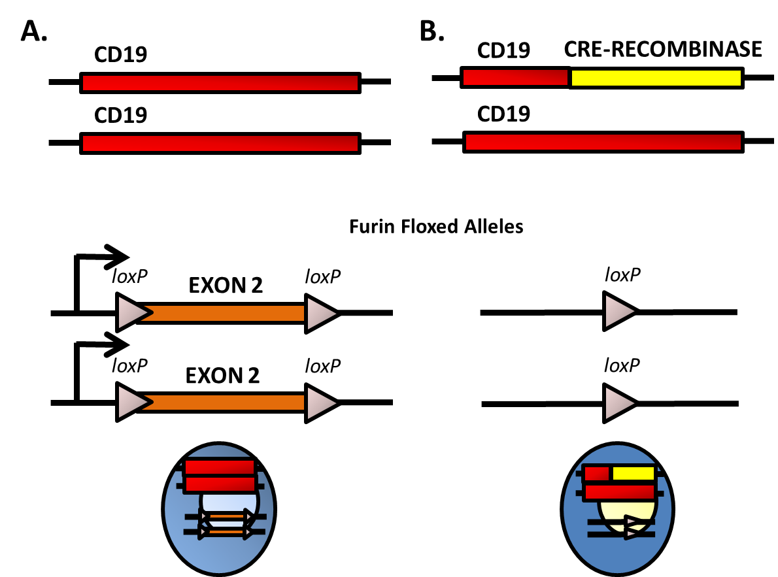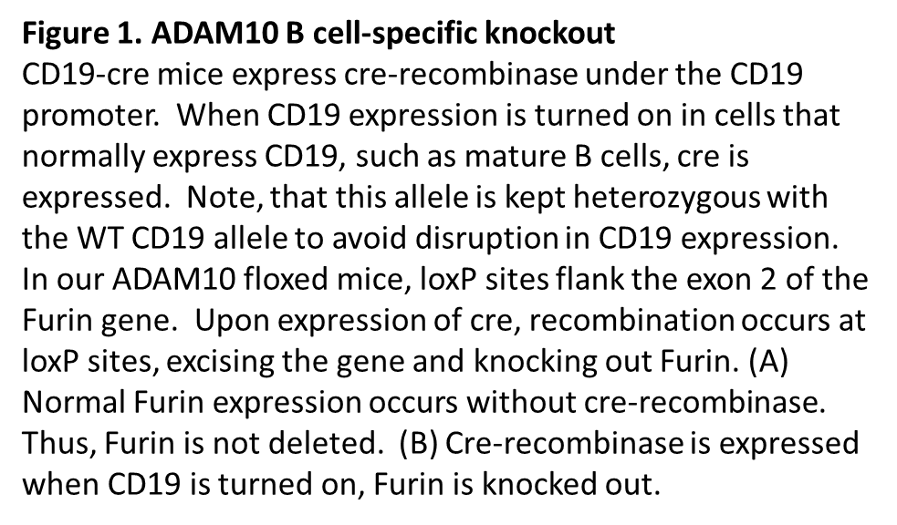
First, I will procure mice that have exon 2 of the furin gene flanked with lox-p sites (fur^{fl/fl}). These lox-p sites will facilitate a looping out and deletion of exon 2 of the DNA in cells that express the protein cre-recombinase. This will essentially delete furin from those cells(Roebroek et al., 2004). Germline deletion of furin is embryonically lethal and therefore cell-specific functionality of furin is still being examined. These mice have been bred to mice expressing T cell-expressing cre-recombinase, but never B cell cre-recombinase (Pesu et al., 2008). Cre-recombinase is essential for the recombination of DNA between the flanked lox-p sites. I propose to breed these mice to CD19-cre mice. CD19 is a transmembrane glycoprotein which is a biomarker for B cells and is critical for B cell signaling (Wang, Wei, & Liu, 2012). CD19-cre mice express cre-recombinase when the CD19 promoter is turned on, which is only in B cells. Once these mice are bred to homozygousity for fur^{fl/fl} and heterozygousity for CD19-cre, they will be fur^{Bcell-/-} mice.

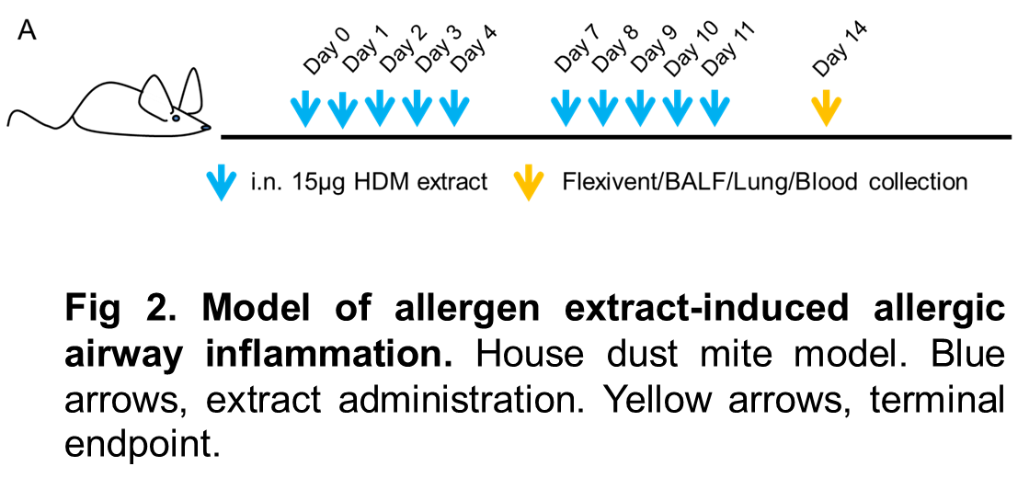
Next, I propose to test these mice in a mouse model of airway hyperresponsiveness (AHR). This is a mouse asthma model. To do this, first house dust mite (HDM) extract is intranasally administered daily for ten days with two, two day breaks (fig 2.) . These mice will be our experimental mice and will be exposed to the allergen for 10 days before the experiment is over. Then, mice are subjected to a Flexivent apparatus that measures the responsiveness of the airway to methacholine(“flexiVent | SCIREQ,” n.d.). Methacholine is a drug which is used to diagnose bronchial hyperreactivity, through the bronchial challenge test. The drugs introduction results in bronchoconstriction and if the mice display a pre-existing hyperreactive airway, such as asthma, a lower dose of the methacholine is needed to stimulate a response (“Methacholine,” 2010). I propose airway resistance will be examined at increasing doses of methacholine(2.5,5,10, 12.5,25, 50, and 100 mg/mL).This procedure can tell if the mice have developed restricted airways in the model or not, as compared to control mice that have not had furin deleted from B cells, as well as to saline controls. In previous studies, ADAM10 inhibition significantly alleviated airway hyperreactivity proposing that increased ADAM10 activity may be a predisposing factor to allergic disease(Cooley et al., 2015).
At the end of the 14-day experiment and the Flexivent procedure, lungs will be removed from the mice after euthanasia and histology will be performed to measure the cell infiltration (with hematoxylin and eosin staining) into airways and also the mucus production (with Periodic acid-Schiff) (“Why Pick PAS for Histology? - Bitesize Bio,” n.d.). Both of these are good indicators of asthma in mice and humans. In addition, spleens will be removed and ICOSL levels will be examined by flow cytometry on B cells and ICOS levels on T cells. This will support the mechanism.

Discussion
It is suspected that inhibiting furin will lead to a less severe allergic response. Compelling evidence suggests that suppressing ADAM10 will alleviate airway hyperactivity. Though the effects of ADAM10 are well known, PC7 is also a large factor that comes into play when studying allergies. PC7 has been found to cleave the prodomain of enough ADAM10 without involvement of furin (Anders et al., 2001). With this in mind, the inhibition of furin may not have a large enough impact on ADAM10 to display the effects of asthma, though the studies may prove otherwise as the effects of furin inhibition have not been tested on ICOS/ICOL. Future experimentation with the inhibition of furin and PC7 may lead to interesting results.
The ICOS/ICOSL response will also be one of the main focuses for this experiment. Recent studies have shown that a deficiency of ICOS or ICOSL terminates T-dependent humoral immune responses. ADAM10 was found to be a relevant ICOSL sheddase and was found to increase ICOSL levels when not present in B cells. This also leads to an increase in B cell ICOSL levels which results in downregulation of T cell ICOS. Increased ICOSL leads us to enhanced T_{H}1 and T_{H}17 cell activation. Shedding of ICOSL is necessary for proper T cell responses (Joseph C Lownik et al., 2017). I hypothesize that the inhibition of furin will lead to a similar regulation of ICOSL if sufficient amounts of ADAM10 remain inactivated.
Furin is responsible for the activation of the zymogen ADAM10, though not all ADAMS contain the consensus sequence for activation by furin. ADAM8 has recently been associated allergic airway inflammation. ADAM8 contains a non-perfect consensus cleavage sequence for furin, so even in high concentrations, furin inhibitors did not inhibit processing of ADAM8. ADAM8 levels have been found to be increased in airway inflammatory cells in mice and human asthma patients (Knolle & Owen, 2009). Although furin inhibition may lead to a decrease in ADAM10, ADAM8 is still a confounding variable that may have an unforeseen effect on inflammation.

References
Anders, A., Gilbert, S., Garten, W., Postina, R., & Fahrenholz, F. (2001). Regulation of the alpha-secretase ADAM10 by its prodomain and proprotein convertases. FASEB Journal : Official Publication of the Federation of American Societies for Experimental Biology, 15(10), 1837–9. Retrieved from http://www.ncbi.nlm.nih.gov/pubmed/11481247
Asthma Statistics | AAAAI. (n.d.). Retrieved October 22, 2017, from http://www.aaaai.org/about-aaaai/newsroom/asthma-statistics
Chaimowitz, N. S., Martin, R. K., Cichy, J., Gibb, D. R., Patil, P., Kang, D.-J., … Conrad, D. H. (2011). A disintegrin and metalloproteinase 10 regulates antibody production and maintenance of lymphoid architecture. Journal of Immunology (Baltimore, Md. : 1950), 187(10), 5114–22. https://doi.org/10.4049/jimmunol.1102172
Cooley, L. F., Martin, R. K., Zellner, H. B., Irani, A.-M., Uram-Tuculescu, C., El Shikh, M. E., & Conrad, D. H. (2015). Increased B Cell ADAM10 in Allergic Patients and Th2 Prone Mice. PloS One, 10(5), e0124331. https://doi.org/10.1371/journal.pone.0124331
David, Gibbs (2010). ADAM10 is a critical regulator of B cell development, antibody production,
and myeloidderived suppressor cell expansion: Effects of B cellspecific ADAM10 deletion and
overexpression in vivo (PHD thesis).
flexiVent | SCIREQ. (n.d.). Retrieved November 23, 2017, from http://www.scireq.com/flexivent
How Is Asthma Treated and Controlled? - NHLBI, NIH. (n.d.). Retrieved November 22, 2017, from https://www.nhlbi.nih.gov/health/health-topics/topics/asthma/treatment
Kim, M., Suh, J., Romano, D., Truong, M. H., Mullin, K., Hooli, B., … Tanzi, R. E. (2009). Potential late-onset Alzheimer’s disease-associated mutations in the ADAM10 gene attenuate {alpha}-secretase activity. Human Molecular Genetics, 18(20), 3987–96. https://doi.org/10.1093/hmg/ddp323
Knolle, M. D., & Owen, C. A. (2009). ADAM8: a new therapeutic target for asthma. Expert Opinion on Therapeutic Targets, 13(5), 523–40. https://doi.org/10.1517/14728220902889788
Lownik, J. C., Luker, A. J., Damle, S. R., Cooley, L. F., El Sayed, R., Hutloff, A., … Conrad, D. H. (2017). ADAM10-Mediated ICOS Ligand Shedding on B Cells Is Necessary for Proper T Cell ICOS Regulation and T Follicular Helper Responses. Journal of Immunology (Baltimore, Md. : 1950), 199(7), 2305–2315. https://doi.org/10.4049/jimmunol.1700833
Lownik, J. C., Luker, A., Martin, R., Damle, S., & Conrad, D. H. (2017). ADAM10 regulates the ICOS:ICOSL axis. The Journal of Immunology, 198(1 Supplement).
Methacholine. (2010). Retrieved from https://www.drugbank.ca/drugs/DB06709
Pesu, M., Watford, W. T., Wei, L., Xu, L., Fuss, I., Strober, W., … O’Shea, J. J. (2008). T-cell-expressed proprotein convertase furin is essential for maintenance of peripheral immune tolerance. Nature, 455(7210), 246–250. https://doi.org/10.1038/nature07210
Roebroek, A. J. M., Taylor, N. A., Louagie, E., Pauli, I., Smeijers, L., Snellinx, A., … Creemers, J. W. M. (2004). Limited redundancy of the proprotein convertase furin in mouse liver. The Journal of Biological Chemistry, 279(51), 53442–50. https://doi.org/10.1074/jbc.M407152200
Wang, K., Wei, G., & Liu, D. (2012). CD19: a biomarker for B cell development, lymphoma diagnosis and therapy. Experimental Hematology & Oncology, 1(1), 36. https://doi.org/10.1186/2162-3619-1-36
Why Pick PAS for Histology? - Bitesize Bio. (n.d.). Retrieved November 25, 2017, from https://bitesizebio.com/13413/why-pick-pas-for-histology/
Woodfolk, J. A. (2007). T-cell responses to allergens. Journal of Allergy and Clinical Immunology, 119(2), 280–294. https://doi.org/10.1016/j.jaci.2006.11.008
Zhang, L., Prietsch, S. O., & Ducharme, F. M. (2014). Inhaled corticosteroids in children with persistent asthma: effects on growth. In L. Zhang (Ed.), Cochrane Database of Systematic Reviews. Chichester, UK: John Wiley & Sons, Ltd. https://doi.org/10.1002/14651858.CD009471.pub2

