Elaf Alaithan
November 26,2017
BNFO 300

Evaluating and Comparing Various Human Sphingosine Kinase Inhibitors
Proposal
Introduction:
Almost every field in molecular biology studies cancer in one way or another. When cells stop working, they grow without stop and the end result is usually cancer. This is naturally not normal, so many studies look to return to the normal function of all cells in the body. But the malfunction that causes cancer is sometimes unstoppable and ends up consuming the life of an entire organism. This can happen very fast in some of the most aggressive types of cancer. Many scientists and researchers search for ways to stop this growth before it becomes deadly, or a threat to an organism. But the main problem is that there is no single solution to cancer. There is a lot that can go wrong in a cell that leads to cancer, and so there are many different treatments that can be tested to fix the damaged cells. One of the protein families associated with cancer is selective sphingosine kinase – SphK (Fig. 1)^{[1]}.
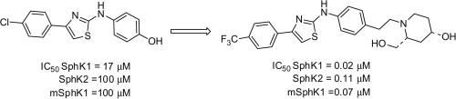
Figure 1: SphK Family of Proteins
Their job is to regulate angiogenesis, vascular maturation, cardiac development and immunity, and are important for directed cell movement ^{[1]}. They are definitely important for the cell to do its job. But when cancer appears, they also help cancer reproduce faster. Some scientists believe that regulating their function when cancer appears can help heal the cells. Some studies think that this family of proteins determines if the cell dies or proliferates when they get chemotherapy (Fig. 2) ^{[2]}.
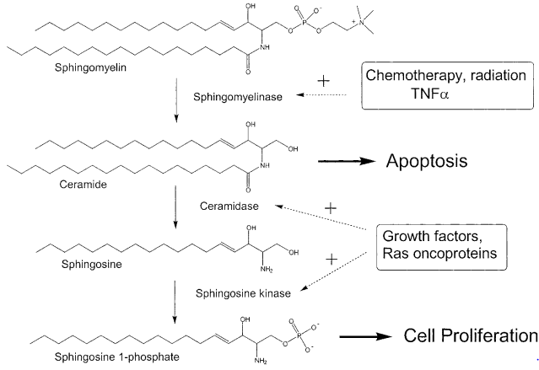
Figure 2: Amount of SphK Decides if Cell Dies or Replicates
These proteins have two sites that can be targeted for drug therapy: an ATP binding site and an Sp binding site ^{[3]}. Different drugs target different bonding sites so the interaction with the proteins is different. The choice of binding site is less important than the effectiveness of the drug. Many drugs have been invented to fight the family of SphK proteins, and they all say it stops cancer. How much of cancer cells they can stop will be the difference that makes one drug better than the other. It is useful to compare some of the many drugs that exist in the literature to determine which one is most effective at killing cancer cells. This would help identify the best treatment possible for cancer. Selectivity will be important to make sure that the drugs are not affecting normal cells. A good drug therapy could save many lives without harming healthy cells.
Available Drugs in Literature:
I. K145.
Its chemical name is 3-(2-amino-ethyl)-5-[3-(4-butoxyl-phenyl)-propylidene]-thiazolidine-2, 4-dione (Fig. 3) ^{[5]}. This anti-cancer drug was used to treat human leukemia cell lines with a good level of success. Most of the results showed that cancer activity went down in the study. This means that the drug was successful at its goal. The goal is to suppress Sp1 levels and inhibit SphK2 exclusively. The drug had success when it was studied with modeling, and with live studies to. Both in-vivo and in-vitro studies had high success rates.
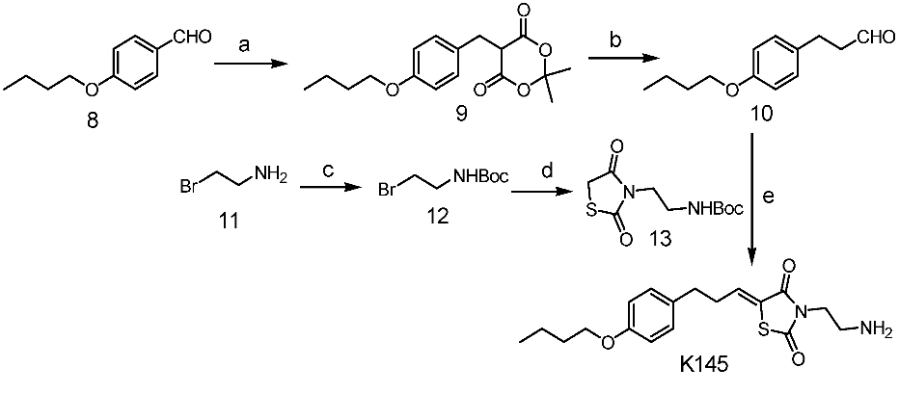
Figure 3: K145 Chemical Composition
II. SK1-I
Its chemical name is (2R,3S,4E)-N-methyl-5-(4′-pentylphenyl)-2-aminopent-4-ene-1,3-diol (BML-258) (Fig 4) ^{[6]}. Contrary to K145, this drug was created without modeling the interaction in 2D or 3D structures with SphK. But similar to K145, the drug attacked SphK2 and left SphK1 intact. The data consistently suggested that this drug was successful in decreasing cancer activity in human leukemia cancer cell lines. This makes the drug very promising for application
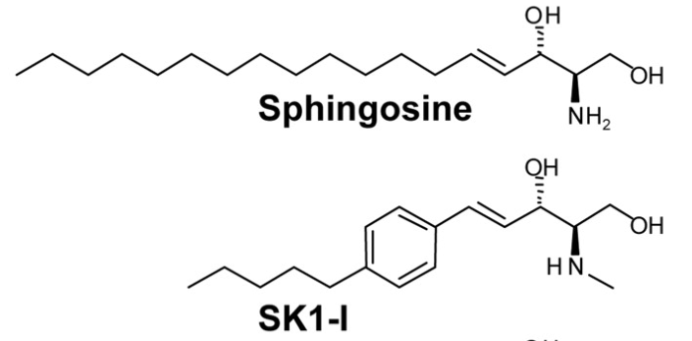
Figure 4: SK1-I Molecular Structure
III. SKI-II
Its chemical name is 2-(p-hydroxyanilino)-4-(pchlorophenyl) thiazole (Fig 5) ^{[7]}. The goal of this drug was to downregulate SphK1 activity and reduce the activity of cancer cells. The results prove that this drug was successful at the goal of regulating SphK1
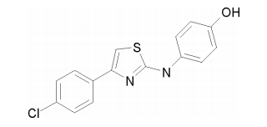
Figure 5: SKI-II Chemical Structure
IV. ABC 294640
Its chemical name is 3-(4-chlorophenyl)-adamantane-1-carboxylic acid (pyridin-4- ylmethyl)amide (Fig 6) ^{[8]}. Similar to SKI-I and K145, this drug targeted SphK2 and tried to avoid damage to SphK1. Results showed that the drug was successful. The results also said that cell proliferation and migration of tumor cell lines went down when they were exposed to ABC 294640.
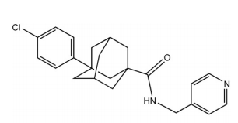
Figure 6: ABC 294640 Chemical Structure
Methods:
Homology and Molecular Modeling
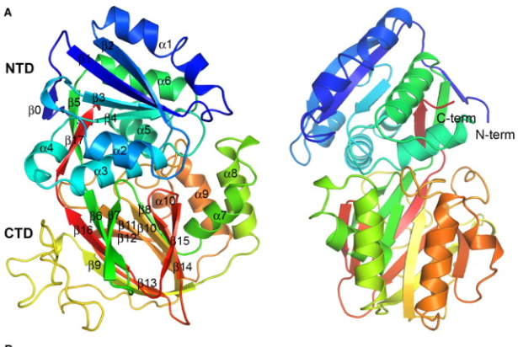
The software MODELLER can be used to model the molecules in 3D. Knowing the right chemicals to put in the drug and their chemical structure is not always enough. The researchers that created the drugs used in this study did not always model the proteins or chemicals that they used. But modeling can be a great tool to predict if a molecule will be successful or non-successful at inhibiting cancer. A software like MODELLER helps put the chemical structure into its 2-dimensional and 3-dimensional structure. The model is helpful to have a visual on how the drugs will work and how they will interact with the family of SphK proteins. When these structures are known, it is possible to model their interactions with the family of proteins SphK. One example of modeling can be seen in (Fig 7) ^{[9]}.
Figure SEQ Figure \* ARABIC 7: Sphk 1 Molecular Modeling
Although some of the studies compared in this proposal already did molecular modelling, doing it a second time is necessary to be able to compare them. Modelling all these drugs at the same time and with the same program is very important to be able to recognize which of all the drugs proposed are most likely to fit best in the family SphK and inhibit it when it is necessary.
Chemistry
The goal of the study is to compare several different drugs and how effective they are to treat cancer cell lines. It is important to recreate these drugs to know if they work. All of the chemical structures already exist. This study will not create any new drugs. The purpose of this study is to recreate drugs that have already been tested before. All of the drugs that will be tested in this study were created before. The literature explains the steps that each researcher took to create these drugs.
To make sure that all of the compounds are right, there are several steps. The first step is to make sure that all of the right chemicals are being used. Next is important to use the right amounts. This is pretty obvious but still necessary to double check. An important step to make sure that the drug has the right shape and concentration is to do mass spectrometry. This will prove that the compound was made properly and that the right drug was created.
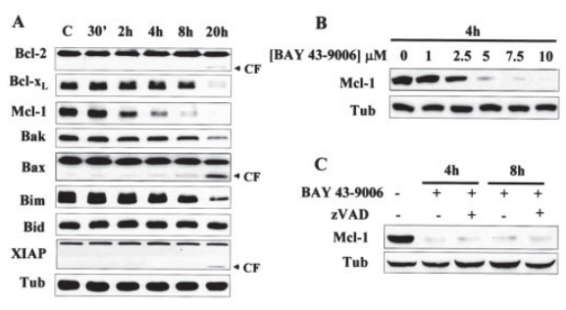
Cell Proliferation and Apoptosis Assays
Figure SEQ Figure \* ARABIC 8: Example of Western Blot Comparison ^{[11]}
After comparing the homology and molecular modeling in 3D, the most important step is to compare how effective each drug is at targeting cancer. To test this, each drug will be tested in a specific cell line while keeping a control sample. The drug that will be considered best will be the one that stops cell proliferation most and causes the cancer cells to destroy themselves. This will be done through cell proliferation and apoptosis assays. A western blot can be used to make sure that the drugs created in the lab do not harm any proteins that would be essential for good cells. A sample is in figure . The results of the western blot, back to back will explain which drug was best at its job and which one was not good enough.
Expected Results:
From this set of results, it is possible to find the best drug. It is expected that all drugs will work in cancer. But it is also expected that one will stand out among the rest. The homology modeling can be used to decide which drug is the best fit to target SphK family and stop the growth of cancer. The chemistry is simply a necessary step to get to the last, and most important test: knowing how much cancer they can kill. Comparing the cell proliferation and apoptosis assays results is expected to be the most important result in the study.
References

[1] Gustin, D. J., Li, Y., Brown, M. L., Min, X., Schmitt, M. J., Wanska, M., ... & Cheng, A. C. (2013). Structure guided design of a series of sphingosine kinase (SphK) inhibitors. Bioorganic & medicinal chemistry letters, 23(16), 4608-4616.
[2] Spiegel S, Milstien S (2003) Sphingosine-1-phosphate: an enigmatic signalling lipid. Nat Rev Mol Cell Biol 4: 397–407
[3] French, K. J., Schrecengost, R. S., Lee, B. D., Zhuang, Y., Smith, S. N., Eberly, J. L., ... & Smith, C. D. (2003). Discovery and evaluation of inhibitors of human sphingosine kinase. Cancer research, 63(18), 5962-5969.
[4] Liu, K., Guo, T. L., Hait, N. C., Allegood, J., Parikh, H. I., Xu, W., ... & Zhang, S. (2013). Biological characterization of 3-(2-amino-ethyl)-5-[3-(4-butoxyl-phenyl)-propylidene]-thiazolidine-2, 4-dione (K145) as a selective sphingosine kinase-2 inhibitor and anticancer agent. PloS one, 8(2), e56471.
[5] Paugh, S. W., Paugh, B. S., Rahmani, M., Kapitonov, D., Almenara, J. A., Kordula, T., ... & Spiegel, S. (2008). A selective sphingosine kinase 1 inhibitor integrates multiple molecular therapeutic targets in human leukemia. Blood, 112(4), 1382-1391.
[6] Ren, S., Xin, C., Pfeilschifter, J., & Huwiler, A. (2010). A novel mode of action of the putative sphingosine kinase inhibitor 2-(p-hydroxyanilino)-4-(p-chlorophenyl) thiazole (SKI II): induction of lysosomal sphingosine kinase 1 degradation. Cellular physiology and biochemistry, 26(1), 97-104.
[7] French, K. J., Zhuang, Y., Maines, L. W., Gao, P., Wang, W., Beljanski, V., ... & Smith, C. D. (2010). Pharmacology and antitumor activity of ABC294640, a selective inhibitor of sphingosine kinase-2. Journal of Pharmacology and Experimental Therapeutics, 333(1), 129-139.
[8] Wang, Z., Min, X., Xiao, S. H., Johnstone, S., Romanow, W., Meininger, D., ... & Thibault, S. (2013). Molecular basis of sphingosine kinase 1 substrate recognition and catalysis. Structure, 21(5), 798-809.
[9] Xiang, Y., Asmussen, G., Booker, M., Hirth, B., Kane, J. L., Liao, J., ... & Yee, C. (2009). Discovery of novel sphingosine kinase 1 inhibitors. Bioorganic & medicinal chemistry letters, 19(21), 6119-6121.
[10] Rahmani, M., Davis, E. M., Bauer, C., Dent, P., & Grant, S. (2005). Apoptosis induced by the kinase inhibitor BAY 43-9006 in human leukemia cells involves down-regulation of Mcl-1 through inhibition of translation. Journal of biological chemistry, 280(42), 35217-35227.

