I. Introduction
According to Mayo Clinic, a spontaneous miscarriage is a loss of a fetal life before the 20th week. It is the most common type of pregnancy loss, with more than 3 million cases per year in the US alone. One of the reasons why this devastating event happens to so many women can be because of immune system imbalances.
The immune system is a complex unit with many parts that work together constantly to keep the human body healthy. Lymphocytes (T cells, natural killer cells and helper T cells) are cells which produce antibodies, which are tiny proteins that attach on to antigens, which are proteins on the surface of cells. These antibodies are used by lymphocytes to detect and kill cells which have antibodies presented on the MHC (major histocompatibility complex). Epitopes are the peptides that are presented on the MHC and recognized by the antibodies and lymphocytes. They have to be a specific peptide sequence in order for an immune response to take place.
Lymphocytes are abundant during pregnancy and are used to protect the mother from foreign invaders. The balance of the immune system needs to be very precise in order to keep the baby healthy. The lymphocytes secrete antibodies that could be detrimental to the fetal health. An excess of the antibodies CD16 and CD56 in the peripheral cells of the mother’s body can lead to activation by lymphocytes and release tumor neurosis factors (TNF) that can destroy the placenta and therefore hurting the fetus’ chances of survival. (9) Women with natural killer cells (NKC) with CD16+ and CD56+ in excess of 20% are at risk of miscarriage because of the TNF. (9). Activation of different types of lymphocytes can be determined by antibodies. For example, CD16 and CD56 are used by NKCs and become activated. CD8 and CD4 are used by T cells to become active. And CD69 are used by both for early activation, which is needed for them to be active. (17)
Endoplasmic Reticulum Aminopeptidase 2 (ERAP2) is an enzyme that cleaves peptides in the cell and determines what the epitopes are that are presented on the MHC class-1. MHC-1 are found on the cell surface of most somatic cells. ERAP2 receives pre-cleaved peptides that are random amino acid sequences from protostomes in the cytosol from the TAP, a transporter protein. ERAP1 and ERAP2 both work together to cleave the random peptides into 8-10 amino acid sequences, which get presented to the MHC. This pathway is illustrated in figure 1.

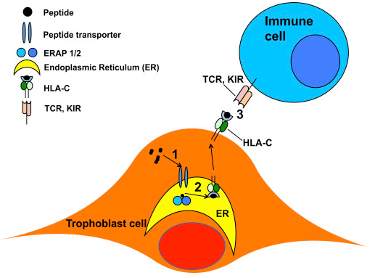
Figure 1: The role of ERAP2 in the immune system. Adapted from (10) Figure 1.
ERAP2 has two alleles: ERAP2K and ERAP2N. The difference between them is a difference in one amino acid at the 392 position. ERAPK has Lysine and ERAP2N has asparagine. (2) Lysine is a basic, polar amino acid where as asparagine is neutral and polar. The genetic difference between these two alleles is a single nucleotide polymorphism, which means that they only differ in one nucleotide. The difference in these nucleotides are in four different spots that effect the transcription of the enzyme. (6)
Although both of the alleles cleave at positively charged N terminal amino acids, the change from lysine and asparagine at the 392 position results in 165-fold greater activity for cleaving (2). The working assumption for why this hyper cleaving happens is that the asparagine results in results in a specificity switch with the peptides that it is trimming. This phenomenon is described as “the largest functional changes described for a common coding polymorphism” (2). This major change in cleaving activity could have a direct effect in the immune response, effecting the rate at which the immune system detects the epitopes. This can have detrimental effects to the fragile balance of the immune system during pregnancy.
This dramatic change in activity in alleles would explain why ERAP2N is not normally expressed in nature. There are four SNP sites that effect the expression of ERAP2. Two of them are rs-2248374 and rs2549782. The latter, if homozygous GG, is the one that has the potential for coding for the hyperactive ERAP2N allele (if it is heterozygous GT it would theoretically make half N and half K) But when this happens, it pairs with the first SNP, and results in a short, null protein expression that has no function. This is because the two alleles are known to be in linkage disequilibrium (LD). SNP rs-2248347 induces a nonsense mutation by an immature stop codon on the ERAP2N allele. This makes it so that there is theoretically no chance that ERAP2N would be expressed, unless there was an alteration to SNP rs-2248347. This is shown part C on figure 3. The stop codon on haplotype B is shown in figure 2.
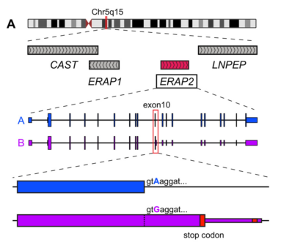Figure 2 shows the two haplotypes, A: which expresses ERAP2K and haplotype B: which is supposed to express ERAP2N, but is instead a nonsense mutation due to SNP rs-2248347. Adapted from (6). Figure 3.
It is proven that the alleles are in LD in most of the world (6). But there is one Chilean population that do not have the alleles linked (4). Theoretically, they should express ERAP2N, but they do not. The reason is unknown. One hypothesis of why ERAP2N is not seen in either fetus or mother’s cells is because the hyper trimming capability of the N allele presents epitopes to the MHC at a faster rate, which then induces more of a response from the mother’s immune system, (i.e. activating more lymphocytes) and the uterus becomes a hostile, fatal environment, resulting in termination of trophoblast cell or fetal survival. (10) This would also explain why there is an LD in most of the world’s population, because it is an evolutionary adaptation that came about because of the effects of ERAP2N on fetal health. (4)
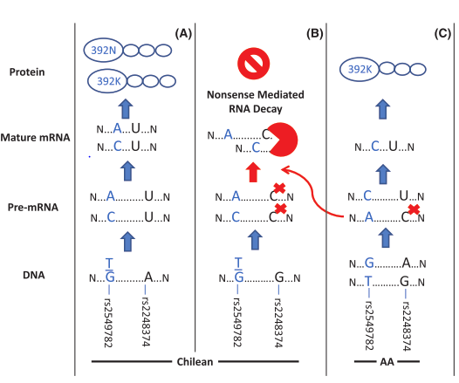
Figure 3. Shows the linkage seen in most populations (here it is AA for African American) vs. the lack of linkage in Chilean population. This is a prediction of what would theoretically happen since there is no linkage, but it is known that ERAP2N still does not get transcribed somehow leaving K at the protein stage in scenario (A). Adapted from (4) Figure 3.
If we can change the SNP rs-2248347 so that ERAP2N is expressed in the cell, it would show that it would be possible to override the LD from a mutation on SNP-rs2248347. Also, if we can see the correlation between ERAP2, both of the alleles, and the number of activated lymphocytes that it produces, we can see the effect that the aminopeptidase has on the immune system and ultimately if ERAP2 can be a factor in immune induced miscarriages. This experiment is going to test the expression of ERAP2N/K in JEG-3 cells through genetic alterations and the effect it has on the amount of activated NKCs and T cells.
II. Experiment
The aim of this experiment is to genetically modify SNP rs-2248347 to induce expression of ERAP2N in JEG-3 cells and the to determine the number of activated lymphocytes (by lymphocyte activation assay) that are present when ERAP2 N and K are genetically altered in the cell by Crispr gene editing so that the enzymes get transcribed. My hypothesis is that If there is ERAP2N, then it is expected that there would be more activated lymphocytes than if there was ERAP2K in the cell.
IIA. Gene editing
IIAa. Cell Line
Jeg-3 cell lines are going to be used in this experiment. It is a type of choriocarcinoma cell that are trophoblast cells which have both TAP (transporter protein) and MHC-Class one. (13) They have the genotype for ERAP2N (SNP-2549782), homozygous TT. And the SNP that suppresses the transcription of ERAP2N, SNP rs-2248374 (homozygous GG) (11). Because they have both homogenous SNPs, the heightened genotype for the N allele causes the SNP rs-2248374 to induce premature mRNA decay. So natural JEG-3 cells do not express ERAP2N or K, but have the genes for them. This makes them an ideal cell line to do gene editing in the SNP rs-2248374.
IIAb. Crispr Gene Editing
The Crispr Cas 9 editing is going to heighten transcription of ERAP2N by using single nucleotide replacement to change SNP rs-2248374, the SNP that causes premature mRNA decay, from homozygous GG to homozygous AA, which would ensure the transcription of ERAP2N because of the SNP rs-2248374 knocked out.
The same technique will be used to make another group of cells to have ERAP2 K allele. The gene editing will change the SNP rs-2549782 from homogenous TT to GG so ERAP2K will be expressed and SNP rs-2248374 will not be needed to alter because it encodes for the K allele.
The different types of cells that I am aiming to obtain is JEG-3 with a. ERAP2K, b. ERAP2N, and c. with no ERAP2 (natural JEG-3 cells).
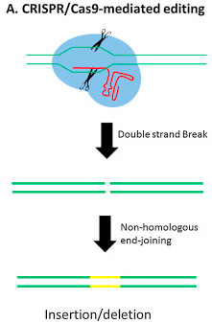
The results of the gene editing will be checked by western blot. SDS page will be used to look at the weight of the peptide. ERAP2 should be 110kDa (4). Beta actin internal control will be also checked in order to keep the amount of protein the same.

Figure 4: Crispr/Cas9 editing. Blue circle is Cas9. Red is sgRNA yellow is the new DNA. Adapted from (18)
IIB. Lymphocyte Activation Assay
IIBa. Isolation of lymphocytes
Isolation of lymphocytes needs to be done from freshly donated blood. The PBMC isolation protocol (14) will be used to isolate lymphocytes based on density gradient centrifugation. The lymphocytes that will be used are NK cells because they are found in abundance in pregnant women, and T cells to see if it induces any other immune response.
IIBb. Insertion of antibodies
The antibodies that will be inserted are anti-CD56, CD16, CD69, CD8, and CD4. CD56 and CD16 activate NKCs, are known to induce tumor necrosis factors when they are both active in excess amounts (9). Also, CD69 will be quantified to show us early activation of cell surface molecules. CD69 needs to be positive in order for the results to be valid because without activation, the antibodies will have no effect. CD8 an CD4 are both different types of T cells. (17)
IIBc. Quantification of Activated Lymphocytes
After 48 hours of keeping the lymphocytes, antibodies, and JEG-3 cells together in incubation, flow cytometry will be used to quantify activated lymphocytes.
The activated lymphocytes (NKC and T Cells) will have CD* protein on the surface of the cell like in figure 4. For NKCs, instead of TCR (T cell receptor) it is KIR (Killer-cell Immunoglobulin-like Receptors). Also shown in Figure 1.
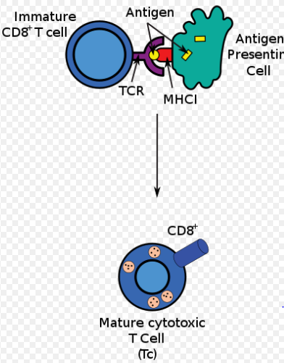
Figure 5: The activation of T cells from the bonding with MHC-C1. Adapted from (16)
III. Discussion
If this experiment goes well, it will show that an alteration in SNP rs-2248374 will result in the hyper cleaving ERAP2N allele to be formed. This will show that although the genes are linked to not be expressed in nature, an alteration in the SNP (which is possible in nature) could make the expression of ERAP2N. ERAP2N has not been induced by gene alteration before, only by transfection. The possibility of the enzyme ERAP2N being expressed could then be one factor of spontaneous miscarriages that happen with no other warning. And would need to be further researched. If the gene alteration is successful, it will also show how the alleles have an effect on the immune system through activation of T cells and NKCs.
The anticipated results are that ERAP2N will produce the highest number of activated lymphocytes. Followed by ERAP2K and then no ERAP2 at all.
The hypothesis is that genetically induced ERAP2N would result in more lymphocytes being activated. The amount of activation increasing would go for the broader hypothesis the genes that are not linked in Chilean population do not result in people expressing the enzyme (although they theoretically should) because the increase in lymphocytes would result in hyperimmune defenses such as TNFs releasing, being fatal to the fetal survival.
One problem that I could come across is that although JEG-3 cell lines do not express ERAP2, it could have other aminopeptidases that are presenting to the MHC. Another complication is that the antibodies sometimes do not have the same affinity to bond when the lymphocytes are isolated instead of doing the experiment in actual blood. Since I would be isolating lymphocytes, the results might not be as strong.
In this proposed experiment, JEG-3 cell lines are used to see the effects of the different alleles clearer because they are homogenous for both SNPs. But another cell line that has heterozygous for the two SNPs can be used to see if the difference in immune response is as big.
If this experiment were to work, it would have many implications and would open op doors for further research. Further research needs to be done on the spontaneous miscarriages and ERAP2N. One experiment that would help the hypothesis is genotyping the mothers and the terminated fetal tissue for ERAP2N and K. This would show the simple association of the two.
Although spontaneous miscarriages are an awful phenomenon to happen to women and their families, advances in not only research, but also technology have lead us closer to the causes of it. We have come far, but there are still more generations of knowledge that is needed to fully assess spontaneous miscarriages.

Citations

- Hill LD, Hilliard DD, York TP, Srinivas S, Kusanovic JP, Gomez R, et al. Fetal ERAP2 variation is associated with preeclampsia in African Americans in a case-control study. BMC Med. Genet. 2011a;12:64.
- Evnouchidou I, Birtley J, Seregin S, Papakyriakou A, Zervoudi E, Samiotaki M, et al. A common single nucleotide polymorphism in endoplasmic reticulum aminopeptidase 2 induces a specificity switch that leads to altered antigen processing. J. Immunol. 2012;189:2383–2392
- Nguyen, T. T., S. C. Chang, I. Evnouchidou, I. A. York, C. Zikos, K. L. Rock, A. L. Goldberg, E. Stratikos, and L. J. Stern. 2011. Structural basis for antigenic peptide precursor processing by the endoplasmic reticulum aminopeptidase ERAP1. Nat. Struct. Mol. Biol. 18: 604–613
- Vanhille DL, Hill LD, Hilliard DD, et al. A novel ERAP2 haplotype structure in a Chilean population: implications for ERAP2 protein expression and preeclampsia risk. Molecular Genetics & Genomic Medicine. 2013;1(2):98-107. doi:10.1002/mgg3.13.
- Cifaldi L, Romania P, Lorenzi S, Locatelli F, Fruci D. Role of Endoplasmic Reticulum Aminopeptidases in Health and Disease: from Infection to Cancer. International Journal of Molecular Sciences. 2012;13(7):8338-8352. doi:10.3390/ijms13078338.
- Andrés AM, Dennis MY, Kretzschmar WW, et al. Balancing Selection Maintains a Form of ERAP2 that Undergoes Nonsense-Mediated Decay and Affects Antigen Presentation. Gojobori T, ed. PLoS Genetics. 2010;6(10):e1001157. doi:10.1371/journal.pgen.1001157.
- Gilbert LA, Larson MH, Morsut L, et al. CRISPR-Mediated Modular RNA-Guided Regulation of Transcription in Eukaryotes. Cell. 2013;154(2):442-451. doi:10.1016/j.cell.2013.06.044.

- Rothbard, J. B., & Taylor, W. R. (1988). A sequence pattern common to T cell epitopes. The EMBO Journal, 7(1), 93–100. Retrieved from http://www.ncbi.nlm.nih.gov/pmc/articles/PMC454220/
- Colucci F, Boulenouar S, Kieckbusch J, Moffett A. How does variability of immune system genes affect placentation? Placenta. 2011;32(8):539-545. doi:10.1016/j.placenta.2011.05.001.
- Lee D, Eun Endoplasmic Reticulum Aminopeptidase 2, a common immunological link to adverse pregnancy outcomes and cancer clearance? Placenta. 2017;(56)40-43 https://doi.org/10.1016/j.placenta.2017.03.012
- Lee D, Eun Comparative expression profiling of endoplasmic reticulum aminopeptidase 2 and human leukocyte antigen-C expression in choriocarcinoma cell lines Pregnancy Hypertension: An International Journal of Women's Cardiovascular Health 2015;5(1)
- Saric, Tomo Chang, Shih-Chung Hattori, Akira York, Ian A. Markant, Shirley Rock, Kenneth L. Tsujimoto, Masafumi Goldberg, Alfred L. An IFN-γ–induced aminopeptidase in the ER, ERAP1, trims precursors to MHC class I–presented peptides Nature Immunology 2002;3 http://dx.doi.org/10.1038/ni859
- Easterfield, A.J., B.M. Austen, and O.M. Westwood, Inhibition of antigen transport by expression of infected cell peptide 47 (ICP47) prevents cell surface expression of HLA in choriocarcinoma cell lines. J Reprod Immunol, 2001. 50(1): p. 19-?‐40.
- Lauren E. Higdon, PhD, Karim Lee, PhD, Qizhi Tang, PhD, and Jonathan S. Maltzman, MD, PhD Virtual Global Transplant Laboratory Standard Operating Procedures for Blood Collection, PBMC Isolation, and Storage Transplantation Direct 2016;2: e101; doi: 10.1097/TXD.0000000000000613
- L. May, D. van Bodegoma, M. Kuningas, J.J. Meij, A.J.M. de Craen, M. Frölich, R.G.J. Westendorp Performance of the whole-blood stimulation assay for assessing innate immune activation under field conditions Cytokine 45 (2009) 184–189 doi:10.1016/j.cyto.2008.12.010
- https://en.wikipedia.org/wiki/Cytotoxic_T_cell#/media/File:Antigen_presentation.svg
- Human and Mouse CD Marker Handbook BD Biosciences 2010
- Scott M.SchaefferPaul A.Nakata CRISPR/Cas9-mediated genome editing and gene replacement in plants: Transitioning from lab to field Plant Science Volume 240, November 2015, Pages 130-142 https://doi.org/10.1016/j.plantsci.2015.09.011

