History 8 Civics
SOL 7.1
US History Early Documents

Students will review:
Declaration of Independence, Articles of Confederation, Constitution
Students will read about each document and answer comprehension
questions.
Students will learn definitions of vocabulary found in our early documents.
Students will complete a word search puzzle.
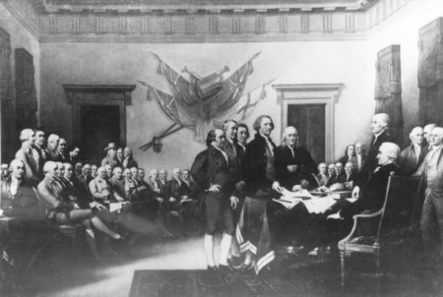
Click Declaration of Independence and read the first two paragraphs.
To learn more about the Declaration of Independence click
here.
Read the Summary and answer the following question.

- State the fundamental American ideal of government?

Click Articles of Confederation
Read and answer.

- Name the three main parts of the Articles of Confederation?

Click Constitution
Read and answer

- The three main principles of our government are....?

- What are the three parts of the Constitution and give their definition?

5. How many articles are there?

6. The first ten amendments are called ?

Click Glossary
Your teacher will assign you 5 vocabulary words. You must read the definition and write the word and its definition in your own words to tell the class.

Click Games and Activities
Press Interactive Games.

Ben’s Word Find
Directions - read them
Play - pick either Our Nation or Constitution solve the puzzle
make sure you know the meaning of all the words in your puzzle.

Other web sites to visit for more information

The Virginia Declaration of Rights
http://www.loc.gov/exhibits/treasures/trt006.html

Charters of the Virginia Company of London
http://www.infoplease.com/ce6/history/A0850989.html

Declaration of Independence
http://www.yale.edu/lawweb/avalon/declare.htm

http://www.educationplanet.com/articles/american_revolution.html

