

Science - SOL 4.3 a-f
Electricity

Directions: This CyberHunt will be a "shocking" experience. Click on each underlined colored phrase or words to visit sites that might help you find the answers. Type your answers on the lines provided, print when you’re done, and turn your paper into your teacher. Good Luck!

- Explain static electricity.

•

- Define energy.

•

3) Forms of energy can be put into two categories. List and describe these categories .

•

•

- Explain what makes up an atom. Please list each ones unique characteristic.
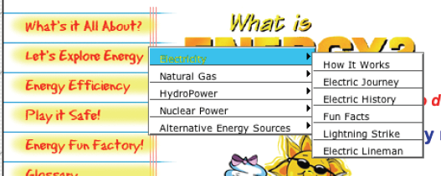
(Go to Let’s Explore Energy> Electricity> How It Works)

•

- What is a parallel circuit? Explain and draw a picture.
•

- What is a current?

•

- What inventions did Thomas Edison develop that changed the world?

•

- List three facts from this web site about electricity.

•

•

•

http://www.idahoptv.org/dialogue4kids/season3/electricity/facts.html
http://www.idahoptv.org/dialogue4kids/season3/electricity/facts.html

http://www.enchantedlearning.com/inventors/page/e/edison.shtml
http://www.firstenergycorp.com/kids/

http://www.energyquest.ca.gov/story/index.html

http://www.animationlibrary.com/a-l/?n=image.php3&image_id=3141

http://www.sciencemadesimple.com/static.html#ICANREAD

http://www.sciencemadesimple.com/static.html

http://www.firstenergycorp.com/kids/
http://www.eia.doe.gov/kids/energyfacts/science/formsofenergy.html

http://www.energyquest.ca.gov/story/chapter04.html

http://www.energyquest.ca.gov/story/index.html

http://www.energyquest.ca.gov/story/chapter03.html

http://www.dom.com/about/safety/kids.jsp

http://www.thetech.org/exhibits/online/topics/12i_flash.html

http://teacher.scholastic.com/dirt/circuits/whatcirc.htm

http://education.jlab.org/qa/electromagnet_is.html

http://uk.dk.com/static/cs/uk/11/clipart/home.html


Directions: This CyberHunt will be a "shocking" experience. Click on each to visit sites that might help you find the answers. Type your answers on the lines provided, print when you’re done, and turn your paper into your teacher. Good Luck!

The hyperlinks will provide some clues to help you discover the answers. When your explorations are complete you may work with your partner to present your findings. Be creative with your presentation. Good Luck!

