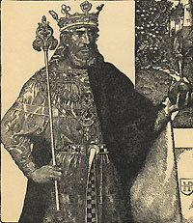
Arthurian Legend
Introduction Worksheet
Answer the following questions using my web page, a partner, and the links provided. Copy and paste this worksheet into a word processing document so you can type directly on the sheet. Keep this open on one computer and search with your partner’s computer. Eventually, you will drop this in my dropbox.
March 2006
The Legend of Arthur
1. According to historians, who could be the real Arthur?
2. Explain the controversy surrounding the legend of "The once and Future King."
The Sword in the Stone
3. According to legend, who put the sword in the stone?
4. Explain why the sword was put here.
5. Briefly explain who removed the sword, and what happened as a result of its removal.
Guenivere
6. Who is Guenivere's husband?
7. Explain how she caused the downfall of Camelot.

Launcelot
8. What are four charges given to The Knights of the Round Table?
1.
2.
3.
4.
9. How did Launcelot cause the disbandment of The Knights of the Round Table?
10. What is the legend of Launcelot's childhood & Vivien?
Merlin
11. What three roles does Merlin play in Arthur's life?
12. How did Merlin help make Stonehenge, according to legend?
The Quest and The Holy Grail
13. Define the term Quest.
14. What is the Holy Grail according to Arthurian legend?
The Round Table
15. What three things does the round table symbolize?
16. According to legend, how many men could sit at the table?
17. Who gave the Round table to Arthur?
18. Why?
19. Copy two different theories regarding the creation of the round table.
20. Why is the round table round?
Camelot
21. What is Camelot?
22. What does Camelot represent?

